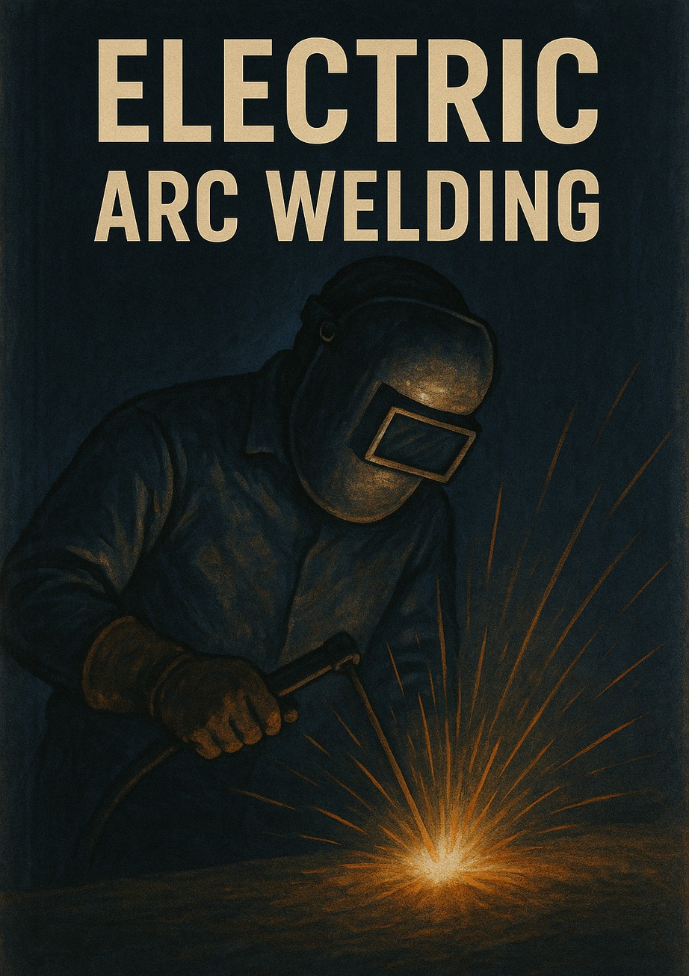

Table of Contents
- ARC WELDING TECHNIQUES 3
  - Beveling Thick Pieces in Horizontal Position 3
  - V Welding in Horizontal Position 7
  - K Welding in Horizontal Position 12
- FILLER WELDING 14
  - Types of Build-Up Welding 14
  - Surface Build-Up Welding 17
  - Shaft Build-Up Welding 18
- VERTICAL WELDING 20
  - Vertical Welding Positions 20
  - Top-to-Bottom Butt Joint Welding 22
  - Bottom-to-Top Butt Joint Welding 23
  - Bottom-to-Top V-Groove Welding 23
  - Bottom-to-Top Fillet Welding 23
  - Top-to-Bottom Fillet Welding 25
  - Top-to-Bottom Outside Corner Welding 26
- CORNICE AND CEILING WELDS 27
  - Welding Positions 27
  - Side (Cornice/Wall) Butt Joint Welding 28
  - Side V-Groove Welding 29
  - Side Fillet Welding 30
  - Overhead Butt Joint Welding 31
  - Overhead V-Groove Welding 32
- CELLULOSIC AND BASIC ELECTRODE WELDING 34
  - Butt Joint Welding with Cellulosic Electrode 35
  - Butt Joint Welding with Basic Electrode 37
- CAST IRON WELDING 40
  - Methods of Cast Iron Welding 40
  - Repair of Broken Parts 42
- WELDING OF NON-FERROUS METALS 53
  - Copper Welding 53
  - Brass Welding 55
  - Welding of Aluminum and Its Alloys 57
- WELDING OF ALLOYED STEELS 70
  - Welding of Alloy Steels 70
  - Welding of Stainless Steels 72
  - Welding of Tool Steels 74
- WELDING OF LARGE DIAMETER PIPES 78
  - Introduction 78
  - Butt Welding of Pipes 81
  - Flange Welding 85
  - T-Welding of Pipes 87
  - L-Welding of Pipes 92

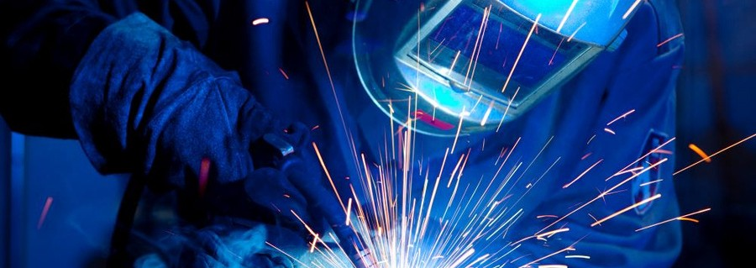P R E P A R E D B Y
I n n o w e l d

ARC WELDING TECHNIQUES

LEARNING UNIT

1 . 1 . B E V E L I N G T H I C K PI E C E S I N H O R I Z O N T A L PO SI T I O N

1 . 2 . V W E L D I N G I N

H O R I Z O N T A L PO SI T I O N

1 . 3 . K W E L D I N G I N

H O R I Z O N T A L PO SI T I O N 3

1 . 1 . B E V E L I N G T H I C K PI E C E S I N H O R I Z O N T A L PO SI T I O N
Ens uri ng de e p pe ne t ra 1 2 t i on of w e l d m e tal and c re ati ng a s t rong j oi nt i s not a l w ay s pos s i bl e s ol e l y by adj us t i ng the w e l di ng c urre nt or e l e c t rode di am e te r .
A ddi t i onal l y , m odi f i c ati ons to the c ros s - s e c t i on of the parts to be w e l de d s houl d be m ade to c re ate a w e l di ng g roov e . For e as e of pre parati on, a V - g roov e i s of te n pre f e rre d i n prac t i c e . Furthe rm ore , U, X , and J g roov e s c an be appl i e d e i the r
s i ng l y or on both s i de s f or butt w e l ds . The s e ty pe s of w e l di ng g roov e s re qui re
m ore pre parati on t i m e and addi t i onal l abor, m aki ng the m g e ne ral l y pre f e rre d f or s pe c i a l appl i c ati ons or autom ati on- f oc us e d w ork.
1 . 1 . 1 . I m p o r t a n c e o f B e v e l i n g
A ke y pre re qui s i te f or j oi ni ng thi c k parts us i ng e l e c t r i c arc w e l di ng i s e ns uri ng
that the j oi nt ac hi e v e s the de s i re d l e v e l of s t re ng th. S e v e ral f ac tors de te rm i ne the i nte g r i ty of a w e l d j oi nt:
The be v e l i ng proc e s s i s pe r f orm e d to e ns ure 1 0 0 % pe ne t rati on of the w e l d m e tal i nto the bas e m ate r i a l .
S i nc e the w e l d m e tal pe ne t rate s the bas e m ate r i a l , i t i nc re as e s the m ate r i a l ' s s e rv i c e l i f e and m e c hani c a l s t re ng th.
Not a l l thi c kne s s e s re qui re be v e l i ng .
The s tandards f or be v e l i ng thi c kne s s and s hape are de te rm i ne d by TS 3 4 7 3 EN IS O 9 6 9 2 - 1 .
Pi e c e s up to 8 m m thi c k do not re qui re be v e l i ng i f w e l de d on both s i de s .
For pi e c e s thi c ke r than 1 0 m m , doubl e - s i de d be v e l i ng m us t be pe r f orm e d, w hi c h m ay i nc l ude doubl e V , doubl e U, or X g roov e s .

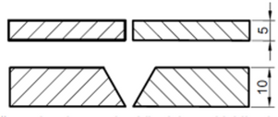
Figure 1.1: Butt Joint Without Beveling and V-Groove Beveling.
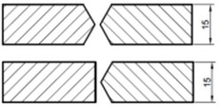
Figure 1.2: Double-Sided V-Groove and Single-Sided K-Groove Beveling.

1 . 1 . 2 . B e v e l i n g M e t h o d s
B e v e l i ng c an be pe r f orm e d us i ng burni ng , m e l t i ng , or m ac hi ni ng proc e s s e s . The
c hos e n m e thod s houl d be c os t - e f f e c t i v e , qui c k, and s houl d not a l te r the c he m i c a l or phy s i c a l prope r t i e s of the bas e m ate r i a l . The re f ore , the m e thod of be v e l i ng
s houl d be de te rm i ne d ac c ordi ng to the m ate r i a l to be w e l de d.
1 . 1 . 3 . 1 . B e v e l i n g w i t h O xy - G a s C u t t i n g
O ne of the the rm a l be v e l i ng m e thods i nv ol v e s c utti ng w i th an ox y - g as torc h. Many m e tal parts c an be c ut and be v e l e d w i th ox y g e n, e x c e pt f or s om e re s t r i c te d
m ate r i a l s . How e v e r , e x c e s s i v e he at i nput and ox y g e n c ons um pti on i m pos e
l i m i tati ons on the ty pe s of m ate r i a l s that c an be us e d. For i ns tanc e , c utti ng s tai nl e s s s te e l s and bras s w i th ox y g e n i s not re c om m e nde d.

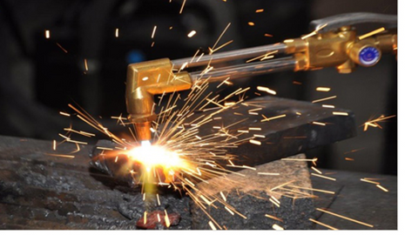
Figure 1.3: Oxy-Gas Cutting
1 . 1 . 3 . 2 . B e v e l i n g w i t h G r i n d i n g W h e e l s
In m ac hi ni ng appl i c ati ons , be v e l i ng c an be pe r f orm e d m anual l y or throug h
autom ati on. In m anual appl i c ati ons , a g r i ndi ng w he e l c an be us e d f or be v e l i ng . The av a i l abi l i ty of g r i ndi ng w he e l s i n m os t m e tal w orks hops and the abi l i ty to pe r f orm the proc e s s qui c kl y m ake thi s m e thod v i abl e f or proj e c t s w i thout
addi t i onal i nv e s tm e nt. Gri ndi ng w he e l s us e d f or be v e l i ng s houl d be c oars e - g rai ne d to e x pe di te the proc e s s .

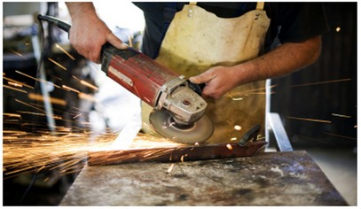
Figure 1.4 Grinfing Wheels

1 . 1 . 3 . 3 . B e v e l i n g w i t h P l a s m a C u t t i n g
T h i s m e t h o d i s p r e f e r r e d f o r c u t t i n g b e v e l s i n f l a t s h e e t m e t a l d u e t o i t s
c o m p a t i b i l i t y w i t h a u t o m a t i o n . P l a s m a c u t t i n g a l l o w s b e v e l i n g a n d s h a p i n g o f m e t a l s t h a t a r e u n s u i t a b l e f o r o x y - g a s c u t t i n g .

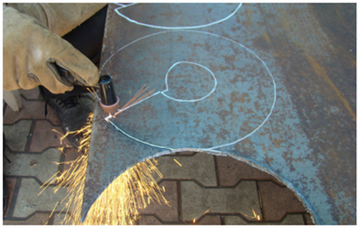
Figure 1.5: Plasma Cutting
. 1 . 3 . 4 . B e v e l i n g w i t h C a r b o n A r c C u t t i n g
T h i s m e t h o d i n v o l v e s u s i n g a c a r b o n e l e c t r o d e a n d p r e s s u r i z e d a i r . I t i s b a s e d o n c r e a t i n g a n a r c s i m i l a r t o e l e c t r i c a r c w e l d i n g . T h i s m e t h o d i s w i d e l y u s e d i n s h i p b u i l d i n g a n d p r e s s u r e v e s s e l m a n u f a c t u r i n g .
S i n c e i t i s a m e l t i n g - b a s e d c u t t i n g p r o c e s s , i t i s s u i t a b l e f o r m e t a l s t h a t c a n n o t b e c u t w i t h t h e r m a l m e t h o d s . T h e s y s t e m c o n s i s t s o f t w o m a i n
c o m p o n e n t s : t h e c a r b o n e l e c t r o d e , w h i c h c r e a t e s t h e m e l t i n g e n v i r o n m e n t , a n d t h e p r e s s u r i z e d a i r s y s t e m .
A d d i t i o n a l l y , c a r b o n a r c c u t t i n g i s u s e d f o r g o u g i n g o p e r a t i o n s , a l s o k n o w n a s g r o o v i n g . M a c h i n i n g t o o l s s u c h a s m i l l i n g m a c h i n e s , l a t h e s , a n d s h a p e r s c a n a l s o b e u s e d f o r b e v e l i n g . P a r t i c u l a r l y , t h i c k s e c t i o n s o f a l u m i n u m a n d s i m i l a r m e t a l s c a n b e p r o c e s s e d u s i n g t h e s e m a c h i n e s i n w e l l - e q u i p p e d
w o r k s h o p s . B e v e l i n g p r o c e s s e s f o r m a s s p r o d u c t i o n c a n a l s o b e p e r f o r m e d o n l a t h e s o r C N C m a c h i n e s .
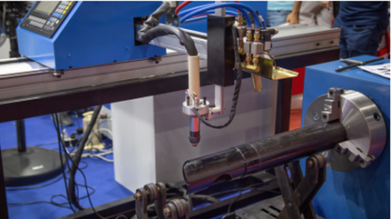

F i gure 1 . 6 : Bev eli n g Mac h i n e fo r Pi pes

1 . 1 . 5 . P r e c a u t i o n s D u r i n g W e l d i n g
B y t a k i n g c e r t a i n p r e c a u t i o n s , t h e n e g a t i v e e f f e c t s o f d i s t o r t i o n s i n w e l d e d j o i n t s c a n b e m i n i m i z e d . T h e p r e c a u t i o n s f o r p r e v e n t i n g d e f o r m a t i o n s
d u r i n g w e l d i n g a r e c a t e g o r i z e d i n t o t w o g r o u p s :
D u r i n g D e s i g n :
T h e d e s i g n s h o u l d b e s u i t a b l e f o r t h e w e l d i n g t e c h n i q u e . W e l d s e a m s s h o u l d b e s y m m e t r i c a l .
W e l d s e a m s s h o u l d n o t b e p l a c e d t o o c l o s e t o e a c h o t h e r . B u t t j o i n t s s h o u l d b e p r e f e r r e d w h e n e v e r p o s s i b l e .
T h e w o r k p i e c e s h o u l d b e d e s i g n e d t o a l l o w n a t u r a l c o n t r a c t i o n d u r i n g w e l d i n g .
D u r i n g W e l d i n g :
A n a p p r o p r i a t e w e l d i n g s e q u e n c e s h o u l d b e f o l l o w e d .
T h e e l e c t r o d e d i a m e t e r a n d c u r r e n t s e t t i n g s s h o u l d m a t c h t h e w o r k p i e c e t h i c k n e s s . E x c e s s i v e h e a t i n p u t d u e t o l a r g e - d i a m e t e r e l e c t r o d e s s h o u l d b e a v o i d e d .
T o p r e v e n t a n g u l a r d i s t o r t i o n s , w e l d g r o o v e s s h o u l d b e f i l l e d w i t h t h i c k w e l d b e a d s .
I f p o s s i b l e , s h o r t s t i t c h e s s h o u l d b e a p p l i e d u s i n g t h e s k i p a n d b a c k - s t e p w e l d i n g t e c h n i q u e s . S u p p o r t s s h o u l d b e w e l d e d l a s t w h e n e v e r
p o s s i b l e .
B u r n - t h r o u g h n o t c h e s c r e a t e s t r e s s c o n c e n t r a t i o n s , s o t h e i r f o r m a t i o n s h o u l d b e p r e v e n t e d .
T o p r e v e n t t r a n s v e r s e s h r i n k a g e , p a r t s s h o u l d b e c l a m p e d o r t a c k w e l d e d f i r m l y b e f o r e w e l d i n g .
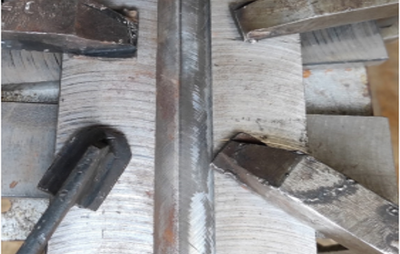

Figure 1.7: Preventing Weld Shrinkage Using a Fixture.

1 . 2 . V W E L D I N G I N H O R I Z O N T A L P O S I T I O N
W h e n t h e t h i c k n e s s o f t h e p a r t t o b e w e l d e d e x c e e d s 1 0 m m , a V - g r o o v e i s c r e a t e d , a n d a w e l d s e a m i s a p p l i e d . T h e c o s t o f g r o o v e p r e p a r a t i o n s h o u l d
b e c o n s i d e r e d i n m a n y a p p l i c a t i o n s ; h o w e v e r , t h i s c o s t i s r e d u c e d i f o x y g e n
c u t t i n g i s u s e d .
V w e l d i n g a l o n e l e a d s t o h i g h e r e l e c t r o d e c o n s u m p t i o n . F o r e x a m p l e , i t
r e q u i r e s m o r e w e l d m e t a l t h a n a n X - w e l d . L i k e b u t t w e l d s , t h e r o o t o f t h e w e l d i s n o t v e r y r e s i s t a n t t o b e n d i n g a n d t o r s i o n .
I n s o m e a p p l i c a t i o n s , f i l l i n g t h e V - g r o o v e w i t h a s i n g l e p a s s m a y n o t b e f e a s i b l e . I n s u c h c a s e s , a r o o t p a s s i s n e c e s s a r y .

1 . 2 . 1 . S t a n d a r d D i m e n s i o n s a n d A n g l e s f o r V W e l d s
A V g r o o v e i s c r e a t e d t o a c h i e v e f u l l p e n e t r a t i o n i n a s i n g l e - s i d e d w e l d .
P i e c e s b e t w e e n 6 - 1 2 m m t h i c k a r e b e v e l e d w i t h a V g r o o v e , w h i c h i s g e n e r a l l y o p e n e d a t a 6 0 - d e g r e e a n g l e .
α : T h e a n g l e d e p e n d s o n t h e w e l d i n g m e t h o d , w e l d i n g p o s i t i o n , a n d w h e t h e r b a c k w e l d i n g i s p o s s i b l e .
c : R o o t h e i g h t d e p e n d s o n α a n g l e a n d w e l d i n g p o s i t i o n .
b : R o o t g a p d e p e n d s o n α a n g l e , w e l d i n g m e t h o d , a n d p o s i t i o n .
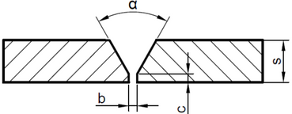
Figure 1.8: V-Groove Weld Dimensions

1 . 2 . 2 . I m p o r t a n c e o f R o o t P a s s
T h e r o o t g a p a l l o w s t h e e l e c t r o d e t o r e a c h t h e j o i n t ’ s b o t t o m o r r o o t . I f t h e r o o t g a p i s t o o n a r r o w , i t b e c o m e s d i f f i c u l t t o a c h i e v e f u l l f u s i o n , r e q u i r i n g a s m a l l e r e l e c t r o d e , w h i c h s l o w s t h e p r o c e s s . I f t h e r o o t g a p i s t o o l a r g e , m o r e w e l d m e t a l i s n e e d e d , i n c r e a s i n g c o s t s a n d d i s t o r t i o n s .
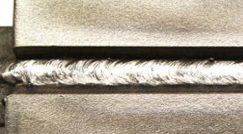
Figure 1.9: Root Pass WeldP

1 . 2 . 3 . T a c k W e l d i n g f o r V J o i n t P r e p a r a t i o n
T a c k w e l d s m a y b e a p p l i e d t o h o l d t h e p a r t s i n p l a c e d u r i n g w e l d i n g . T h e
l e n g t h a n d s p a c i n g o f e a c h t a c k w e l d s h o u l d b e s p e c i f i e d i n t h e f a b r i c a t i o n d r a w i n g , w e l d i n g p r o c e d u r e s p e c i f i c a t i o n , o r a n o t h e r r e l e v a n t d o c u m e n t . I n f u l l y m e c h a n i z e d o r a u t o m a t e d w e l d i n g p r o c e s s e s , t a c k w e l d a c c u m u l a t i o n c o n d i t i o n s m u s t b e d e f i n e d i n t h e s p e c i f i c a t i o n . T a c k w e l d s s h o u l d b e
a p p l i e d i n a b a l a n c e d s e q u e n c e t o m i n i m i z e d i s t o r t i o n a n d e n s u r e p r o p e r a s s e m b l y .
F o r m a t e r i a l s t h i n n e r t h a n 1 2 m m , t h e t a c k w e l d s p a c i n g s h o u l d b e a t l e a s t f o u r t i m e s t h e m a t e r i a l t h i c k n e s s .
I f t h e t a c k w e l d i s t o r e m a i n w i t h i n t h e f i n a l w e l d , i t m u s t c o n f o r m t o t h e
f i n a l w e l d p r o f i l e a n d s h o u l d b e p e r f o r m e d o n l y b y c e r t i f i e d w e l d e r s . T a c k w e l d s m u s t n o t c o n t a i n c r a c k s o r o t h e r u n a c c e p t a b l e d i s c o n t i n u i t i e s i n t h e w e l d m e t a l a n d s h o u l d b e c o m p l e t e l y c l e a n e d b e f o r e f i n a l w e l d i n g . T a c k
w e l d s t h a t c o n t a i n d e f e c t s s u c h a s c r a c k s , c o l d l a p s , o r c r a t e r c r a c k s m u s t b e r e m o v e d b e f o r e w e l d i n g . A n y t a c k w e l d s t h a t a r e n o t i n t e n d e d t o b e
i n c o r p o r a t e d i n t o t h e f i n a l w e l d s h o u l d b e r e m o v e d b y m a c h i n i n g .

1 . 2 . 4 . P e r f o r m i n g t h e R o o t P a s s
T h e a r c g e n e r a t e d b y w e l d i n g c u r r e n t c a u s e s t h e h e a t - a f f e c t e d z o n e o n t h e w o r k p i e c e s u r f a c e t o m e l t . A t t h e b e g i n n i n g o f t h e a r c , t h e w e l d m e t a l i s
f l u i d d u e t o t h e h i g h t e m p e r a t u r e , f o r m i n g w h a t i s k n o w n a s t h e w e l d p o o l . I f t h e e l e c t r o d e i s s t r u c k a n d h e l d i n o n e p l a c e , t h e w e l d p o o l w i l l e x p a n d a n d s p r e a d . I f t h e e l e c t r o d e m o v e s f o r w a r d , t h e w e l d p o o l w i l l m o v e i n t h e s a m e d i r e c t i o n .
T h e w e l d e r c a n a d j u s t t h e e l e c t r o d e c o n t a c t p o i n t s b a s e d o n t h e w o r k p i e c e p o s i t i o n , b e v e l s h a p e , a n d m a t e r i a l t h i c k n e s s . T h e s e a d j u s t m e n t s , k n o w n
a s e l e c t r o d e m o v e m e n t , i n f l u e n c e t h e s h a p e o f t h e w e l d p o o l , t h e a m o u n t o f d e p o s i t e d w e l d m e t a l , a n d o t h e r p a r a m e t e r s . O n e o f t h e k e y f a c t o r s i s
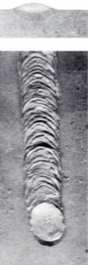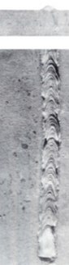w e l d i n g s p e e d , w h i c h a f f e c t s b o t h p e n e t r a t i o n d e p t h a n d w e l d s h a p e .
.
Figure 1.10: Weld Bead Appearance at Different Speeds
a) Normal speed b) Higher than normal speed
a
b )
9

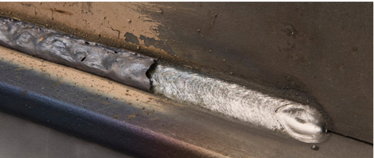

Figure 1.11: Protective Coating of the Weld

t I n s t a n t a n e o u s s o l i d i f i c a t i o n o f t h e w e l d p o o l i s u n d e s i r a b l e . T h e
m o s t c r u c i a l f a c t o r i n p r e v e n t i n g r a p i d s o l i d i f i c a t i o n i s t h e e l e c t r o d e c o a t i n g m a t e r i a l . A d d i t i o n a l l y , f o r t h e c o a t i n g m a t e r i a l t o p r o t e c t
t h e w e l d b e a d f r o m a d v e r s e a t m o s p h e r i c e f f e c t s a n d f u l f i l l i t s o t h e r f u n c t i o n s , i t m u s t c o n t i n u o u s l y a n d u n i f o r m l y c o v e r t h e w e l d m e t a l .
T h e w e l d e r m u s t a s s i s t t h e c o a t i n g m a t e r i a l i n c o v e r i n g t h e w e l d
m e t a l ’ s s u r f a c e b y h o l d i n g t h e e l e c t r o d e a t a n a n g l e . A t t h e s t a r t o f w e l d i n g , t h e e l e c t r o d e i s h e l d p e r p e n d i c u l a r t o t h e w o r k p i e c e .
A s w e l d i n g p r o g r e s s e s , t h e e l e c t r o d e i s g r a d u a l l y t i l t e d a t
p r e d e t e r m i n e d a n g l e s t o w a r d t h e w e l d i n g d i r e c t i o n , f o r m i n g a n
a n g l e w i t h t h e s u r f a c e o f t h e w o r k p i e c e . T h i s a n g l e i s c a l l e d t h e e l e c t r o d e m o v e m e n t a n g l e .
I f t h e e l e c t r o d e t i p i s d i r e c t e d t o w a r d t h e w e l d i n g d i r e c t i o n , t h e a n g l e i s r e f e r r e d t o a s n e g a t i v e , w h e r e a s i f i t i s d i r e c t e d i n t h e o p p o s i t e d i r e c t i o n , i t i s t e r m e d p o s i t i v e . A d d i t i o n a l l y , t h e r e i s
a n o t h e r a n g l e k n o w n a s t h e w o r k i n g a n g l e , w h i c h r e f e r s t o t h e a n g l e o f t h e e l e c t r o d e r e l a t i v e t o t h e w e l d b e a d e d g e s . T h e s e a n g l e s v a r y d e p e n d i n g o n t h e p o s i t i o n o f t h e w o r k p i e c e .
A s t h e w e l d i n g p r o c e s s c o n t i n u e s , t h e s e s t e p s a r e r e p e a t e d ,
l e a d i n g t o t h e a c c u m u l a t i o n o f w e l d m e t a l o n t h e w o r k p i e c e . T h e s t r u c t u r e d a c c u m u l a t i o n o f w e l d m e t a l i s c a l l e d a w e l d b e a d .

1 . 2 . 5 . S t e p s f o r P e r f o r m i n g V - G r o o v e W e l d i n g
A f t e r t h e w o r k p i e c e s t o b e w e l d e d a r e t a c k - w e l d e d , t h e s l a g f r o m t h e t a c k w e l d s i s c l e a n e d .
T h e r o o t p a s s i s u s u a l l y p e r f o r m e d u s i n g a Ø 2 . 5 m m e l e c t r o d e , a n d t h e r o o t p a s s i s t h e n c l e a n e d .
D u e t o t h e n a r r o w w o r k s p a c e o f t h e r o o t p a s s a n d t o m i n i m i z e d e f e c t s , a Ø 2 . 5 m m e l e c t r o d e s h o u l d b e u s e d .

T h e s e c o n d a n d s u b s e q u e n t p a s s e s a r e w e l d e d u s i n g t h i c k e r
. e l e c t r o d e s .
U s i n g a t h i c k e r e l e c t r o d e h e l p s d e p o s i t m o r e w e l d m e t a l , s a v i n g t i m e a n d l a b o r .
P r o p e r c l e a n i n g m u s t b e p e r f o r m e d a f t e r e a c h w e l d p a s s .

I f t h o r o u g h c l e a n i n g i s n o t d o n e a f t e r e a c h p a s s , s l a g i n c l u s i o n s m a y o c c u r .
T h e r o o t p a s s a n d s e c o n d p a s s a r e a p p l i e d t o t h e w o r k p i e c e .
I f t h e g r o o v e c a n n o t b e f u l l y f i l l e d w i t h t w o p a s s e s , w e l d i n g c o n t i n u e s u n t i l t h e g r o o v e i s c o m p l e t e l y f i l l e d .
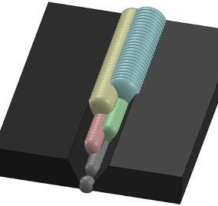

Figure 1.12: Weld Passes in V Groove Welding

1 . 2 . 6 . W e l d S e a m C l e a n i n g
A f t e r t h e r o o t p a s s i s c o m p l e t e d , s l a g s h o u l d b e r e m o v e d u s i n g a c h i p p i n g h a m m e r . S i n c e t h e r o o t p a s s i s p e r f o r m e d i n a n a r r o w
a r e a , c l e a n i n g t h e s l a g c a n b e c h a l l e n g i n g . I n c a s e s w h e r e t h e w e l d w a s m a d e t o o q u i c k l y , t h e s l a g m a y b e t h i n a n d f i r m l y a t t a c h e d t o
t h e g r o o v e , m a k i n g i t d i f f i c u l t t o r e m o v e .
I f t h e s l a g c a n n o t b e r e m o v e d w i t h a c h i p p i n g h a m m e r , i t s h o u l d b e c l e a n e d u s i n g c h i s e l s t h a t c a n r e a c h t h e s u r f a c e o f t h e r o o t p a s s .
F o l l o w i n g t h i s , a w i r e b r u s h s h o u l d b e u s e d t o e n s u r e a c l e a n w e l d s e a m . I f c h i s e l s a n d w i r e b r u s h i n g a r e i n s u f f i c i e n t t o r e m o v e s l a g d e p o s i t s , t h e a r e a s h o u l d b e t h o r o u g h l y g r o u n d w i t h a g r i n d e r .
O t h e r w i s e , r e s i d u a l s l a g m a y b e c o m e t r a p p e d u n d e r s u b s e q u e n t w e l d p a s s e s , l e a d i n g t o d e f e c t s .

1 . 3 . K W E L D I N G I N H O R I Z O N T A L P O S I T I O N
K - g r o o v e w e l d i n g i s a p r o c e s s i n w h i c h a d o u b l e V - g r o o v e i s m a d e
o n t h e e d g e s o f o n e o f t h e w o r k p i e c e s , w h i l e t h e o t h e r i s p o s i t i o n e d a t a 9 0 - d e g r e e a n g l e f o r t h e w e l d e d j o i n t .
1 . 3 . 1 . S t a n d a r d D i m e n s i o n s a n d A n g l e s o f K - G r o o v e W e l d i n g
K - g r o o v e w e l d i n g c a n b e a p p l i e d t o p a r t s w i t h t h i c k n e s s e s r a n g i n g f r o m 1 5 t o 4 0 m m , a n d t h e g r o o v e a n g l e c a n v a r y b e t w e e n 4 5 a n d 6 0 d e g r e e s .
T h e t e r m s a n d t h e i r m e a n i n g s i n K - g r o o v e w e l d i n g a r e a s f o l l o w s : β : T h i s a n g l e d e p e n d s o n t h e w e l d i n g m e t h o d , w e l d i n g p o s i t i o n , a n d w h e t h e r b a c k w e l d i n g i s p o s s i b l e .
s : I n d i c a t e s t h e t h i c k n e s s o f t h e w o r k p i e c e .
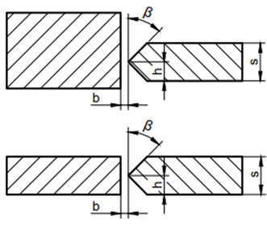
h : R e p r e s e n t s t h e d i s t a n c e o f t h e g r o o v e o p e n i n g f r o m t h e e d g e . b : R o o t g a p , w h i c h d e p e n d s o n t h e α a n g l e , w e l d i n g m e t h o d , a n d p o s i t i o n .

.

Figure 1.13: K-Groove Weld Cross-Section

1 . 3 . 2 . S t e p s f o r P e r f o r m i n g K W e l d i n g
T a c k w e l d i n g i s p e r f o r m e d a c c o r d i n g t o t h e w e l d i n g m e t h o d .
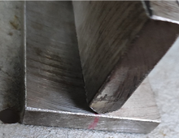
Figure 1.14: Tack Welding in K-Groove Welding
W h e n p e r f o r m i n g w i d e w e l d p a s s e s , a p p r o p r i a t e e l e c t r o d e m o v e m e n t s h o u l d b e a p p l i e d .

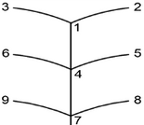
Figure 1.15: Electrode Movement for Root Pass in K-Groove Welding

T h e e l e c t r o d e s h o u l d p a u s e s l i g h t l y a t e a c h f a c e o f t h e g r o o v e t o e n s u r e p r o p e r f u s i o n .
I n o r d e r t o f u l l y f u s e t h e t o p e d g e o f t h e g r o o v e , t h e f i n a l p a s s e s m a y b e s l i g h t l y o s c i l l a t e d .
T h i s i s t h e m o s t c o m m o n l y u s e d t e c h n i q u e , b u t i n s o m e c a s e s ,
l i m i t e d o s c i l l a t i o n a n d n a r r o w p a s s e s m a y b e n e c e s s a r y t o c o n t r o l h e a t i n p u t .
T h e w e l d b e a d w i d t h s h o u l d b e t h r e e t o f o u r t i m e s t h e c o r e d i a m e t e r o f t h e e l e c t r o d e .
W e l d b e a d s s h o u l d v a r y i n l e n g t h b e t w e e n o n e - t h i r d t o h a l f o f a n e l e c t r o d e ’ s f u l l l e n g t h .
T h e e l e c t r o d e m o v e m e n t s h o u l d p u s h s l a g a w a y b y s l i g h t l y b e n d i n g b a c k w a r d .
D u e t o t h e t h i c k n e s s o f t h e e l e c t r o d e c o v e r i n g , s l a g a c c u m u l a t i o n i n c r e a s e s , m a k i n g i t h a r d e r t o c l e a n . T h e r e f o r e , t h e b a c k w a r d
m o v e m e n t s h o u l d b e s l i g h t l y e m p h a s i z e d .
A t t h e s a m e c u r r e n t i n t e n s i t y , a w i d e w e l d b e a d g e n e r a t e s m o r e h e a t t h a n a n a r r o w o n e , r e s u l t i n g i n d e e p e r p e n e t r a t i o n .
S l a g s h o u l d b e c a r e f u l l y c l e a n e d w i t h a p o i n t e d c h i p p i n g h a m m e r o r a b r u s h . I f t h e s e a r e i n s u f f i c i e n t , a c h i s e l a n d h a m m e r s h o u l d b e u s e d w i t h c a r e .
O n e o f t h e m a i n p u r p o s e s o f s l a g i s t o s l o w d o w n t h e c o o l i n g o f t h e w e l d b e a d , p r e v e n t i n g s u d d e n c o o l i n g . F o r t h i s r e a s o n ,
c l e a n i n g s h o u l d n o t b e g i n t o o e a r l y .

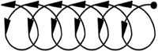
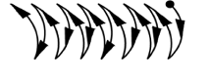
Figure 1.16: Recommended Electrode Movements for Fill Passes

P R E P A R E D B Y
I n n o w e l d

FILLER WELDING

LEARNING UNIT

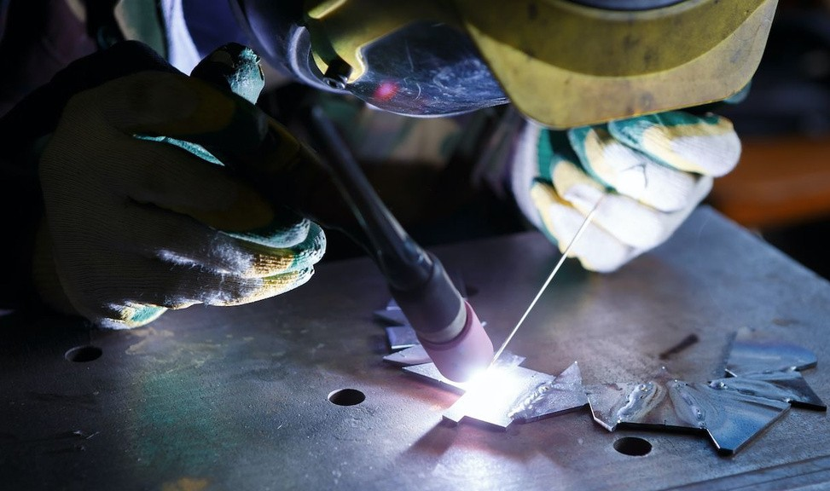

TYPES OF BUILD-UP WELDING

SURFACE BUILD-UP WELDING

SHAFT BUILD-UP WELDING

14

2 . 1 . T Y P E S O F B U I L D - U P W E L D I N G
M a c h i n e c o m p o n e n t s s u c h a s s h a f t s , g e a r s , t h e s o i l - c o n t a c t i n g s u r f a c e s o f a g r i c u l t u r a l t o o l s , t h e e d g e s o f e a r t h m o v i n g
m a c h i n e r y , s h e a r b l a d e s , m i l l c r u s h e r s , f r i c t i o n - o p e r a t e d d i s c s , a n d h a r d e n e d s u r f a c e s a r e s u b j e c t t o w e a r o v e r t i m e d u e t o
f r i c t i o n .
R e p a i r i n g o r r e p l a c i n g w o r n , b r o k e n , o r c r a c k e d c o m p o n e n t s i s s o m e t i m e s n o t f e a s i b l e o r e c o n o m i c a l . T h e r e f o r e , b u i l d - u p
w e l d i n g i s u s e d t o r e s t o r e t h e m .
B u i l d - u p w e l d i n g r e f e r s t o t h e p r o c e s s o f d e p o s i t i n g w e l d b e a d s e i t h e r i n a s i n g l e p a s s o r b y o v e r l a p p i n g l a y e r s t o r e s t o r e w o r n m a c h i n e p a r t s t o t h e i r o r i g i n a l d i m e n s i o n s b e f o r e w e a r .
E l e c t r o d e s U s e d i n H a r d S u r f a c e B u i l d - U p W e l d i n g
I n h a r d s u r f a c e b u i l d - u p w e l d i n g , p r i m a r i l y b a s i c - c o a t e d
e l e c t r o d e s a n d , o c c a s i o n a l l y , r u t i l e - c o a t e d e l e c t r o d e s a r e u s e d . T h e s e e l e c t r o d e s c a n b e c a t e g o r i z e d a s f o l l o w s :
B a s i c - c o a t e d e l e c t r o d e s u s e d i n b u i l d - u p w e l d i n g y i e l d b e t t e r r e s u l t s i f d r i e d a t 2 5 0 - 3 0 0 ° C f o r t w o h o u r s b e f o r e u s e .

V e r y H a r d S u r f a c e E l e c t r o d e s : T h e s e e l e c t r o d e s a r e m a d e o f
t u n g s t e n c a r b i d e . D u e t o t h e i r e x t r e m e l y h a r d c o m p o s i t i o n , t h e w e l d b e a d d e p o s i t e d w i t h t h e s e e l e c t r o d e s h a r d e n s t h e w o r k p i e c e t o t h e s a m e e x t e n t . T h e y a r e c o m m o n l y u s e d i n t h e b u i l d - u p w e l d i n g o f
s h e a r b l a d e s , d i s c s , a n d k n i v e s .
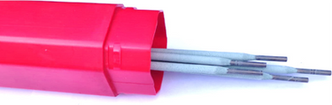
Figure 2.1: Hard Surface Electrodes
N o r m a l W e a r a n d I m p a c t E l e c t r o d e s : T h e s e e l e c t r o d e s h a v e h i g h c a r b o n c o n t e n t a n d p r o d u c e a h a r d a n d d e n s e w e l d b e a d . T h e y a r e s u i t a b l e f o r s u r f a c e b u i l d - u p w e l d i n g .
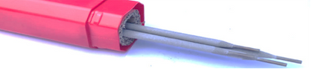

Figure 2.2 : Normal Wear and Impact Electrodes:

M o d e r a t e l y H a r d a n d I m p a c t - R e s i s t a n t E l e c t r o d e s : U s e d i n
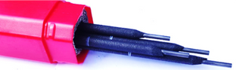
a p p l i c a t i o n s s u c h a s c h a i n c o n v e y o r s , p i n s , b e a r i n g s , a n d s t o n e c r u s h e r s .

Figure 2.3 : Moderately Hard and Impact-Resistant Electrodes

C h r o m i u m - N i c k e l E l e c t r o d e s : P r i m a r i l y u s e d f o r t h e b u i l d - u p w e l d i n g o f s t a i n l e s s s t e e l e q u i p m e n t i n t h e f o o d i n d u s t r y .
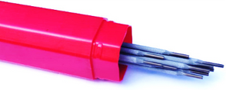
Figure 2.4 : Chromium-Nickel Electrodess
M a n g a n e s e E l e c t r o d e s : U s e d f o r t h e b u i l d - u p w e l d i n g o f e x c a v a t o r
t e e t h i n e a r t h m o v i n g m a c h i n e r y , d r i l l b i t s , s c r a p e r s a n d r i p p e r s , a n d r o l l i n g m i l l r o l l e r s .
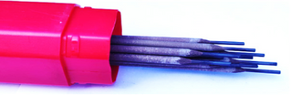
Figure 2.5 :Manganese Electrodes
W o r k - H a r d e n i n g E l e c t r o d e s : T h e s e e l e c t r o d e s a r e m a c h i n a b l e a f t e r w e l d i n g b u t h a r d e n d u r i n g o p e r a t i o n .

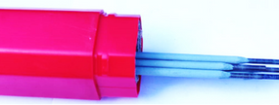
Figure 2.6 :Work-Hardening Electrodes
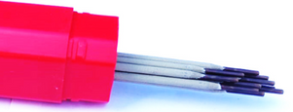
H e a t - T r e a t a b l e H a r d e n i n g E l e c t r o d e s : T h e s e e l e c t r o d e s c a n b e h a r d e n e d t h r o u g h h e a t t r e a t m e n t a f t e r t h e b u i l d - u p w e l d i n g
p r o c e s s .

Figure 2.7 :Heat-Treatable Hardening Electrodes

M a c h i n a b l e B u i l d - U p E l e c t r o d e s : T h e s e a r e t h i c k - c o a t e d m a n g a n e s e b u i l d - u p e l e c t r o d e s w i t h h i g h i m p a c t a b s o r p t i o n
c a p a c i t y . T h e i r s l a g i s e a s i l y r e m o v a b l e , a n d t h e y c a n b e m a c h i n e d b y c h i p r e m o v a l .
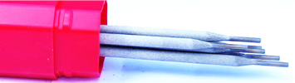
Figure 2.8 : Machinable Build-Up Electrodeses

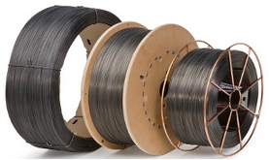
H a r d - C o r e W i r e E l e c t r o d e s : T h e s e e l e c t r o d e s a r e p r i m a r i l y u s e d a s f i l l e r w i r e s i n M I G - M A G a n d T I G - W I G w e l d i n g p r o c e s s e s . T h e y c a n b e m a d e o f s t e e l , c o p p e r , a l u m i n u m , o r b r a s s .
Figure 2.9 :Hard-Core Wire Electrodes

2 . 2 . S U R F A C E B U I L D - U P W E L D I N G
T h e t y p e s o f s u r f a c e b u i l d - u p w e l d i n g a r e a s f o l l o w s : S i n g l e - p a s s s u r f a c e b u i l d - u p w e l d i n g
O v e r l a y ( m u l t i - l a y e r ) b u i l d - u p w e l d i n g
T h e g e n e r a l p u r p o s e s o f s u r f a c e b u i l d - u p w e l d i n g c a n b e l i s t e d a s : R e s t o r i n g w o r n s u r f a c e s t o t h e i r o r i g i n a l d i m e n s i o n s b e f o r e w e a r R e j o i n i n g b r o k e n p a r t s t o m a k e t h e m f u n c t i o n a l a g a i n
R e p a i r i n g d e f o r m e d s u r f a c e s t o t h e i r o r i g i n a l s h a p e b e f o r e d a m a g e

2 . 2 . 1 . S i n g l e - P a s s S u r f a c e B u i l d - U p W e l d i n g
S i n g l e - p a s s s u r f a c e b u i l d - u p w e l d i n g i s t y p i c a l l y a p p l i e d t o m a c h i n e c o m p o n e n t s t h a t h a v e n o t u n d e r g o n e e x c e s s i v e w e a r .
I f t h e w e l d e d s u r f a c e s r e q u i r e h i g h p r e c i s i o n , t h e y a r e p r o c e s s e d u s i n g m a c h i n i n g t e c h n i q u e s s u c h a s t u r n i n g , m i l l i n g , s h a p i n g , o r h o n i n g b e f o r e b e i n g p u t i n t o s e r v i c e .
H o w e v e r , i f t h e a p p l i c a t i o n d o e s n o t r e q u i r e f i n e w o r k m a n s h i p ( e . g . , a g r i c u l t u r a l t o o l s , b u c k e t j a w s ) , t h e w e l d e d s u r f a c e c a n b e u s e d
w i t h o u t a d d i t i o n a l m a c h i n i n g .

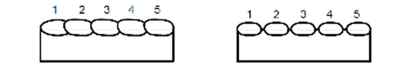

a)False b)True
Figure 2.10 : Single-Pass Surface Build-Up Welding

2 . 2 . 2 . O v e r l a y ( M u l t i - L a y e r ) B u i l d - U p W e l d i n g
M u l t i - l a y e r b u i l d - u p w e l d i n g i s a p p l i e d t o e x c e s s i v e l y w o r n o r
d a m a g e d k e y w a y s , b r o k e n o r c r a c k e d m a c h i n e c o m p o n e n t s , a n d t h e
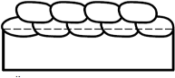
e d g e s o f e l e m e n t s r e q u i r i n g h i g h s t r e n g t h .

Figure 2.11 :Overlay (Multi-Layer) Build-Up Welding

2 . 3 . S H A F T B U I L D - U P W E L D I N G
S h a f t b u i l d - u p w e l d i n g r e f e r s t o t h e p r o c e s s o f f i l l i n g o n l y t h e w o r n s e c t i o n s o f s h a f t s u s i n g w e l d i n g m e t h o d s .

2 . 3 . 1 . A p p l i c a t i o n s o f S h a f t s a n d J o u r n a l s
U s e d i n m a c h i n e s t o t r a n s m i t p o w e r a n d m o t i o n w h i l e r o t a t i n g , c a r r y i n g c o m p o n e n t s s u c h a s g e a r s , c l u t c h e s , p u l l e y s , a n d
f l y w h e e l s .
F o u n d i n c y l i n d r i c a l m a c h i n e p a r t s t h a t a r e s u b j e c t e d t o w e a r , d e f o r m a t i o n , a n d b e n d i n g u n d e r l o a d .
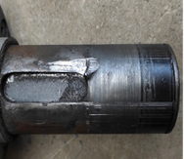
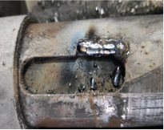
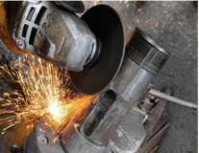
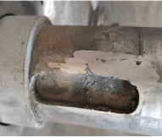
a ) b ) c ) d )
Figure 2.12: Steps for Repairing a Deformed Surface

- D e f o r m e d s h a f t
- A p p l i c a t i o n o f b u i l d - u p w e l d i n g
- M a c h i n i n g p r o c e s s
- R e s t o r i n g t o i t s o r i g i n a l c o n d i t i o n

. 3 . 2 . P u r p o s e o f S h a f t B u i l d - U p W e l d i n g
S i n c e s h a f t s a r e r o t a t i n g m a c h i n e c o m p o n e n t s , t h e y a r e p r o n e t o w e a r d u e t o :
H i g h - s p e e d o p e r a t i o n
O s c i l l a t i o n s c a u s e d b y t h e r o t a t i o n o f a t t a c h e d c o m p o n e n t s I r r e g u l a r l u b r i c a t i o n
O v e r h e a t i n g
W o r n s h a f t s c a n n o t m a i n t a i n s m o o t h a n d b a l a n c e d r o t a t i o n , l e a d i n g t o n o i s y o p e r a t i o n a n d p o t e n t i a l d a m a g e t o t h e c o n n e c t e d m a c h i n e . T h i s c a n u l t i m a t e l y r e s u l t i n i r r e p a r a b l e f a i l u r e s .
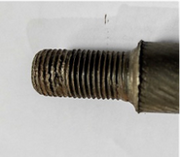
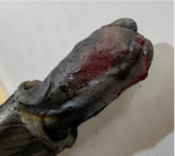
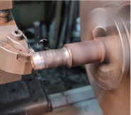
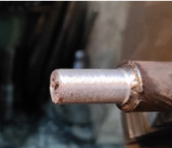
  - b ) c ) d )

Figure 2.13: Steps for Repairing Threaded Sections on a Shaft

- W o r n a n d d a m a g e d t h r e a d s
- A p p l i c a t i o n o f b u i l d - u p w e l d i n g
- M a c h i n i n g p r o c e s s
- R e s t o r i n g t o i t s o r i g i n a l c o n d i t i o n
I n s o m e c a s e s , r e p l a c i n g w o r n s h a f t s m a y n o t b e f e a s i b l e .
R e c r e a t i n g t h e m m a n u a l l y o n a l a t h e r e q u i r e s s i g n i f i c a n t l a b o r ,
l e a d i n g t o t i m e l o s s a n d i n c r e a s e d c o s t s . I n s t e a d , o n l y t h e w o r n
s e c t i o n s o f t h e s h a f t c a n b e f i l l e d w i t h w e l d m e t a l , m a c h i n e d , a n d r e u s e d e f f i c i e n t l y .

P R E P A R E D B Y
I n n o w e l d

VERTICAL WELDING

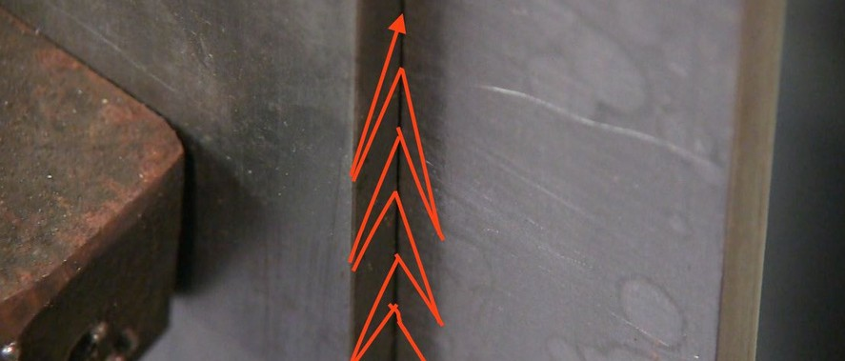

LEARNING UNIT

3 . 1 . V e r t i c a l W e l d i n g P o s i t i o n s

3 . 2 . T o p - t o - B o t t o m B u t t J o i n t W e l d i n g 3 . 3 . B o t t o m - t o - T o p B u t t J o i n t W e l d i n g 3 . 4 . B o t t o m - t o - T o p V - G r o o v e W e l d i n g 3 . 5 . B o t t o m - t o - T o p F i l l e t W e l d i n g
3 . 6 . T o p - t o - B o t t o m F i l l e t W e l d i n g

20
3 . 7 . T o p - t o - B o t t o m O u t s i d e C o r n e r W e l d i n g

. 1 . V E R T I C A L W E L D I N G P O S I T I O N S
T h e h o r i z o n t a l p o s i t i o n i s t h e m o s t c o m f o r t a b l e a n d c o n t r o l l e d
p o s i t i o n f o r s h a p i n g w e l d b e a d s i n p o s i t i o n a l w e l d i n g . S i n c e t h e w o r k p i e c e i s p a r a l l e l t o t h e g r o u n d , t h i s t y p e o f w e l d i n g i s c a l l e d h o r i z o n t a l w e l d i n g .
H o w e v e r , f o r a t r a i n e d w e l d e r , b e i n g a b l e t o w e l d i n t h e h o r i z o n t a l p o s i t i o n i s n o t a l w a y s s u f f i c i e n t , a s w o r k p i e c e s e n c o u n t e r e d i n
p r o d u c t i o n a r e n o t a l w a y s p o s i t i o n e d t h i s w a y . T h e r e f o r e , a w e l d e r m u s t b e c a p a b l e o f p e r f o r m i n g w e l d s i n v a r i o u s p o s i t i o n s a n d
u n d e r s t a n d t h e t e c h n i q u e s r e q u i r e d f o r e a c h .
I n g e n e r a l , w e l d i n g p o s i t i o n s a r e c l a s s i f i e d a s f o l l o w s a n d a r e
d e n o t e d b y l e t t e r s a c c o r d i n g t o t h e T u r k i s h S t a n d a r d s I n s t i t u t i o n ( T S E ) :
H o r i z o n t a l ( F l a t )
V e r t i c a l ( T o p - t o - b o t t o m , B o t t o m - t o - t o p ) S i d e ( W a l l p o s i t i o n )
O v e r h e a d ( C e i l i n g p o s i t i o n )
I n s i d e a n d o u t s i d e c o r n e r i n t h e o v e r h e a d p o s i t i o n
T h e a r c c r e a t e d b y t h e w e l d i n g c u r r e n t c a u s e s t h e h e a t - a f f e c t e d
z o n e o f t h e w o r k p i e c e s u r f a c e t o m e l t . A s t h e e l e c t r o d e m e l t s , t h e c o r e m e t a l o f t h e e l e c t r o d e c o m b i n e s w i t h t h e m o l t e n m a s s i n t h e h e a t - a f f e c t e d z o n e o f t h e w o r k p i e c e .
T h e c o r e m e t a l o f t h e e l e c t r o d e p l a y s a c r u c i a l r o l e i n t h i s f u s i o n ,
f o r m i n g t h e w e l d m e t a l . T h e m a j o r i t y o f t h e w e l d m e t a l i s c o m p o s e d o f t h e e l e c t r o d e ’ s c o r e m e t a l .
T h u s :
T h i n e l e c t r o d e s a r e u s e d f o r j o i n i n g t h i n m a t e r i a l s .
T h i c k e r e l e c t r o d e s w i t h a l a r g e r c o r e m e t a l d i a m e t e r a r e u s e d f o r j o i n i n g t h i c k e r m a t e r i a l s .
T h i s e n s u r e s t h a t t h e n e c e s s a r y w e l d m e t a l i s p r o v i d e d t o f i l l t h e g a p b e t w e e n t h e p a r t s .
I n t o p - t o - b o t t o m a n d b o t t o m - t o - t o p w e l d i n g , m e t a l f l o w o c c u r s d u e
t o t h e w e i g h t o f t h e m o l t e n w e l d m e t a l . T h e a m o u n t a n d b e h a v i o r o f m e t a l f l o w v a r y d e p e n d i n g o n t h e w e l d i n g m e t h o d , e l e c t r o d e
m o v e m e n t , a n d w e l d i n g a n g l e s .

3 . 2 . T O P - T O - B O T T O M B U T T J O I N T W E L D I N G
T h e t o p - t o - b o t t o m b u t t j o i n t w e l d i n g m e t h o d i s m o s t c o m m o n l y p r e f e r r e d f o r s h e e t m e t a l w e l d i n g a p p l i c a t i o n s .
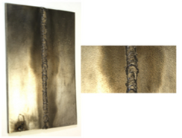
Figure 3.1: Sheet Metal Piece Welded from Top to Bottom

3 . 2 . 1 . P e r f o r m i n g T o p - t o - B o t t o m V e r t i c a l B u t t J o i n t W e l d i n g
I n v e r t i c a l w e l d i n g , a l s o k n o w n a s d o w n w a r d b u t t j o i n t w e l d i n g , t h e w o r k p i e c e i s p o s i t i o n e d a t a 9 0 - d e g r e e a n g l e t o t h e h o r i z o n t a l
p l a n e .
T h e m o s t s i g n i f i c a n t d i f f e r e n c e b e t w e e n h o r i z o n t a l w e l d i n g a n d o t h e r w e l d i n g p o s i t i o n s i s t h e t y p e o f e l e c t r o d e s u s e d .
I n h o r i z o n t a l w e l d i n g , a n y t y p e o f e l e c t r o d e c a n b e u s e d .
I n v e r t i c a l w e l d i n g a n d o t h e r p o s i t i o n a l w e l d s , t h e s u i t a b i l i t y o f t h e e l e c t r o d e m u s t b e c h e c k e d b e f o r e h a n d .
T h e e l e c t r o d e c o a t i n g m a t e r i a l s h o u l d h a v e l o w f l u i d i t y a n d s o l i d i f y q u i c k l y .
I f t h e c o a t i n g m a t e r i a l d o e s n o t h a v e t h e s e p r o p e r t i e s , i t w i l l f l o w a w a y d u r i n g w e l d i n g a n d f a i l t o p r o v i d e p r o p e r s h i e l d i n g .
T o p r e v e n t e x c e s s i v e f l u i d i t y o f t h e w e l d m e t a l , h i g h t e m p e r a t u r e s m u s t b e a v o i d e d .
T h e r e f o r e , t h e w e l d i n g c u r r e n t s h o u l d b e k e p t a s l o w a s p o s s i b l e .
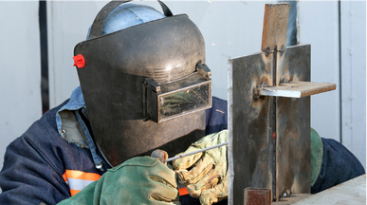
Figure 3.2: Vertical Welding with Electric Arc

3 . 2 . 2 . A p p l i c a t i o n A r e a s
T y p i c a l l y u s e d f o r w o r k p i e c e s t h a t a r e i n t e n d e d t o b e w e l d e d w i t h a s i n g l e p a s s .
S i n c e t h i s m e t h o d p r o d u c e s a w e a k e r w e l d b e a d , i t i s n o t
r e c o m m e n d e d f o r j o i n t s r e q u i r i n g h i g h s t r e n g t h a n d d u r a b i l i t y .

3 . 3 . B O T T O M - T O - T O P B U T T J O I N T W E L D I N G
3 . 3 . 1 . P e r f o r m i n g B o t t o m - t o - T o p V e r t i c a l B u t t J o i n t W e l d i n g I n t h i s w e l d i n g m e t h o d , t h e w o r k p i e c e s t o b e w e l d e d a r e j o i n e d e d g e t o e d g e .
W e l d i n g s t a r t s f r o m t h e b o t t o m a n d p r o g r e s s e s u p w a r d a s t h e e l e c t r o d e m o v e s i n a n u p w a r d d i r e c t i o n .
C o m p a r e d t o t o p - t o - b o t t o m w e l d i n g , t h i s p o s i t i o n p r o v i d e s g r e a t e r p e n e t r a t i o n a n d s t r e n g t h .
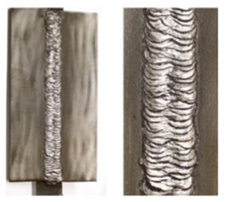
Figure 3.3: Bottom-to-Top Welding Application

3 . 3 . 2 . A p p l i c a t i o n A r e a s
B o t t o m - t o - t o p v e r t i c a l w e l d s g e n e r a l l y i n v o l v e h i g h h e a t i n p u t , l e a d i n g t o s i g n i f i c a n t l o c a l i z e d h e a t i n g .
F o r t h i s r e a s o n , e x c e p t f o r v e r y s h o r t w e l d s , t h i s m e t h o d i s n o t r e c o m m e n d e d f o r m a t e r i a l s t h i n n e r t h a n 4 m m .

3 . 4 . B O T T O M - T O - T O P V - G R O O V E W E L D I N G
I n b o t t o m - t o - t o p v e r t i c a l w e l d i n g , t h e w e l d i n g p r o c e s s b e g i n s a t t h e b o t t o m o f t h e j o i n t , a n d t h e a r c m o v e s u p w a r d .

3 . 4 . 1 . P e r f o r m i n g B o t t o m - t o - T o p V - G r o o v e W e l d i n g
T h i s m e t h o d i s g e n e r a l l y u s e d f o r t h i c k e r m a t e r i a l s , w h i c h r e q u i r e s g r o o v e p r e p a r a t i o n .
I f a V - g r o o v e i s c u t i n t o t h e w o r k p i e c e b e f o r e w e l d i n g , a n d t h e
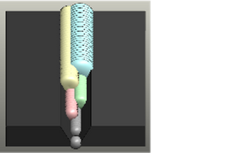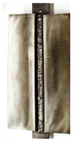w e l d p r o g r e s s e s f r o m b o t t o m t o t o p , i t i s c a l l e d b o t t o m - t o - t o p V - g r o o v e w e l d i n g .

Figure 3.3: Bottom-to-Top Welding Application

B o t t o m - t o - t o p w e l d s g e n e r a t e h i g h h e a t i n p u t , c a u s i n g
s i g n i f i c a n t l o c a l i z e d h e a t i n g . T h e r e f o r e , e x c e p t f o r v e r y s h o r t p a s s e s , t h i s m e t h o d i s n o t r e c o m m e n d e d f o r m a t e r i a l s t h i n n e r t h a n 4 m m .
B o t t o m - t o - t o p V - g r o o v e w e l d i n g i s s u i t a b l e f o r m a t e r i a l s w i t h a t h i c k n e s s b e t w e e n 1 0 m m a n d 2 0 m m .
F o r m a t e r i a l s t h i c k e r t h a n 2 0 m m , X - a n d K - g r o o v e p r e p a r a t i o n s a r e r e q u i r e d f o r d o u b l e - s i d e d w e l d i n g .

3 . 5 . B O T T O M - T O - T O P F I L L E T W E L D I N G
I n b o t t o m - t o - t o p w e l d i n g , t h e p r o c e s s b e g i n s a t t h e b o t t o m o f t h e j o i n t a n d p r o g r e s s e s u p w a r d .
T h i s t e c h n i q u e i s c o m m o n l y u s e d i n v e r t i c a l f i l l e t w e l d s , r e f e r r e d t o a s b o t t o m - t o - t o p v e r t i c a l f i l l e t w e l d i n g .

3 . 5 . 1 . P e r f o r m i n g B o t t o m - t o - T o p F i l l e t W e l d i n g
F i l l e t w e l d s a r e a m o n g t h e m o s t c o m m o n l y u s e d w e l d j o i n t t y p e s i n f a b r i c a t i o n a n d m a n u f a c t u r i n g .
B o t t o m - t o - t o p f i l l e t w e l d i n g c a n b e p e r f o r m e d o n o n e o r b o t h s i d e s , d e p e n d i n g o n t h e r e q u i r e d s t r e n g t h .
U n l i k e b u t t j o i n t s , f i l l e t w e l d s d o n o t r e q u i r e g r o o v e p r e p a r a t i o n , b u t e x t r a c a r e i s n e e d e d w h e n f o r m i n g t h e w e l d b e a d .
G r a v i t y c a u s e s t h e m o l t e n w e l d m e t a l t o s a g , s o p r o p e r h e a t c o n t r o l i s e s s e n t i a l t o e n s u r e a u n i f o r m a n d s t r o n g w e l d .

Figure 3.4: Completed Bottom-to-Top Fillet Weld
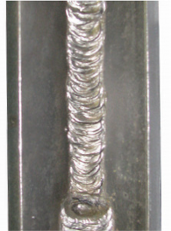
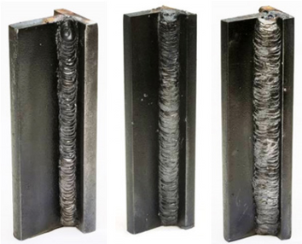
- First pass. b) Second pass c) Third pass
  - b) c)

B o t t o m - t o - t o p f i l l e t w e l d i n g i s m o s t l y a p p l i e d t o t h i c k e r
m a t e r i a l s . I t h a s a w i d e r a n g e o f a p p l i c a t i o n s i n c o n s t r u c t i o n i n d u s t r y p r o j e c t s .
W e l d e d m a n u f a c t u r i n g ( o r d e s i g n ) h o l d s a s i g n i f i c a n t p l a c e i n
t o d a y ' s p r o d u c t i o n m e t h o d s . I t i s n o t o n l y i m p o r t a n t t h a t w e l d i n g i s d o n e w e l l , b u t a l s o t h a t i t i s u s e d a p p r o p r i a t e l y a n d
c a l c u l a t e d , w i t h p a r t s s h a p e d a c c o r d i n g t o t h e r e q u i r e m e n t s o f t h e w e l d i n g p r o c e s s .
T h e s a f e s t w e l d c o n n e c t i o n , e s p e c i a l l y u n d e r d y n a m i c l o a d i n g
c o n d i t i o n s , i s t h e f i l l e t w e l d . T h e r e f o r e , e x c e s s i v e s a f e t y s h o u l d n o t b e e x p e c t e d i n f i l l e t w e l d s . P a r t i c u l a r l y i n t h i n s h e e t m e t a l
s t r u c t u r e s , c o n t i n u o u s f i l l e t w e l d s s h o u l d b e a v o i d e d a s m u c h a s p o s s i b l e .
T h e w e l d c r o s s - s e c t i o n a n d t h i c k n e s s s h o u l d n o t b e e x c e s s i v e . I n f i l l e t w e l d s , t h e p r o d u c t i o n c o s t s i n c r e a s e w i t h t h e t h i c k n e s s o f t h e w e l d .
I f t h e w e l d v o l u m e i s s m a l l , t h e e x i s t i n g s t r e s s e s , w a r p i n g , a n d t h e n e e d f o r l a t e r s t r a i g h t e n i n g a r e a l s o m i n i m i z e d .

3 . 6 . B O T T O M - T O - T O P F I L L E T W E L D I N G
I n b o t t o m - t o - t o p f i l l e t w e l d i n g , m u l t i p l e p a s s e s c a n b e m a d e o n t h e w e l d j o i n t .

3 . 6 . 1 . P e r f o r m i n g B o t t o m - t o - T o p F i l l e t W e l d i n g
I n t h i s w e l d i n g m e t h o d , t h e s e c o n d p a s s i s n o t m a d e i n o n e s t e p t o c o v e r t h e r o o t p a s s , a s i s d o n e i n b o t t o m - t o - t o p w e l d i n g . T h i s i s
b e c a u s e w i d e r b e a d s a r e n o t c r e a t e d i n t o p - d o w n w e l d i n g .

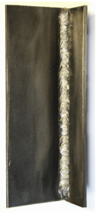
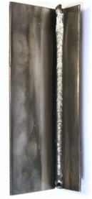
Figure 3.5 : Top-Down Fillet Welds

I t i s n o t r e c o m m e n d e d t o u s e i n w e l d s w h e r e s a f e t y i s a p r i o r i t y . I t i s r e c o m m e n d e d f o r w e l d s w h e r e a e s t h e t i c w e l d s a r e d e s i r e d a n d s t r e n g t h i s s e c o n d a r y .
I t i s p r i m a r i l y a p p l i e d t o p a r t s t h a t a r e 8 m m t h i c k o r t h i n n e r .
F o r p a r t s t h i c k e r t h a n 8 m m , b a s i c e l e c t r o d e s a r e r e c o m m e n d e d .

3 . 7 . T O P - D O W N O U T E R C O R N E R W E L D I N G

3 . 7 . 1 . P e r f o r m i n g T o p - D o w n O u t e r C o r n e r W e l d i n g
I n t h i s w e l d i n g m e t h o d , t h e p a r t s h a v e d i f f e r e n t o u t e r c o r n e r
p o s i t i o n s . T h e s e a r e c l a s s i f i e d i n t o t h r e e t y p e s : o p e n , s e m i - o p e n , a n d c l o s e d . T h e w e l d i n g s p e e d f o r c l o s e d o u t e r c o r n e r w e l d i n g i s h i g h e r c o m p a r e d t o t h e o t h e r t w o .

3 . 7 . 2 . A p p l i c a t i o n A r e a s
I t i s m a i n l y a p p l i e d t o p a r t s 8 m m t h i c k o r t h i n n e r .
F o r p a r t s t h i c k e r t h a n 8 m m , b a s i c e l e c t r o d e s a r e r e c o m m e n d e d .
I t i s u s e d i n t h e i n d u s t r y t o w e l d t h e o u t e r p a r t s o f a n g u l a r p i e c e s i n v e r t i c a l p o s i t i o n s .

P R E P A R E D B Y
I n n o w e l d

CORNICE AND
CEILING WELDS

LEARNING UNIT

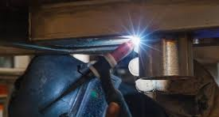

27
4 . 1 . | C o r n | i c e a n d C e i l i n g W e l d i n g P o s i t i o n s
4 . 2 . | S i d e | ( C o r n i c e / W a l l ) B u t t J o i n t W e l d i n g
4 . 3 . | S i d e | V - G r o o v e W e l d i n g
4 . 4 . | S i d e | F i l l e t W e l d i n g
4 . 5 . | O v e r | h e a d B u t t J o i n t W e l d i n g
4 . 6 . | O v e r | h e a d V - G r o o v e W e l d i n g

4 . 1 . C O R N I C E A N D C E I L I N G W E L D I N G P O S I T I O N S
D u r i n g w e l d i n g , t h e i d e a l p o s i t i o n o f t h e w o r k p i e c e s h o u l d p r e v e n t t h e m o l t e n w e l d p o o l f r o m f l o w i n g d u e t o g r a v i t y , e n s u r i n g i t
r e m a i n s s t a b l e i n p l a c e .
T h e h o r i z o n t a l w e l d i n g p o s i t i o n o f f e r s t h e b e s t c o n d i t i o n s f o r t h e w e l d e r , a s i t a l l o w s f o r b e t t e r c o n t r o l o v e r t h e w e l d p o o l .
I n t h i s p o s i t i o n , h i g h e r w e l d i n g c u r r e n t v a l u e s a r e u s e d , e n a b l i n g a f a s t e r w e l d i n g p r o c e s s .
T o p e r f o r m a l l w e l d s i n t h e h o r i z o n t a l p o s i t i o n , t h e w o r k p i e c e m u s t b e e a s i l y r o t a t a b l e o r m a n e u v e r a b l e .
H o w e v e r , i n m a n y m a n u f a c t u r i n g p r o c e s s e s , w o r k p i e c e s c a n n o t b e p o s i t i o n e d c o n v e n i e n t l y .
T h u s , m o s t i n d u s t r i a l w e l d i n g a p p l i c a t i o n s a r e c a r r i e d o u t i n t h r e e m a i n p o s i t i o n s :
- H o r i z o n t a l
- V e r t i c a l
- O v e r h e a d ( C e i l i n g p o s i t i o n )
I n m a s s - p r o d u c t i o n f a c t o r i e s , s k i l l e d w e l d e r s t r y t o p e r f o r m a s m a n y w e l d s a s p o s s i b l e i n t h e h o r i z o n t a l p o s i t i o n .
H o w e v e r , i n c o n s t r u c t i o n s i t e s , s u c h a s s t e e l s t r u c t u r e s , t a n k s , a n d p i p i n g s y s t e m s , t h i s i s i m p r a c t i c a l .
I n s u c h c a s e s :
S p e c i a l e l e c t r o d e s s u i t e d t o t h e w o r k i n g p o s i t i o n a r e u s e d .
W e l d i n g p a r a m e t e r s a n d w o r k i n g c o n d i t i o n s a r e c a r e f u l l y a d j u s t e d t o e n s u r e a p r o p e r w e l d b e a d .

2 . S I D E ( C O R N I C E / W A L L ) B U T T J O I N T W E L D I N G
T h i s w e l d i n g p o s i t i o n i s a l s o c a l l e d t h e s i d e , c o r n i c e , o r w a l l p o s i t i o n .
T h e w o r k p i e c e s a r e p o s i t i o n e d v e r t i c a l l y , b u t t h e w e l d b e a d i s l a i d p a r a l l e l t o t h e h o r i z o n t a l a x i s .
T h e w o r k p i e c e s a r e j o i n e d e d g e t o e d g e ( b u t t j o i n t ) .
T h e w e l d e r m o v e s f r o m l e f t t o r i g h t o r r i g h t t o l e f t w h i l e w e l d i n g .
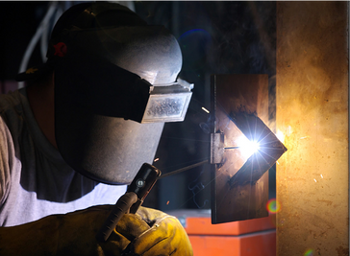
Figure 4.1: Side Butt Joint Welding

4 . 2 . 1 . P e r f o r m i n g S i d e B u t t J o i n t W e l d i n g
I n a l l w e l d i n g p o s i t i o n s e x c e p t t h e h o r i z o n t a l p o s i t i o n , t h e m o l t e n w e l d p o o l t e n d s t o f l o w o u t w a r d f r o m t h e j o i n t d u e t o g r a v i t y .
T h i s c h a l l e n g e i s o v e r c o m e b y u s i n g a p p r o p r i a t e w e l d i n g t e c h n i q u e s , s u c h a s :
C o n t r o l l i n g w e l d i n g s p e e d a n d e l e c t r o d e a n g l e .
U s i n g e l e c t r o d e s w i t h s u i t a b l e c o a t i n g s , w h i c h c o n t a i n a d d i t i v e s t h a t h e l p p r e v e n t t h e w e l d m e t a l f r o m f l o w i n g o u t o f t h e j o i n t .
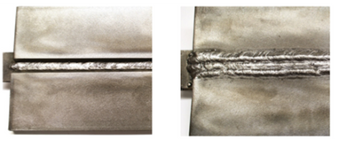
Figure 4.2: Side Butt Joint Welding Application
T h e w e l d e r s h o u l d a i m t o r e d u c e h e a t i n p u t d u r i n g w e l d i n g t o
d e c r e a s e f l u i d i t y a n d i m p r o v e c o n t r o l o v e r t h e m o l t e n w e l d p o o l .
T h e a n g l e b e t w e e n t h e e l e c t r o d e a x i s a n d t h e w e l d i n g s u r f a c e s h o u l d b e a d j u s t e d t o m a i n t a i n t h e o p t i m a l p o s i t i o n o f t h e w e l d p o o l .
W h i l e 3 5 0 - a m p c u r r e n t v a l u e s c a n b e u s e d e a s i l y i n h o r i z o n t a l w e l d i n g , i n o t h e r p o s i t i o n s , t h e w e l d i n g c u r r e n t m u s t b e k e p t
l o w e r t o p r e v e n t e x c e s s i v e m e t a l f l o w a n d e n s u r e b e t t e r w e l d q u a l i t y .
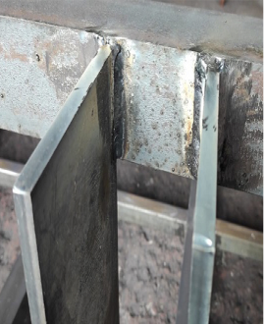
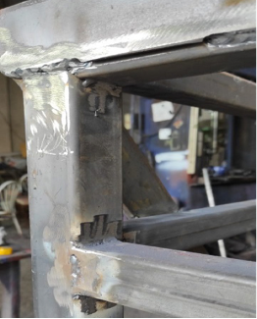
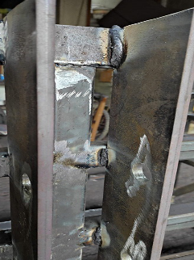
Figure 4.3: Welded Joints in Different Positions

K e y C o n s i d e r a t i o n s f o r S i d e B u t t J o i n t W e l d i n g
E x c e p t f o r t h e s t a r t i n g p o i n t a n d w e l d i n g d i r e c t i o n , t h e p r o c e s s f o l l o w s t h e s t a n d a r d r i g h t - t o - l e f t w e l d i n g c h a r a c t e r i s t i c s .
W h e n h a r d - t o - r e a c h a r e a s a r e e n c o u n t e r e d , o n e o f t h e t w o
w e l d i n g d i r e c t i o n s ( l e f t - t o - r i g h t o r r i g h t - t o - l e f t ) i s s e l e c t e d b a s e d o n f e a s i b i l i t y .

4 . 3 . S I D E V - G R O O V E W E L D I N G
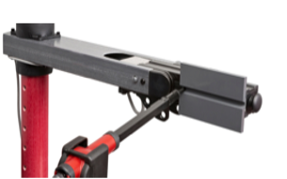
S i d e V - g r o o v e w e l d i n g i s a w e l d i n g m e t h o d p e r f o r m e d i n t h e s i d e ( w a l l ) p o s i t i o n a f t e r V - g r o o v e p r e p a r a t i o n h a s b e e n a p p l i e d t o t h e w o r k p i e c e s .
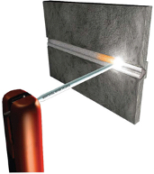
Figure 4.5: Side V-Groove Welding

4 . 3 . 1 . P e r f o r m i n g S i d e V - G r o o v e W e l d i n g
I n c o r n i c e ( w a l l ) w e l d i n g , m a t e r i a l s t h i c k e r t h a n 1 0 m m r e q u i r e g r o o v e p r e p a r a t i o n b e f o r e w e l d i n g .
F o r m a t e r i a l s b e t w e e n 1 0 - 2 0 m m t h i c k , a s i n g l e - s i d e d V - g r o o v e i s a p p l i e d .
F o r m a t e r i a l s o v e r 2 0 m m t h i c k , a d o u b l e - s i d e d X - o r K - g r o o v e i s u s e d .
T h e g r o o v e a n g l e s s h o u l d b e : 5 0 ° f o r t h e u p p e r p i e c e
2 0 ° f o r t h e l o w e r p i e c e
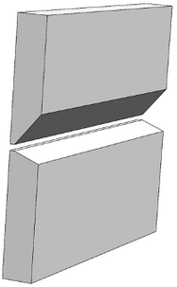
S i n g l e - s i d e d V - g r o o v e w e l d s a r e a l s o c a l l e d h a l f - V w e l d s .
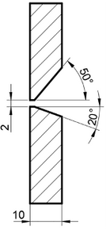
Figure 4.5: Side Butt Joint V-Groove Angles

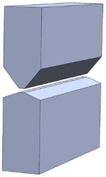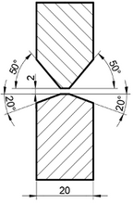
Figure 4.5: Side Butt Joint X-Groove Angles
I n t h e c o r n i c e ( w a l l ) p o s i t i o n , t h e e f f e c t o f g r a v i t y c a u s e s t h e w e l d p o o l t o f l o w o u t w a r d , h i g h l i g h t i n g t h e i m p o r t a n c e o f t h e w e l d
g r o o v e . T h e h a l f - V w e l d g r o o v e i s t h e m o s t c o m m o n l y u s e d g r o o v e i n s i d e w e l d i n g .
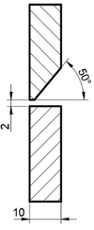
FFigure 4.6: Single-Sided Lateral Butt Joint V Weld Groove (Half-V) Angles

T o m i n i m i z e t h e f l o w c a u s e d b y g r a v i t y i n t h e c o r n i c e p o s i t i o n , t h e u s e o f a b a c k i n g i s p r e f e r r e d .

4 . 3 . 2 . A p p l i c a t i o n s o f L a t e r a l V W e l d i n g
G e n e r a l l y u s e d f o r p a r t s t h i c k e r t h a n 1 0 m m S t e e l b o i l e r m a n u f a c t u r i n g
S t e e l r o o f a s s e m b l y S h i p b u i l d i n g i n d u s t r y P i p e l i n e i n s t a l l a t i o n
S t e e l c o n s t r u c t i o n j o i n t s

4 . 4 . L A T E R A L F I L L E T W E L D I N G
T h i s i s t h e f i l l e t w e l d i n g m e t h o d a p p l i e d t o p a r t s i n a l a t e r a l p o s i t i o n .
4 . 4 . 1 . E x e c u t i o n o f L a t e r a l F i l l e t W e l d i n g
I n t h i s w e l d i n g p o s i t i o n , p a r t s a r e t a c k - w e l d e d a t a 9 0 - d e g r e e a n g l e ( T o r L s h a p e ) a n d a r e r o t a t e d 4 5 d e g r e e s , c e n t e r i n g t h e j o i n i n g
c o r n e r s .

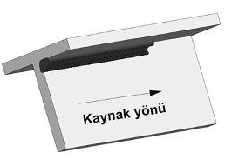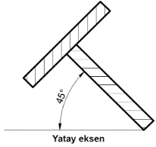

Figure 4.7: Lateral Fillet Weld
I f t h e a n g l e b e t w e e n t h e p a r t a n d t h e h o r i z o n t a l a x i s i s 8 0 - 9 0
d e g r e e s , i t i s c l a s s i f i e d a s o v e r h e a d f i l l e t w e l d i n g ; f o r l o w e r a n g l e s , i t i s c o n s i d e r e d c o r n i c e f i l l e t w e l d i n g .

4 . 4 . 2 . A p p l i c a t i o n s o f L a t e r a l F i l l e t W e l d i n g
L a t e r a l f i l l e t w e l d i n g i s o n e o f t h e c o m m o n l y u s e d p o s i t i o n a l w e l d i n g m e t h o d s i n l a r g e c o n s t r u c t i o n p r o j e c t s a n d m a c h i n e r y
m a n u f a c t u r i n g . A s i n g l e - p a s s w e l d i s a p p l i e d t o p a r t s u p t o 1 0 m m t h i c k , w h i l e t h i c k e r p a r t s m a y r e q u i r e m u l t i p l e w e l d p a s s e s
d e p e n d i n g o n t h e c o n s t r u c t i o n r e q u i r e m e n t s .

4 . 5 . O V E R H E A D B U T T W E L D I N G
O v e r h e a d b u t t w e l d i n g i s a l s o k n o w n a s o v e r h e a d p o s i t i o n w e l d i n g .
T h i s m e t h o d i s g e n e r a l l y a p p l i e d t o t h i c k a n d l a r g e p a r t s t h a t c a n n o t b e r o t a t e d .

4 . 5 . 1 . E x e c u t i o n o f O v e r h e a d B u t t W e l d i n g
D u r i n g w e l d i n g , t h e w e l d p o o l m u s t b e c o n t i n u o u s l y m o n i t o r e d t o
p r e v e n t s l a g d r i p p i n g s . I f c o n t i n u o u s o v e r h e a d w e l d i n g i s r e q u i r e d , s e l e c t i n g t h i n n e r w e l d i n g c a b l e s i s r e c o m m e n d e d .

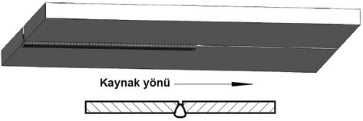
Figure 4.8: Direction of Overhead Butt Welding

D u e t o t h e p h y s i c a l l y d e m a n d i n g n a t u r e o f t h e o v e r h e a d w e l d i n g
p o s i t i o n , i t i s e s s e n t i a l t o r e d u c e t h e w e i g h t o f t h e w e l d i n g c a b l e s .
F o r t h i s r e a s o n , a c a b l e c r o s s - s e c t i o n o f 3 5 m m ² i s s u f f i c i e n t f o r o v e r h e a d w e l d i n g . T h i s r e d u c e s t h e l o a d o n t h e w e l d e r ' s a r m ,
a l l o w i n g f o r l o n g e r w e l d i n g s e s s i o n s w i t h o u t e x c e s s i v e f a t i g u e .

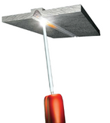
Figure 4.9: Overhead Butt Welding

4 . 5 . 2 . A p p l i c a t i o n s o f O v e r h e a d B u t t W e l d i n g
S t e e l r o o f a s s e m b l y
S t e e l b r i d g e c o n s t r u c t i o n S h i p b u i l d i n g i n d u s t r y
S t e e l c o n s t r u c t i o n w o r k s

4 . 6 . O V E R H E A D V W E L D I N G
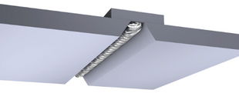
Figure 4.10: Overhead V Welding
O v e r h e a d V w e l d i n g i s a p p l i e d w i t h t h e w e l d p o s i t i o n e d a b o v e t h e w e l d e r ' s h e a d .

4 . 6 . 1 . E x e c u t i o n o f O v e r h e a d V W e l d i n g
T h i s w e l d i n g m e t h o d i s u s e d f o r m a t e r i a l s t h i c k e r t h a n 1 0 m m b y p r e p a r i n g a t o t a l g r o o v e a n g l e o f 6 0 d e g r e e s ( 3 0 d e g r e e s o n e a c h p i e c e ) . U n l i k e s i d e w e l d i n g , t h e w e l d b e a d s s h o u l d b e p l a c e d s i d e b y s i d e r a t h e r t h a n f o r m i n g a c a p - l i k e s t r u c t u r e . A n a r r o w e r w e l d b e a d i n c r e a s e s t h e s t r e n g t h o f t h e j o i n t .

4 . 6 . 2 . A p p l i c a t i o n s o f O v e r h e a d V W e l d i n g
L a r g e , i m m o v a b l e , a n d n o n - r o t a t a b l e c o n s t r u c t i o n p r o j e c t s a n d t h i c k m a t e r i a l s ( I m a g e 4 . 1 1 )
S t e e l r o o f a s s e m b l y
S t e e l b r i d g e c o n s t r u c t i o n S h i p b u i l d i n g i n d u s t r y
S t e e l c o n s t r u c t i o n w o r k s
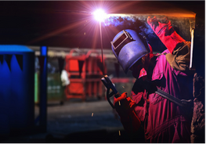
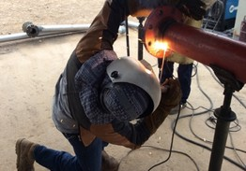
Figure 4.11: Applications of Overhead V Welding

P R E P A R E D B Y
I n n o w e l d
CELLULOSIC AND BASIC ELECTRODE WELDING

LEARNING UNIT

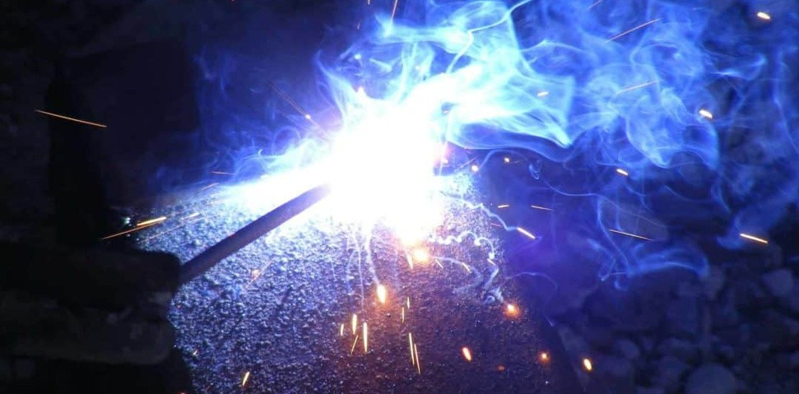

5 . 1 . B U T T J O I N T W E L D I N G W I T H C E L L U L O S I C E L E C T R O D E

5 . 2 . B U T T J O I N T W E L D I N G W I T H B A S I C E L E C T R O D E 34

5 . 1 . B U T T J O I N T W E L D I N G W I T H C E L L U L O S I C E L E C T R O D E
E l e c t r o d e m a n u f a c t u r i n g c o m p a n i e s h a v e d e v e l o p e d e l e c t r o d e s t o m e e t a l l t y p e s o f i n d u s t r i a l e l e c t r o d e n e e d s .
T h e v a r i e t y o f e l e c t r o d e s h a s i n c r e a s e d i n l i n e w i t h i n d u s t r y
d e m a n d s . O n e o f t h e b e s t e x a m p l e s o f e l e c t r o d e s d e s i g n e d t o m e e t d i f f e r e n t n e e d s i s t h e c e l l u l o s i c e l e c t r o d e .

5 . 1 . 1 . T h e R o l e a n d I m p o r t a n c e o f C e l l u l o s i c E l e c t r o d e s i n I n d u s t r y
A p p r o x i m a t e l y 3 0 % o f t h e c o a t i n g f o r m u l a o f c e l l u l o s i c e l e c t r o d e s c o n s i s t s o f c e l l u l o s e a n d o t h e r o r g a n i c s u b s t a n c e s . W h e n t h e s e
b u r n w i t h i n t h e a r c , t h e y g e n e r a t e C O a n d C O ₂ s h i e l d i n g g a s e s .
T h e a r c o f c e l l u l o s i c e l e c t r o d e s i s s t r o n g , a n d t h e i r p e n e t r a t i o n i s g r e a t e r c o m p a r e d t o o t h e r e l e c t r o d e s .
F o r t h e c o m p l e t e c o m b u s t i o n o f o r g a n i c s u b s t a n c e s , m o i s t u r e i s
r e q u i r e d . T h e r e f o r e , t h e c o a t i n g o f c e l l u l o s i c e l e c t r o d e s c o n t a i n s u p t o 5 % m o i s t u r e .
T h i s m o i s t u r e r e q u i r e m e n t p r o v i d e s a n a d v a n t a g e i n s t o r a g e , a s t h e e l e c t r o d e d o e s n o t n e e d t o b e b a k e d i n a n o v e n .
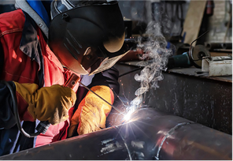
Figure 5.1: Butt Joint with Cellulosic Electrode

D u e t o t h e s t r o n g a r c o f c e l l u l o s i c e l e c t r o d e s , w e l d i n g c a n b e e a s i l y p e r f o r m e d i n a l l p o s i t i o n s , i n c l u d i n g v e r t i c a l - d o w n w e l d i n g .
T h i s e n s u r e s t h e f o r m a t i o n o f a d e e p - p e n e t r a t i o n , s t r o n g w e l d s e a m .
F o r t h i s r e a s o n , c e l l u l o s i c e l e c t r o d e s a r e c o m m o n l y u s e d i n t h e f o l l o w i n g a r e a s :
N a t u r a l g a s a n d o i l p i p e l i n e s W a t e r a n d w a s t e w a t e r p i p e s
S t o r a g e t a n k s a n d b o i l e r m a n u f a c t u r i n g S h i p b u i l d i n g i n d u s t r y
S t e e l b r i d g e c o n s t r u c t i o n
S t e e l s t r u c t u r e s r e q u i r i n g d e e p p e n e t r a t i o n w e l d i n g

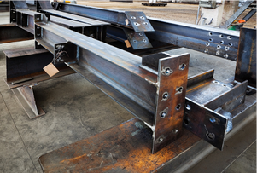

Figure 5.2: Example Cellulosic Elecktrodes in Industry 5 . 1 . 2 . D i f f e r e n c e s B e t w e e n R u t i l e a n d C e l l u l o s i c E l e c t r o d e s P r o p e r t i e s o f R u t i l e - C o a t e d E l e c t r o d e s
C o n t a i n s u p t o 5 0 % t i t a n i u m o x i d e . E a s y t o u s e .
P r o d u c e s a h i g h l y s t a b l e a r c .
C o n t a i n s a m o d e r a t e a m o u n t o f o x y g e n ( w e l d s e a m p r o f i l e s a r e s m o o t h ) .
S l a g i s e a s y t o r e m o v e .
N o t s u i t a b l e f o r c o l d w e l d i n g o f p a r t s t h i c k e r t h a n 2 0 m m ( d u e t o i t s h i g h h y d r o g e n a n d o x y g e n c o n t e n t , i t h a s l o w i m p a c t
r e s i s t a n c e a n d a h i g h r i s k o f c r a c k i n g ) . N o t s u i t a b l e f o r h i g h - s t r e n g t h s t e e l s .
T y p i c a l l y u s e d w i t h D C c u r r e n t ( n e g a t i v e - p o l a r i t y ) a n d A C c u r r e n t .

P r o p e r t i e s o f C e l l u l o s i c - C o a t e d E l e c t r o d e s
C o n t a i n s c e l l u l o s e .
D u e t o t h e p r e s e n c e o f h y d r o g e n i n t h e a r c a t m o s p h e r e , i t s p e n e t r a t i o n i s 7 0 % h i g h e r t h a n o t h e r e l e c t r o d e s .
W e l d s e a m p r o f i l e i s c o n v e x .
P a r t i c u l a r l y s u i t a b l e f o r v e r t i c a l - d o w n a n d o v e r h e a d w e l d i n g .
H a s a s t a b l e a r c , p r o d u c e s v e r y l i t t l e s l a g , a n d i s e a s y t o c l e a n . G e n e r a l l y u s e d w i t h D C c u r r e n t ( p o s i t i v e + p o l a r i t y ) .
P r e f e r r e d i n w e l d s r e q u i r i n g X - r a y i n s p e c t i o n .

5 . 1 . 3 . P r o c e d u r e f o r B u t t J o i n t W e l d i n g w i t h C e l l u l o s i c E l e c t r o d e s
B e f o r e s t a r t i n g w e l d i n g w i t h a c e l l u l o s i c e l e c t r o d e , p r o p e r p r e p a r a t i o n s m u s t b e m a d e . T h e s e p r e p a r a t i o n s i n c l u d e :
W e a r i n g p r o t e c t i v e c l o t h i n g s i n c e c e l l u l o s i c e l e c t r o d e s p r o d u c e e x c e s s i v e s p a t t e r a n d s m o k e d u r i n g w e l d i n g .
U s i n g a n e x h a u s t s y s t e m i f w e l d i n g i n e n c l o s e d s p a c e s .

P r e p a r i n g t h e w o r k p i e c e s b y o p e n i n g t h e a p p r o p r i a t e g r o o v e a n g l e s b a s e d o n t h e i r t h i c k n e s s a n d s e t t i n g t h e w e l d i n g
m a c h i n e ’ s a m p e r a g e a c c o r d i n g t o t h e e l e c t r o d e d i a m e t e r ( a s i n d i c a t e d o n t h e e l e c t r o d e p a c k a g i n g ) .
T a c k i n g t h e w o r k p i e c e s i n t h e c o r r e c t p o s i t i o n b e f o r e w e l d i n g .
E l e c t r o d e a n g l e a n d m o v e m e n t s h o u l d f o l l o w t h e s a m e
t e c h n i q u e s a s u s e d f o r r u t i l e e l e c t r o d e s . S i n c e l e s s s l a g i s
f o r m e d , t h e m o l t e n p o o l i s e a s i e r t o c o n t r o l , a l l o w i n g w e l d i n g i n a n y p o s i t i o n .
T h e a m p e r a g e s e t t i n g a n d c u r r e n t t y p e i n c e l l u l o s i c e l e c t r o d e w e l d i n g v a r y a c c o r d i n g t o e l e c t r o d e d i a m e t e r :
C e l l u l o s i c e l e c t r o d e s a r e g e n e r a l l y u s e d w i t h D C c u r r e n t a n d p o s i t i v e ( + ) p o l a r i t y .
W e l d i n g p a r a m e t e r s s h o u l d b e a d j u s t e d b a s e d o n t h e e l e c t r o d e d i a m e t e r a n d c u r r e n t v a l u e s .

5 . 2 . B u t t J o i n t W e l d i n g w i t h B a s i c E l e c t r o d e s
B a s i c e l e c t r o d e s , w h i c h h a v e a l o w - h y d r o g e n c o a t i n g , a r e u s e d t o p r o d u c e w e l d s e a m s w i t h e x c e l l e n t s t r e n g t h a n d d u c t i l i t y .
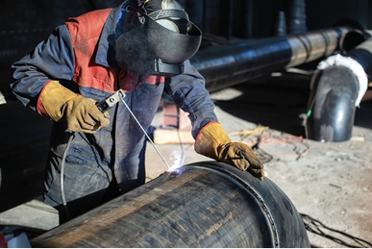
Figure 5.3: Welding Application with Basic Electrode

5 . 2 . 1 . P r o p e r t i e s o f B a s i c E l e c t r o d e s
T h e e l e c t r o d e c o a t i n g c o n s i s t s o f c a l c i u m c o m p o u n d s .
S a f e l y u s e d f o r h i g h - s t r e n g t h s t e e l s a n d t h i c k - s e c t i o n p a r t s . C a n b e u s e d i n c o l d e n v i r o n m e n t s .
R e s i s t a n t t o h o t a n d c o l d c r a c k i n g .
H a s l o w p e n e t r a t i o n , a n d t h e w e l d b e a d p r o f i l e i s c o n v e x . D u e t o i t s t h i c k c o a t i n g , d r o p l e t t r a n s f e r o c c u r s i n m e d i u m - s i z e d d r o p s .

5 . 2 . 2 . T h e R o l e a n d I m p o r t a n c e o f B a s i c E l e c t r o d e s i n I n d u s t r y
T h e w e l d m e t a l h a s h i g h r e s i s t a n c e t o c r a c k i n g .
B a s i c e l e c t r o d e s c a n b e u s e d i n a l l w e l d i n g p o s i t i o n s a n d h a v e e x c e l l e n t g a p - f i l l i n g c a p a b i l i t y .
A d d i t i o n a l l y , b a s i c e l e c t r o d e s a r e h i g h l y e f f e c t i v e i n w e l d i n g
m a c h i n e p a r t s o p e r a t i n g b e l o w 0 ° C , w h e r e o t h e r e l e c t r o d e t y p e s o f t e n f a i l .
I n m o d e r n t e c h n o l o g y , o n e o f t h e b i g g e s t c h a l l e n g e s i s b r i t t l e f r a c t u r e , a n d b a s i c e l e c t r o d e s a r e u s e d t o p r o d u c e t h e m o s t
r e s i s t a n t w e l d s e a m s a g a i n s t t h i s i s s u e .

C o m m o n A p p l i c a t i o n s o f B a s i c E l e c t r o d e s :
S h i p b u i l d i n g i n d u s t r y
B o i l e r s a n d p r e s s u r e v e s s e l s
H e a v y m a c h i n e r y a n d e q u i p m e n t i n d u s t r y
W e l d i n g o f u n k n o w n c o m p o s i t i o n c a r b o n a n d l o w - a l l o y s t e e l s W e l d i n g o f s t e e l s c o n t a i n i n g h i g h l e v e l s o f c a r b o n , s u l f u r ,
p h o s p h o r u s , a n d n i t r o g e n
J o i n i n g s t e e l s w i t h d i f f e r e n t c a r b o n c o n t e n t s W e l d i n g o f c a s t i r o n a n d s t e e l s
W e l d i n g o f c o m p o n e n t s s u b j e c t e d t o d y n a m i c l o a d s
W e l d i n g o f t h i c k - s e c t i o n p a r t s t o r e d u c e t h e r i s k o f c r a c k i n g W e l d i n g o f m a c h i n e r y , e q u i p m e n t , a n d s t r u c t u r e s o p e r a t i n g b e l o w 0 ° C

5 . 2 . 3 . E l e c t r o d e D r y i n g B e f o r e W e l d i n g
B a s i c e l e c t r o d e s h a v e a h i g h m o i s t u r e a b s o r p t i o n t e n d e n c y d u e t o t h e i r c o a t i n g c o m p o s i t i o n , s o t h e y m u s t b e s t o r e d c a r e f u l l y .
E l e c t r o d e s t h a t h a v e a b s o r b e d m o i s t u r e s h o u l d b e d r i e d a t 2 5 0 ° C f o r a t l e a s t 3 0 m i n u t e s b e f o r e w e l d i n g .
O t h e r w i s e , t h e m o i s t u r e i n t h e c o a t i n g w i l l c a u s e p o r o s i t y i n t h e w e l d a n d l e a d t o h y d r o g e n e m b r i t t l e m e n t .
S t o r a g e a n d D r y i n g o f B a s i c a n d A l l o y E l e c t r o d e s
F o r e l e c t r o d e s t h a t a r e p r o p e r l y s t o r e d a n d u s e d s h o r t l y a f t e r b e i n g r e m o v e d f r o m t h e i r p a c k a g i n g , d r y i n g i s n o t n e c e s s a r y .
R e c o m m e n d e d D r y i n g P a r a m e t e r s :
F o r g e n e r a l a p p l i c a t i o n s :
I f u n a l l o y e d e l e c t r o d e s a r e e x p o s e d t o a i r f o r m o r e t h a n 4 h o u r s , t h e y s h o u l d b e d r i e d a t 2 5 0 - 4 0 0 ° C f o r 2 - 3 h o u r s .
I f a l l o y e d e l e c t r o d e s a r e e x p o s e d t o a i r f o r m o r e t h a n 2 h o u r s , t h e y s h o u l d b e d r i e d a t 2 5 0 - 4 0 0 ° C f o r 2 - 3 h o u r s .

F o r c r i t i c a l a p p l i c a t i o n s :
I f u n a l l o y e d e l e c t r o d e s a r e e x p o s e d t o a i r f o r m o r e t h a n 2 h o u r s . I f l o w - a l l o y e l e c t r o d e s a r e e x p o s e d t o a i r f o r m o r e t h a n 1 h o u r .
I f h i g h - s t r e n g t h e l e c t r o d e s a r e e x p o s e d t o a i r f o r m o r e t h a n 3 0 m i n u t e s , t h e y s h o u l d b e d r i e d a t 3 6 0 - 4 2 0 ° C f o r 2 - 3 h o u r s .
I m p o r t a n t c o n s i d e r a t i o n s :
T h e m a x i m u m t e m p e r a t u r e s h o u l d n o t b e e x c e e d e d , b u t t h e t i m e r e q u i r e d f o r t h e d r y i n g u n i t t o r e a c h t h i s t e m p e r a t u r e s h o u l d b e c o n s i d e r e d .
I f t h e d r y i n g u n i t i s c o l d a n d f u l l y l o a d e d w i t h e l e c t r o d e s , i t m a y t a k e u p t o 8 h o u r s t o r e a c h t h e r e q u i r e d t e m p e r a t u r e .
T h e n u m b e r o f e l e c t r o d e s i n s i d e t h e d r y i n g u n i t i s c r u c i a l f o r d r y i n g e f f i c i e n c y .
T h e d i s t r i b u t i o n o f e l e c t r o d e s i n s i d e t h e u n i t s i g n i f i c a n t l y a f f e c t s t h e o u t c o m e .
T h e e l e c t r o d e a t t h e c e n t e r o f t h e b u n d l e w i l l r e a c h t h e t a r g e t t e m p e r a t u r e l a t e r t h a n t h e o v e r a l l u n i t t e m p e r a t u r e .

5 . 2 . 4 . P r o c e d u r e f o r B u t t J o i n t W e l d i n g w i t h B a s i c E l e c t r o d e s
B a s i c e l e c t r o d e s a r e g e n e r a l l y u s e d w i t h D C c u r r e n t a n d p o s i t i v e ( + ) p o l a r i t y .
W e l d i n g p a r a m e t e r s s h o u l d b e a d j u s t e d a c c o r d i n g t o t h e e l e c t r o d e d i a m e t e r a n d c u r r e n t v a l u e s .
B a s i c e l e c t r o d e s m u s t b e d r i e d a t 2 5 0 - 3 0 0 ° C f o r 2 - 3 h o u r s b e f o r e w e l d i n g .
T h e t h i c k c o a t i n g o f b a s i c e l e c t r o d e s a l l o w s o p e r a t i o n a t h i g h c u r r e n t i n t e n s i t i e s . H o w e v e r , h i g h c u r r e n t s m a y c a u s e t h e
e l e c t r o d e t o o v e r h e a t q u i c k l y , s o t h e w e l d i n g p r o c e s s s h o u l d b e c o m p l e t e d w i t h o u t i n t e r r u p t i o n s .
T h e e l e c t r o d e a n g l e s h o u l d b e b e t w e e n 8 0 - 9 0 d e g r e e s .
T h e a r c l e n g t h s h o u l d b e k e p t s h o r t ; t h e g a p b e t w e e n t h e e l e c t r o d e a n d t h e w o r k p i e c e s h o u l d b e h a l f t h e c o r e w i r e d i a m e t e r .
T h e w e l d i n g s p e e d s h o u l d b e l o w e r t h a n t h a t o f r u t i l e e l e c t r o d e s ; o t h e r w i s e , t h e s l a g w i l l n o t s u f f i c i e n t l y c o v e r t h e m o l t e n m e t a l ,
l e a d i n g t o p o o r w e l d q u a l i t y . T h e s l a g c o v e r a g e o f t h e w e l d p o o l i s d i r e c t l y r e l a t e d t o t h e w e l d i n g s p e e d ( F i g u r e 5 . 4 ) .

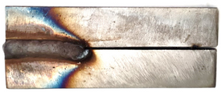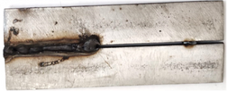
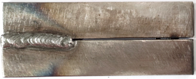
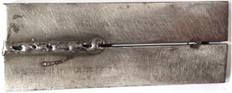
a) Slow b) Fast
Figure 5.4: Slag Coverage of the Weld Pool Depending on Welding Speed

S t r i k i n g t h e a r c r e q u i r e s s p e c i a l c a r e , e s p e c i a l l y w h e n w e l d i n g o v e r a p r e v i o u s l y w e l d e d s e a m w i t h a n e x i s t i n g w e l d c r a t e r . I n s u c h c a s e s , t h e a r c s h o u l d n e v e r b e s t a r t e d d i r e c t l y o n t h e
c r a t e r . O t h e r w i s e , t h e p r e v i o u s w e l d c r a t e r w i l l d e v e l o p p o r o s i t y .
T h e r e f o r e , t h e e l e c t r o d e s h o u l d b e i g n i t e d o n a n u n w e l d e d
s e c t i o n a n d t h e n m o v e d b a c k w a r d t o c o n t i n u e w e l d i n g f r o m t h e c r a t e r .
T h e e l e c t r o d e s h o u l d b e s t r u c k b y r u b b i n g i t a g a i n s t t h e w o r k p i e c e , n o t b y t a p p i n g .
A t t h e e n d o f t h e e l e c t r o d e , a p r o p e r w e l d c r a t e r m u s t b e
f o r m e d . W h e n a p p r o x i m a t e l y 4 0 - 5 0 m m o f e l e c t r o d e l e n g t h
r e m a i n s , t h e w e l d e r s h o u l d m o v e b a c k 1 5 - 2 0 m m a l o n g t h e w e l d
s e a m t o c r e a t e a s t r o n g f i n i s h . T h i s p r o c e s s s h o u l d n o t b e d o n e
t o o q u i c k l y , e n s u r i n g t h e w e l d p o o l r e m a i n s l i q u i d .
T h e e l e c t r o d e s h o u l d b e h e l d m o t i o n l e s s f o r a f e w s e c o n d s a n d t h e n r e m o v e d f r o m t h e w o r k p i e c e t o f o r m a p r o p e r c r a t e r .
S l a g r e m o v a l i s m o r e d i f f i c u l t i n b a s i c e l e c t r o d e s , a n d t h e w e l d i n g s p e e d a f f e c t s t h i s p r o c e s s .
T a c k i n g t h e w o r k p i e c e s t o g e t h e r i s p r e f e r a b l y d o n e u s i n g a r u t i l e e l e c t r o d e .
T h e e l e c t r o d e t i p s h o u l d b e o r i e n t e d t o w a r d t h e c e n t e r o f t h e
c r a t e r i n t h e h o r i z o n t a l p o s i t i o n . S w i n g i n g m o v e m e n t s s h o u l d b e m i n i m i z e d , b u t i f n e c e s s a r y , s l i g h t o s c i l l a t i o n s w i t h i n 2 - 3 t i m e s
t h e c o r e w i r e d i a m e t e r c a n b e a p p l i e d .

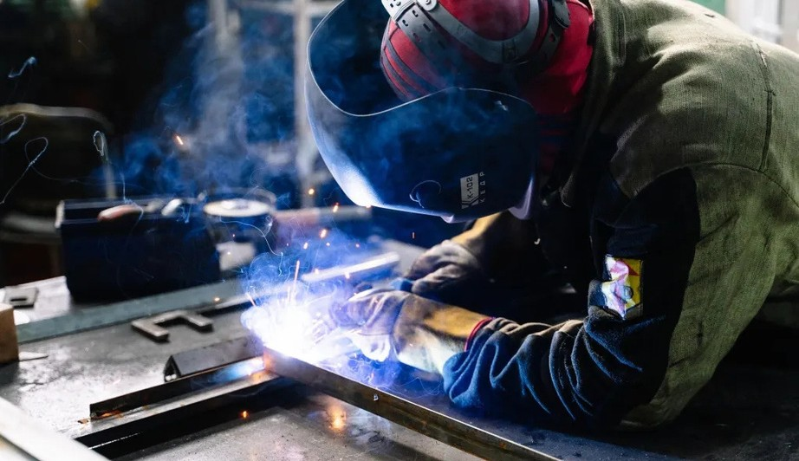P R E P A R E D B Y
I n n o w e l d

CAST IRON WELDING

LEARNING UNIT

6 . 1 . T Y P E S O F C A S T I R O N W E L D I N G
6 . 2 . W E L D I N G O F C R A C K E D C A S T I R O N
6 . 3 . W E L D I N G O F B R O K E N C A S T I R O N 41

6 . 1 . C A S T I R O N W E L D I N G
C a s t i r o n s a r e i r o n - c a r b o n a l l o y s c o n t a i n i n g b e t w e e n 2 . 1 % a n d 6 . 6 7 % c a r b o n .
T h e y m a y a l s o c o n t a i n p h o s p h o r u s , s u l f u r , s i l i c o n , a n d m a n g a n e s e a s a d d i t i o n a l e l e m e n t s .
D u e t o t h e i r h i g h c a r b o n c o n t e n t , c a s t i r o n s e x h i b i t : H i g h w e a r r e s i s t a n c e
H i g h c o m p r e s s i v e s t r e n g t h L o w m e l t i n g t e m p e r a t u r e
G o o d c a s t a b i l i t y
H o w e v e r , t h e h i g h c a r b o n c o n t e n t o f c a s t i r o n c a u s e s r a p i d h e a t i n g i n t h e w e l d a r e a d u r i n g w e l d i n g a n d r a p i d c o o l i n g a f t e r w e l d i n g .
T h i s r e s u l t s i n i n t e r n a l s t r e s s e s i n t h e m a t e r i a l .
D u r i n g r a p i d c o o l i n g , c a r b o n r e m a i n s i n t h e F e ₃ C ( c e m e n t i t e ) s t r u c t u r e , m a k i n g t h e a f f e c t e d a r e a h a r d e r a n d m o r e b r i t t l e .
T h e d i f f e r e n c e i n c a r b o n d i s t r i b u t i o n b e t w e e n t h e b a s e m e t a l a n d t h e w e l d a r e a l e a d s t o a d d i t i o n a l s t r e s s e s .
A s a r e s u l t , t h e r i s k o f c r a c k i n g a n d f r a c t u r e s i n o r n e a r t h e w e l d z o n e i n c r e a s e s s i g n i f i c a n t l y .

6 . 2 . W E L D I N G O F C R A C K E D C A S T I R O N
I n m o d e r n i n d u s t r y , c a s t i r o n i s w i d e l y u s e d , a n d c r a c k s a n d f r a c t u r e s c a n o c c u r i n t h e s e m a t e r i a l s .
T h e p u r p o s e s o f c a s t i r o n w e l d i n g i n c l u d e :
R e p a i r i n g d e f e c t s t h a t o c c u r d u r i n g c a s t i n g M a n u f a c t u r i n g c o m p l e x p a r t s a s a s i n g l e u n i t R e p a i r i n g b r o k e n o r w o r n - o u t p a r t s
E x c e p t f o r w h i t e c a s t i r o n , a l l t y p e s o f c a s t i r o n c a n b e w e l d e d , b u t t h e i r w e l d a b i l i t y i s l o w e r c o m p a r e d t o s t e e l s .
H o w e v e r , w i t h t h e a p p r o p r i a t e w e l d i n g t e c h n i q u e s , a s t r o n g b o n d c a n b e a c h i e v e d .
R e a s o n s f o r w e l d i n g c a s t i r o n : L o w c o s t
E a s e o f u s e
S i m p l e e q u i p m e n t r e q u i r e m e n t s
D o e s n o t r e q u i r e e x t e n s i v e t e c h n o l o g i c a l k n o w l e d g e

Figure 5.4: Slag Coverage of the Weld Pool Depending on Welding Speed

c o n t e n t o f c a s t i r o n c a u s e s r a p i d h e a t i n g i n t h e w e l d a r e a d u r i n g w e l d i n g a n d r a p i d c o o l i n g a f t e r w e l d i n g .
T h i s r e s u l t s i n i n t e r n a l s t r e s s e s i n t h e m a t e r i a l .
D u r i n g r a p i d c o o l i n g , c a r b o n r e m a i n s i n t h e F e ₃ C ( c e m e n t i t e ) s t r u c t u r e , m a k i n g t h e a f f e c t e d a r e a h a r d e r a n d m o r e b r i t t l e .
T h e d i f f e r e n c e i n c a r b o n d i s t r i b u t i o n b e t w e e n t h e b a s e m e t a l a n d t h e w e l d a r e a l e a d s t o a d d i t i o n a l s t r e s s e s .
A s a r e s u l t , t h e r i s k o f c r a c k i n g a n d f r a c t u r e s i n o r n e a r t h e w e l d z o n e i n c r e a s e s s i g n i f i c a n t l y .

6 . 2 . W E L D I N G O F C R A C K E D C A S T I R O N
I n m o d e r n i n d u s t r y , c a s t i r o n i s w i d e l y u s e d , a n d c r a c k s a n d f r a c t u r e s c a n o c c u r i n t h e s e m a t e r i a l s .
T h e p u r p o s e s o f c a s t i r o n w e l d i n g i n c l u d e :
R e p a i r i n g d e f e c t s t h a t o c c u r d u r i n g c a s t i n g M a n u f a c t u r i n g c o m p l e x p a r t s a s a s i n g l e u n i t R e p a i r i n g b r o k e n o r w o r n - o u t p a r t s
E x c e p t f o r w h i t e c a s t i r o n , a l l t y p e s o f c a s t i r o n c a n b e w e l d e d , b u t t h e i r w e l d a b i l i t y i s l o w e r c o m p a r e d t o s t e e l s .
H o w e v e r , w i t h t h e a p p r o p r i a t e w e l d i n g t e c h n i q u e s , a s t r o n g b o n d c a n b e a c h i e v e d .
R e a s o n s f o r w e l d i n g c a s t i r o n : L o w c o s t
E a s e o f u s e
S i m p l e e q u i p m e n t r e q u i r e m e n t s
D o e s n o t r e q u i r e e x t e n s i v e t e c h n o l o g i c a l k n o w l e d g e

6 . 2 . 1 . C a s t i n g E l e c t r o d e s U s e d i n C a s t I r o n W e l d i n g
I n t h e w e l d i n g o f c o l d a n d a n n e a l e d c a s t i r o n ( u p t o a m a x i m u m o f 3 0 0 ° C ) , b e s i d e s h i g h - c a r b o n c a s t i r o n e l e c t r o d e s , e l e c t r o d e s w i t h a p u r e n i c k e l c o r e w i r e a r e a l s o u s e d ( F i g u r e 6 . 1 ) .
P u r p o s e s o f U s i n g C a s t i n g E l e c t r o d e s w i t h a P u r e N i c k e l C o r e W i r e :
U s e d i n t h e w e l d i n g o f g r e y c a s t i r o n , w h i t e m a l l e a b l e c a s t i r o n , a n d d u c t i l e c a s t i r o n , a s w e l l a s t h e i r w e l d i n g w i t h s t e e l .
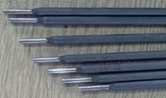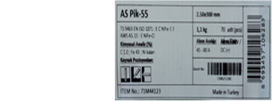E s p e c i a l l y u s e d f o r j o i n i n g a n d r e p a i r w e l d i n g o f b r o k e n o r w o r n - o u t c a s t i r o n p a r t s .
Figure 6.1: Casting Electrode and Information Label
a) Casting Electrode b) Electrode Information Label

P r o v i d e s e x c e l l e n t r e s u l t s i n r e p a i r i n g c a s t i n g d e f e c t s t h r o u g h w e l d i n g .
E v e n a t l o w c u r r e n t , i t c o v e r s t h e b a s e m e t a l w e l l a n d r e d u c e s t h e m i x i n g r a t i o w i t h t h e b a s e m a t e r i a l .
T h i s a l l o w s w e l d i n g w i t h o u t a n n e a l i n g , e s p e c i a l l y f o r t h i c k - s e c t i o n p a r t s , a n d m i n i m i z e s t h e r i s k o f c r a c k i n g .
W e l d s e a m s s h o u l d b e s h o r t e r t h a n 3 0 m m t o r e d u c e w e l d i n g s t r e s s e s .
I f t h e w e l d i s h a m m e r e d b e f o r e c o o l i n g , w e l d i n g s t r e s s e s c a n b e r e d u c e d .
S i n c e c a s t i r o n c o n t a i n s a h i g h a m o u n t o f c a r b o n , i t b e c o m e s b r i t t l e a n d h a r d , s o i t s h o u l d n o t b e h a m m e r e d w h i l e c o l d .

P u r p o s e s o f U s i n g M o n e l ( N i c k e l - C o p p e r ) C o r e C a s t i n g E l e c t r o d e s :
U s e d i n c o l d a n d s e m i - h o t ( 3 0 0 ° C ) w e l d i n g o f g r e y c a s t i r o n , m a l l e a b l e c a s t i r o n , a n d d u c t i l e ( s p h e r o i d a l ) c a s t i r o n .
U s e d f o r w e l d i n g g r e y c a s t i r o n t o s t e e l .
U s e d f o r j o i n i n g a n d r e p a i r w e l d i n g o f b r o k e n o r w o r n - o u t c a s t i r o n p a r t s .
U s e d f o r r e p a i r i n g c a s t i n g o r m a c h i n i n g d e f e c t s t h r o u g h w e l d i n g . N o h a r d n e s s i s s u e s i n t h e t r a n s i t i o n z o n e , r e s u l t i n g i n a c r a c k -
f r e e a n d p o r o s i t y - f r e e w e l d s e a m .
I f t h e w e l d s e a m i s l i g h t l y h a m m e r e d b e f o r e c o o l i n g , w e l d i n g s t r e s s e s a r e r e d u c e d .

P u r p o s e s o f U s i n g N i c k e l - I r o n C o r e C a s t i n g E l e c t r o d e s :
P r o v i d e s s m o o t h m e l t i n g a n d f u s i o n . H a s a q u i e t a n d s t a b l e a r c .
S u i t a b l e f o r p o s i t i o n w e l d i n g .
U s e d i n c o l d a n d h o t w e l d i n g o f p a r t s s u b j e c t e d t o d y n a m i c f o r c e s .
S i n c e t h e t h e r m a l e x p a n s i o n o f t h e w e l d m e t a l i s l o w , i t e x h i b i t s m i n i m a l s h r i n k a g e a f t e r w e l d i n g .
H a s h i g h e r s t r e n g t h c o m p a r e d t o p u r e n i c k e l e l e c t r o d e s .
T h e r e f o r e , i t i s h i g h l y s u i t a b l e f o r w e l d i n g d u c t i l e c a s t i r o n , m a l l e a b l e c a s t i r o n , g r e y c a s t i r o n , a n d t h e i r w e l d i n g w i t h
s t e e l , c o p p e r , a n d n i c k e l m a t e r i a l s .
E a s y a r c i n i t i a t i o n a n d r e - s t r i k i n g w i t h a s t a b l e a r c . E n s u r e s a s m o o t h w e l d s e a m .

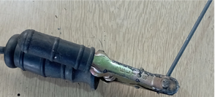

Figure 6.2: Casting Electrode and Information Label

6 . 2 . 2 . R e v e r s e P o l a r i t y i n C a s t I r o n W e l d i n g
W h e n t h e e l e c t r o d e h o l d e r i s c o n n e c t e d t o t h e n e g a t i v e ( - ) p o l e i n d i r e c t c u r r e n t ( D C ) , m o s t o f t h e h e a t i s g e n e r a t e d o n t h e
w o r k p i e c e .
W h e n t h e e l e c t r o d e h o l d e r i s c o n n e c t e d t o t h e p o s i t i v e ( + ) p o l e , a p p r o x i m a t e l y 6 6 % o f t h e h e a t i s c o n c e n t r a t e d o n t h e e l e c t r o d e , r e d u c i n g t h e t h e r m a l e f f e c t o n t h e w o r k p i e c e .

6 . 2 . 3 . D r i l l i n g H o l e s a t t h e S t a r t a n d E n d P o i n t s o f C r a c k s
F o r c r a c k s t h a t s t a r t a n d e n d w i t h i n t h e m a t e r i a l , h o l e s s h o u l d b e d r i l l e d a t b o t h e n d s o f t h e c r a c k .
I n c a s t i r o n w e l d i n g , a n n e a l i n g i s r e c o m m e n d e d t o f a c i l i t a t e d r i l l i n g a n d t o p r e v e n t c r a c k p r o p a g a t i o n d u r i n g w e l d i n g .
T o e l i m i n a t e t h e t e m p e r a t u r e d i f f e r e n c e b e t w e e n t h e w e l d s e a m a n d t h e b a s e m e t a l , t h e b a s e m e t a l s h o u l d b e k e p t a t w e l d i n g
t e m p e r a t u r e .
T h i s i s e s p e c i a l l y c r i t i c a l f o r l a r g e - v o l u m e p a r t s .
T h u s , p r e h e a t i n g t h e b a s e m e t a l b e f o r e w e l d i n g i s n e c e s s a r y .

P r e h e a t i n g R e q u i r e m e n t s :
A l a r g e h e a t i n g t o r c h s h o u l d b e u s e d w h e n e v e r p o s s i b l e t o e n s u r e b e t t e r h e a t d i s t r i b u t i o n .
T h e w o r k p i e c e s h o u l d b e p l a c e d o n a f i r e b r i c k t o m i n i m i z e h e a t l o s s t o t h e s u r r o u n d i n g s .
A s u p p o r t s h o u l d b e u s e d t o p r e v e n t w a r p i n g a n d d e f o r m a t i o n o f t h e w o r k p i e c e .
I f t h e w o r k p i e c e i s h e a t e d i n a f u r n a c e , t h e f u r n a c e s h o u l d b e
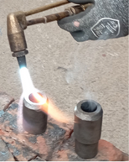
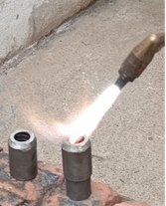
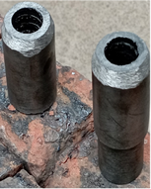
p r e h e a t e d t o t h e t a r g e t t e m p e r a t u r e b e f o r e p l a c i n g t h e w o r k p i e c e i n s i d e .

Figure 6.3: Preheating Processes

P r e p a r a t i o n o f J o i n t A r e a s
T h e f o l l o w i n g s t e p s s h o u l d b e t a k e n w h e n p r e p a r i n g j o i n t a r e a s :
I d e n t i f y i n g t h e e x a c t s t a r t a n d e n d p o i n t s o f t h e c r a c k i s c r u c i a l .
I f t h e w e l d i s c o m p l e t e d b e f o r e r e a c h i n g t h e a c t u a l e n d o f t h e c r a c k , t h e c r a c k w i l l c o n t i n u e t o s p r e a d a f t e r w e l d i n g .
I f t h e c r a c k e x t e n d s t o t h e e d g e o f t h e p a r t , a s t r o n g t a c k w e l d s h o u l d b e a p p l i e d a t t h e e d g e b e f o r e a n y o t h e r p r o c e s s .
T h e e x a c t e n d p o i n t o f t h e c r a c k m u s t b e d e t e r m i n e d . F o r t h i s p u r p o s e , p e n e t r a n t l i q u i d , c o m m o n l y u s e d i n n o n - d e s t r u c t i v e
t e s t i n g ( N D T ) m e t h o d s , s h o u l d b e a p p l i e d t o t h e c r a c k a n d l e f t t o s e t t l e ( i o d i n e s o l u t i o n c a n a l s o b e u s e d f o r t h i s ) .
I o d i n e e v a p o r a t e s f r o m t h e s u r f a c e b u t s t a i n s t h e c r a c k d o w n t o i t s f i n e s t p o i n t .
T h e l a s t v i s i b l e p o i n t o f t h e c r a c k s h o u l d b e i d e n t i f i e d u s i n g a m a g n i f y i n g g l a s s a n d m a r k e d w i t h a d o t .
A 3 - 4 m m h o l e s h o u l d b e d r i l l e d a t t h e m a r k e d p o i n t t o p r e v e n t t h e c r a c k f r o m s p r e a d i n g d u r i n g a n d a f t e r w e l d i n g . O t h e r w i s e , t h e c r a c k w i l l c o n t i n u e t o p r o p a g a t e .
I f t h e c r a c k r e a c h e s t h e o u t e r e d g e o f t h e p a r t , t h e e x p o s e d e n d s h o u l d b e s e c u r e d w i t h a s t r o n g t a c k w e l d b e f o r e a n y o t h e r
p r o c e s s .
I f t h e t a c k w e l d b r e a k s d u r i n g w e l d i n g , t h e r e m a i n i n g t a c k w e l d
m a t e r i a l s h o u l d b e r e m o v e d u s i n g a c h i s e l o r g r i n d i n g w h e e l , a n d a n e w s t r o n g t a c k w e l d s h o u l d b e a p p l i e d .
W e l d i n g s h o u l d n e v e r c o n t i n u e w h i l e t h e e d g e i s o p e n . O t h e r w i s e , d e f o r m a t i o n o f t h e p a r t w i l l b e i n e v i t a b l e .
F o r c r a c k s t h a t s t a r t a n d e n d w i t h i n t h e p a r t , 3 - 4 m m h o l e s s h o u l d b e d r i l l e d a t b o t h e n d s o f t h e c r a c k .
I f t h e p a r t i s l a r g e a n d t h e c r a c k i s l o n g e r t h a n 5 0 c m , a n d o n e e n d o f t h e w e l d d o e s n o t t h e r m a l l y a f f e c t t h e o t h e r e n d , s h o r t w e l d p a s s e s s h o u l d b e m a d e f i r s t f r o m o n e e n d , t h e n f r o m t h e o t h e r .
H o w e v e r , b e f o r e s t a r t i n g t h e t h i r d p a s s , t h e f i r s t p a s s s h o u l d b e a l l o w e d t o c o o l t o t h e t o u c h .
A d d i t i o n a l l y , a s t h e t w o s i d e s a p p r o a c h t h e c e n t e r o f t h e
w e l d , w e l d i n g s h o u l d p a u s e a t b o t h e n d s , a n d w e l d i n g s h o u l d c o n t i n u e f r o m o n l y o n e s i d e .

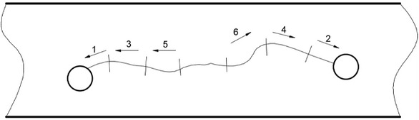

Figure 6.4: Preheating Processes
H i g h p h o s p h o r u s a n d s u l f u r c o n t e n t i n c r e a s e s t h e b r i t t l e n e s s a n d c r a c k i n g t e n d e n c y o f g r e y c a s t i r o n .
O i l - o r g r e a s e - a b s o r b e d c a s t i r o n s h o u l d b e h e a t e d t o 2 5 0 ° C f o r a f e w h o u r s b e f o r e w e l d i n g .
I n s o m e c a s e s , i t s h o u l d b e e x p o s e d t o h i g h t e m p e r a t u r e s o f t h e e l e c t r i c a r c t o r e m o v e o i l o r g r e a s e .
F o r t h i s , a r u t i l e e l e c t r o d e s h o u l d f i r s t b e u s e d t o a p p l y a f i l l e r l a y e r t o t h e w e l d i n g a r e a , w h i c h i s t h e n c l e a n e d .
T h e c a s t i n g s k i n , w h i c h b e c o m e s o x i d i z e d d u r i n g c o o l i n g a n d p r e v e n t s p r o p e r a d h e s i o n o f t h e e l e c t r o d e m e t a l t o t h e b a s e m e t a l , s h o u l d b e g r o u n d b e f o r e w e l d i n g .
T h e g r i n d i n g s h o u l d b e d o n e o n b o t h s i d e s o f t h e w e l d a r e a , w i t h a w i d t h o f a t l e a s t 1 0 m m a n d a d e p t h o f 1 m m .
S h a r p e d g e s m u s t b e r e m o v e d w i t h a f i l e .
O t h e r w i s e , t h i n , s h a r p p a r t s m a y b u r n d u r i n g w e l d i n g a n d m i x i n t o t h e w e l d s e a m a s o x i d e s .
F o r c r a c k s l o n g e r t h a n 5 0 c m , s h o r t w e l d p a s s e s s h o u l d b e m a d e s t a r t i n g f r o m t h e e n d s .
T h e t h i r d p a s s s h o u l d o n l y b e a p p l i e d a f t e r t h e f i r s t p a s s h a s c o o l e d t o t h e t o u c h ( F i g u r e 6 . 5 ) .
A s w e l d p a s s e s a p p r o a c h t h e c e n t e r o f t h e c r a c k , w e l d i n g s h o u l d b e p a u s e d b e f o r e c o n t i n u i n g w i t h t h e f i n a l p a s s .
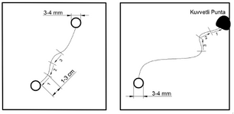
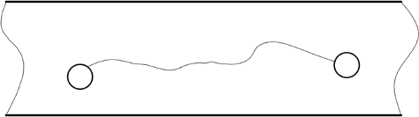

Figure 6.5: Pass Sequences in Cracked Castings
- Passes in a crack within the part
- Passes in a crack extending to the edge of the part
- Pass sequence for cracks longer than 50 cm

6 . 2 . 4 . I m p o r t a n c e o f G r o o v e P r e p a r a t i o n f o r W e l d i n g T h i c k -
S e c t i o n e d C r a c k e d C a s t I r o n
T h e w e l d g r o o v e s h o u l d b e p r e p a r e d a c c o r d i n g t o t h e t h i c k n e s s o f t h e s e c t i o n .
I f t h e g r o o v e i s n o t a d e q u a t e l y o p e n e d , t w o m a j o r p r o b l e m s m a y a r i s e :
I n c r e a s e d r i s k o f t h e c r a c k o p e n i n g f u r t h e r d u r i n g w e l d i n g .
I n s u f f i c i e n t s t r e n g t h i n t h e w e l d e d s e c t i o n , l e a d i n g t o a n e w c r a c k t h a t m a y s o o n b e c o m e i r r e p a r a b l e .
S t e p s f o r G r o o v e P r e p a r a t i o n i n C r a c k e d C a s t I r o n P a r t s :
T h e s i d e s o f t h e o p e n e d w e l d g r o o v e s h o u l d b e g r o u n d t o a
m i n i m u m w i d t h o f 1 0 m m a n d a d e p t h o f 1 m m t o r e m o v e o x i d e l a y e r s .
T h e w e l d g r o o v e s h o u l d o n l y b e o p e n e d a f t e r d r i l l i n g h o l e s a t t h e c r a c k e n d p o i n t s .
T h e w e l d g r o o v e s h a p e s h o u l d b e d e s i g n e d a c c o r d i n g t o t h e t h i c k n e s s o f t h e s e c t i o n :
I t s h o u l d h a v e a U o r d o u b l e U s h a p e d e p e n d i n g o n t h e t h i c k n e s s .
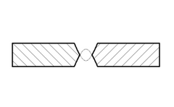
A 2 m m g a p s h o u l d b e l e f t a t t h e b o t t o m o f t h e g r o o v e .
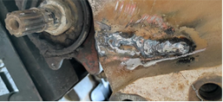

Figure 6.6: a) Weld Groove Cross-Section b) Weld Groove
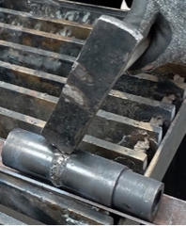

Figure 6.7: Peening of the Weld

O n c e t h e p a r t h a s c o o l e d t o a t e m p e r a t u r e t h a t c a n b e t o u c h e d b y h a n d , a 1 - 3 c m w e l d s h o u l d b e a p p l i e d .
W e l d i n g s h o u l d n e v e r s t a r t f r o m t h e e n d b u t a l w a y s f r o m t h e i n s i d e , p r o g r e s s i n g t o w a r d t h e e n d o f t h e c r a c k .
B e f o r e s t a r t i n g t h e n e x t 1 - 3 c m w e l d , t h e e n d o f t h e p r e v i o u s w e l d p a s s m u s t b e c l e a n e d u s i n g a g r i n d i n g w h e e l o r c h i s e l .
I n m u l t i - p a s s w e l d i n g , t h e f i r s t p a s s s h o u l d b e c o m p l e t e d f a s t e r t h a n t h e f o l l o w i n g p a s s e s .

6 . 2 . 5 . W e l d i n g P r o c e d u r e f o r C r a c k e d C a s t I r o n
W h e n w e l d i n g c a s t i r o n , i t i s e s s e n t i a l t o r e m e m b e r t h a t c a r b o n c l u s t e r s w i t h i n c a s t i r o n c a n a b s o r b o i l s a n d o t h e r f l u i d s .
I f t h e s e f l u i d s a r e n o t r e m o v e d b e f o r e w e l d i n g , t h e y c a n c a u s e p o r o s i t y i n t h e w e l d .
I m p o r t a n t C o n s i d e r a t i o n s B e f o r e W e l d i n g :
T h e w e l d i n g a r e a m u s t b e c l e a n e d o f a l l f o r e i g n s u b s t a n c e s ( o i l , g r e a s e , r u s t ) .
T h e t y p e o f c a s t i r o n m u s t b e i d e n t i f i e d .
T h e e l e c t r o d e m u s t b e s e l e c t e d a c c o r d i n g t o t h e c a s t i n g m a t e r i a l .

W e l d i n g o f C a s t I r o n
T h e e n t i r e w o r k p i e c e s h o u l d b e h e a t e d t o a p p r o x i m a t e l y 2 0 0 - 3 0 0 ° C t o p r e v e n t h a r d e n i n g i n t h e t r a n s i t i o n z o n e a n d r e d u c e s h r i n k a g e s t r e s s e s .
N i c k e l o r n i c k e l - b a s e d a l l o y s s h o u l d b e u s e d a s f i l l e r m a t e r i a l . A n e n t i r e e l e c t r o d e c a n b e b u r n e d i n o n e g o , b u t t h e w e l d s e a m m u s t b e h a m m e r e d i m m e d i a t e l y a f t e r w e l d i n g .
I f t h e w o r k p i e c e i s h e a t e d a b o v e 6 0 0 ° C , w e l d i n g s h o u l d b e d o n e w i t h f i l l e r m e t a l t h a t m a t c h e s t h e b a s e m e t a l c o m p o s i t i o n .
S i n c e c a s t i r o n w e l d i n g r e q u i r e s h i g h p r e c i s i o n a n d e x p e r i e n c e , p r o p e r t e c h n i q u e s a r e e s s e n t i a l .
D i f f e r e n t t y p e s o f c a s t i r o n — s u c h a s g r e y c a s t i r o n , d u c t i l e i r o n , a n d m a l l e a b l e c a s t i r o n — r e q u i r e s p e c i f i c w e l d i n g p r o c e d u r e s .
S o m e c a s t i r o n p a r t s m a y u n d e r g o s t r u c t u r a l c h a n g e s d u e t o e x t e r n a l f a c t o r s , s u c h a s o p e r a t i n g c o n d i t i o n s .
E x a m p l e : C a s t i r o n v a l v e s e x p o s e d t o h i g h - p r e s s u r e s t e a m f o r l o n g p e r i o d s .
T h e s e m a t e r i a l s b e c o m e e x t r e m e l y b r i t t l e , a n d g a s
p e n e t r a t i o n i n t o m i c r o v o i d s r e d u c e s s t r e n g t h , m a k i n g w e l d i n g n e a r l y i m p o s s i b l e .
P r o l o n g e d e x p o s u r e t o d i r e c t f i r e o r h i g h t e m p e r a t u r e s c a n c a u s e c a r b o n a n d s i l i c o n t o o x i d i z e , m a k i n g t h e m a t e r i a l d i f f i c u l t t o
m e l t . 49

P o s t - W e l d i n g C o o l i n g P r o c e s s
A f t e r w e l d i n g , t h e e n t i r e w o r k p i e c e s h o u l d b e h e a t e d t o a t e m p e r a t u r e c l o s e t o t h e w e l d i n g t e m p e r a t u r e .
T h e p a r t s h o u l d b e s l o w l y c o o l e d b y p l a c i n g i t i n a s b e s t o s
m a t e r i a l o r a s t i l l - a i r e n v i r o n m e n t t o p r e v e n t r a p i d c o o l i n g a n d c r a c k i n g .

6 . 2 . 6 . A p p l i c a t i o n o f W e l d i n g M e t h o d a n d P o s t - W e l d i n g P r o c e s s e s
U s e t h e t h i n n e s t p o s s i b l e e l e c t r o d e ( Ø 2 . 5 o r 3 . 2 5 m m ) a n d a p p l y l o w c u r r e n t i n t e n s i t y w h i l e k e e p i n g t h e a r c s h o r t .
N e v e r e x c e e d t h e m a x i m u m r e c o m m e n d e d a m p e r a g e s e t t i n g .
W e l d s e a m l e n g t h s s h o u l d b e l i m i t e d t o 4 - 5 t i m e s t h e e l e c t r o d e d i a m e t e r .
U s e d i r e c t c u r r e n t ( D C ) w e l d i n g .
P e r i o d i c a l l y p a u s e t o p r e v e n t e x c e s s i v e h e a t c o n c e n t r a t i o n i n o n e a r e a .
E a c h w e l d s h o u l d b e h a m m e r e d i m m e d i a t e l y a f t e r w e l d i n g .
T h e h a m m e r i n g p r o c e s s s h o u l d s t a r t f r o m t h e h o t t e s t p a r t o f t h e w e l d a n d m o v e b a c k w a r d .
C o n t r o l l e d s t o p s s h o u l d b e m a d e t o e n s u r e t h e p a r t ' s t e m p e r a t u r e d o e s n o t e x c e e d 7 0 ° C .
S h o r t w e l d b e a d s s h o u l d b e a p p l i e d t o r e d u c e w e l d i n g s t r e s s e s . A f t e r w e l d i n g , t h e e n t i r e w o r k p i e c e s h o u l d b e h e a t e d c l o s e t o t h e w e l d i n g t e m p e r a t u r e a n d s l o w l y c o o l e d i n a s b e s t o s o r a s t i l l - a i r
e n v i r o n m e n t .

6 . 3 . W E L D I N G O F B R O K E N C A S T I R O N
H e a t i n p u t i n c a s t i r o n w e l d i n g s h o u l d b e k e p t a s l o w a s p o s s i b l e .
H i g h e r h e a t i n p u t i n c r e a s e s t h e l i k e l i h o o d o f b r e a k a g e i n t h e w e l d e d a r e a o r h e a t - a f f e c t e d z o n e ( H A Z ) .
R a p i d h e a t i n g a n d c o o l i n g m a k e c a s t i r o n m o r e b r i t t l e .

6 . 3 . 1 . I m p o r t a n c e o f G r o o v e P r e p a r a t i o n f o r W e l d i n g T h i c k - S e c t i o n e d B r o k e n C a s t I r o n
I f t h e w e l d g r o o v e i s n o t o p e n e d s u f f i c i e n t l y , t w o m a j o r i s s u e s m a y a r i s e :
- I n c r e a s e d r i s k o f c r a c k p r o p a g a t i o n d u r i n g w e l d i n g .
- I n s u f f i c i e n t s t r e n g t h , w h i c h m a y l a t e r r e s u l t i n a n i r r e p a r a b l e c r a c k d u r i n g o p e r a t i o n .

S t e p s f o r G r o o v e P r e p a r a t i o n i n B r o k e n C a s t I r o n P a r t s :
T h e w e l d g r o o v e s h o u l d b e o p e n e d a c c o r d i n g t o t h e t h i c k n e s s o f t h e s e c t i o n .
T h e g r o o v e s h o u l d b e i n V o r X s h a p e w i t h a n a n g l e o f 8 0 - 9 0 ° , d e p e n d i n g o n t h i c k n e s s .
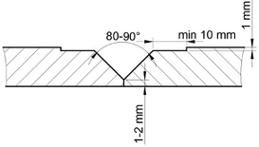
A 2 m m r o o t g a p s h o u l d b e l e f t a t t h e b o t t o m .

Figure 6.8: Advanced Weld Groove Design

S h a r p e d g e s o n b o t h s i d e s o f t h e g r o o v e s h o u l d b e r o u n d e d .
E a c h b r o k e n p a r t s h o u l d b e p r e p a r e d w i t h t h e g r o o v e m e n t i o n e d a b o v e a n d t h e n t a c k w e l d e d a t a p p r o p r i a t e i n t e r v a l s ( F i g u r e 6 . 9 ) .

6 . 3 . 2 . W e l d i n g P r o c e s s f o r B r o k e n C a s t I r o n
B e f o r e w e l d i n g , t h e f o l l o w i n g f a c t o r s m u s t b e c o n s i d e r e d :
I d e n t i f y t h e t y p e o f c a s t i r o n b e i n g w e l d e d .
S e l e c t t h e a p p r o p r i a t e e l e c t r o d e b a s e d o n t h e c a s t i n g m a t e r i a l . E n s u r e a l l p a r t s a r e c l e a n e d o f f o r e i g n s u b s t a n c e s ( o i l , g r e a s e , r u s t , e t c . ) .

6 . 3 . 3 . A p p l i c a t i o n o f W e l d i n g M e t h o d a n d P o s t - W e l d i n g P r o c e d u r e s
I n m u l t i - p a s s w e l d i n g , t h e f i r s t p a s s s h o u l d b e a p p l i e d f a s t e r t h a n s u b s e q u e n t p a s s e s .
T h e a r c l e n g t h s h o u l d b e k e p t s h o r t , a p p r o x i m a t e l y e q u a l t o t h e e l e c t r o d e c o r e d i a m e t e r .
W e l d b e a d s s h o u l d b e l i m i t e d t o 1 - 3 c m a t a t i m e a n d i m m e d i a t e l y h a m m e r e d a n d b r u s h e d a f t e r e a c h p a s s .
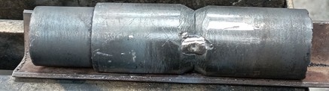
Figure 6.9: Weld Groove Preparation

U s e t h e t h i n n e s t p o s s i b l e e l e c t r o d e ( Ø 2 . 5 m m o r 3 . 2 5 m m ) a n d a p p l y l o w c u r r e n t i n t e n s i t y w h i l e k e e p i n g t h e a r c s h o r t .
N e v e r e x c e e d t h e m a x i m u m r e c o m m e n d e d a m p e r a g e s e t t i n g .
W e l d b e a d l e n g t h s s h o u l d b e l i m i t e d t o 4 - 5 t i m e s t h e e l e c t r o d e d i a m e t e r .
U s e d i r e c t c u r r e n t ( D C ) w e l d i n g .
P a u s e i n t e r m i t t e n t l y t o p r e v e n t e x c e s s i v e l o c a l h e a t c o n c e n t r a t i o n .
E a c h w e l d b e a d m u s t b e i m m e d i a t e l y h a m m e r e d a f t e r w e l d i n g . T h e h a m m e r i n g p r o c e s s s h o u l d s t a r t f r o m t h e h o t t e s t p a r t o f t h e w e l d a n d m o v e b a c k w a r d .
W e l d i n g s h o u l d b e s t o p p e d p e r i o d i c a l l y t o k e e p t h e w o r k p i e c e t e m p e r a t u r e b e l o w 7 0 ° C .
S h o r t w e l d p a s s e s s h o u l d b e a p p l i e d t o r e d u c e w e l d i n g s t r e s s e s .
T h e w e l d s e a m s h o u l d b e h a m m e r e d b e f o r e i t c o o l s t o m i n i m i z e i n t e r n a l s t r e s s e s .
A f t e r w e l d i n g , t h e e n t i r e w o r k p i e c e s h o u l d b e h e a t e d t o a s u i t a b l e t e m p e r a t u r e a n d s l o w l y c o o l e d .

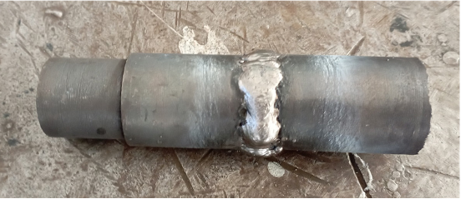

Figure 6.10: Welded Broken Cast Iron

P R E P A R E D B Y
I n n o w e l d

WELDING OF NON-FERROUS
METALS

LEARNING UNIT

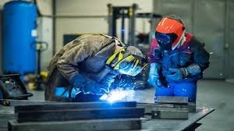

7 . 1 . C O P P E R W E L D I N G
7 . 2 . B R A S S W E L D I N G
7 . 3 . W E L D I N G O F A L U M I N U M A N D I T S A L L O Y S 53

7 . 1 . C O P P E R W E L D I N G
A m o n g n o n - f e r r o u s m e t a l s , c o p p e r ( C u ) , a l u m i n u m ( A l ) , a n d b r a s s a l l o y s a r e t h e m o s t c o m m o n l y u s e d m a t e r i a l s .
C o p p e r h a s a m e l t i n g p o i n t o f 1 0 8 3 ° C a n d i s t h e s e c o n d - b e s t t h e r m a l a n d e l e c t r i c a l c o n d u c t o r a f t e r s i l v e r ( A g ) .
I t s h i g h s e n s i t i v i t y t o o x y g e n c a u s e s a t h i n o x i d e l a y e r t o f o r m o n i t s s u r f a c e .
D u e t o t h i s o x i d e l a y e r , c o p p e r h a s h i g h c o r r o s i o n r e s i s t a n c e .
O v e r t i m e , c o p p e r f o r m s a g r e e n - c o l o r e d o x i d e l a y e r o n i t s s u r f a c e , w h i c h c a n b e h a r m f u l t o h u m a n h e a l t h .
T h e r e f o r e , c o p p e r u t e n s i l s u s e d i n t h e f o o d i n d u s t r y a n d k i t c h e n s a r e c o a t e d w i t h t i n .

T y p e s o f C o p p e r
T h e r e a r e t w o t y p e s o f c o p p e r c o m m o n l y a v a i l a b l e i n t h e m a r k e t :
- P u r e C o p p e r ( 9 9 . 9 % C u )
- E l e c t r o l y t i c C o p p e r , o b t a i n e d b y s u b j e c t i n g p u r e c o p p e r t o a n e l e c t r o l y s i s p r o c e s s
A d d i t i o n a l l y , c o p p e r a l l o y s w i t h d i f f e r e n t p r o p e r t i e s a n d a p p l i c a t i o n s a r e f o r m e d b y a d d i n g e l e m e n t s s u c h a s :
T i n ( S n ) Z i n c ( Z n )
N i c k e l ( N i ) S i l i c o n ( S i )
A l u m i n u m ( A l ) P h o s p h o r u s ( P )

I m p o r t a n c e o f C o p p e r W e l d i n g i n I n d u s t r y
M a n y c o p p e r a n d c o p p e r a l l o y p r o d u c t s a r e d e s i g n e d f o r v a r i o u s e l e c t r i c a l , m e c h a n i c a l , a n d a r c h i t e c t u r a l a p p l i c a t i o n s .
A l t h o u g h n o t a l l c o p p e r a l l o y s a r e e q u a l l y e a s y t o w e l d , a l l c o p p e r a n d c o p p e r a l l o y s c a n b e w e l d e d .
T h e i n c r e a s i n g u s e o f T I G a n d M I G w e l d i n g m e t h o d s h a s l i m i t e d t h e u s e o f s h i e l d e d m e t a l a r c w e l d i n g ( S M A W ) w i t h c o v e r e d e l e c t r o d e s
f o r c o p p e r .
H o w e v e r , S M A W i s s t i l l p r e f e r r e d d u e t o i t s s i m p l i c i t y , a f f o r d a b i l i t y , p o r t a b i l i t y , a n d w i d e s p r e a d a v a i l a b i l i t y .
S h i e l d e d m e t a l a r c w e l d i n g ( S M A W ) f o r c o p p e r i s p r i m a r i l y u s e d f o r : J o i n i n g a n d r e p a i r w e l d i n g o f c o m p o n e n t s
P a r t s w i t h t h i c k n e s s e s l e s s t h a n 2 5 m m
A p p l i c a t i o n s t h a t a r e n o t e x p o s e d t o s e v e r e c h e m i c a l c o r r o s i o n o r h e a v y l o a d s

Figure 7.1: Copper Welding

7 . 1 . 1 . I m p o r t a n c e o f R e v e r s e P o l a r i t y i n C o p p e r W e l d i n g
W h e n w e l d i n g c o p p e r a n d i t s a l l o y s w i t h c o v e r e d e l e c t r o d e s , i t i s g e n e r a l l y d o n e u s i n g D i r e c t C u r r e n t R e v e r s e P o l a r i t y ( D C R P ) .
T h i s e n s u r e s t h a t t w o - t h i r d s o f t h e h e a t i s c o n c e n t r a t e d n e a r t h e p o s i t i v e ( + ) p o l e .
I n t h i s c a s e , t h e a r c t e m p e r a t u r e e x c e e d s 3 5 0 0 ° C .
T h e r e m a i n i n g o n e - t h i r d o f t h e h e a t i s c o n c e n t r a t e d n e a r t h e n e g a t i v e ( - ) p o l e , w h e r e t h e w o r k p i e c e i s c o n n e c t e d .
S i n c e a n e l e c t r o d e c o n n e c t e d t o t h e p o s i t i v e ( + ) p o l e m e l t s f a s t e r t h a n o n e c o n n e c t e d t o t h e n e g a t i v e ( - ) p o l e , t h e r e q u i r e d h e a t t o m e l t c o p p e r i s a c h i e v e d m o r e q u i c k l y .
F o r t h i c k - c o a t e d e l e c t r o d e s , h i g h e r h e a t i n p u t i s r e q u i r e d f o r p r o p e r c o m b u s t i o n , m a k i n g o p e r a t i o n w i t h t h e p o s i t i v e ( + ) p o l e m o r e
e f f e c t i v e .

7 . 1 . 2 . P r e h e a t i n g P r o c e s s
C o p p e r h a s h i g h t h e r m a l c o n d u c t i v i t y , w h i c h c a u s e s h e a t t o
d i s s i p a t e i n t o t h e s u r r o u n d i n g m a t e r i a l d u r i n g w e l d i n g , m a k i n g t h e w e l d i n g p r o c e s s m o r e d i f f i c u l t .
T h i s i s s u e c a n b e r e s o l v e d b y p r e h e a t i n g t h e m a t e r i a l b e f o r e w e l d i n g .
G e n e r a l l y , p r e h e a t i n g i s a p p l i e d t o p a r t s t h i c k e r t h a n 2 m m a t a p p r o x i m a t e l y 2 0 0 - 3 0 0 ° C u s i n g a n o x y - a c e t y l e n e f l a m e .
F o r p a r t s t h i c k e r t h a n 6 . 5 m m , t h e p r e h e a t i n g t e m p e r a t u r e c a n g o u p t o 5 0 0 ° C .

7 . 1 . 3 . H e a t C o l l e c t i n g B a c k i n g P l a t e s T h e u n i q u e p r o p e r t i e s o f c o p p e r s i g n i f i c a n t l y i m p a c t i t s w e l d a b i l i t y .

Figure 7.1: Copper Welding

7 . 1 . 1 . I m p o r t a n c e o f R e v e r s e P o l a r i t y i n C o p p e r W e l d i n g
W h e n w e l d i n g c o p p e r a n d i t s a l l o y s w i t h c o v e r e d e l e c t r o d e s , i t i s g e n e r a l l y d o n e u s i n g D i r e c t C u r r e n t R e v e r s e P o l a r i t y ( D C R P ) .
T h i s e n s u r e s t h a t t w o - t h i r d s o f t h e h e a t i s c o n c e n t r a t e d n e a r t h e p o s i t i v e ( + ) p o l e .
I n t h i s c a s e , t h e a r c t e m p e r a t u r e e x c e e d s 3 5 0 0 ° C .
T h e r e m a i n i n g o n e - t h i r d o f t h e h e a t i s c o n c e n t r a t e d n e a r t h e n e g a t i v e ( - ) p o l e , w h e r e t h e w o r k p i e c e i s c o n n e c t e d .
S i n c e a n e l e c t r o d e c o n n e c t e d t o t h e p o s i t i v e ( + ) p o l e m e l t s f a s t e r t h a n o n e c o n n e c t e d t o t h e n e g a t i v e ( - ) p o l e , t h e r e q u i r e d h e a t t o m e l t c o p p e r i s a c h i e v e d m o r e q u i c k l y .
F o r t h i c k - c o a t e d e l e c t r o d e s , h i g h e r h e a t i n p u t i s r e q u i r e d f o r p r o p e r c o m b u s t i o n , m a k i n g o p e r a t i o n w i t h t h e p o s i t i v e ( + ) p o l e m o r e
e f f e c t i v e .

7 . 1 . 2 . P r e h e a t i n g P r o c e s s
C o p p e r h a s h i g h t h e r m a l c o n d u c t i v i t y , w h i c h c a u s e s h e a t t o
d i s s i p a t e i n t o t h e s u r r o u n d i n g m a t e r i a l d u r i n g w e l d i n g , m a k i n g t h e w e l d i n g p r o c e s s m o r e d i f f i c u l t .
T h i s i s s u e c a n b e r e s o l v e d b y p r e h e a t i n g t h e m a t e r i a l b e f o r e w e l d i n g .
G e n e r a l l y , p r e h e a t i n g i s a p p l i e d t o p a r t s t h i c k e r t h a n 2 m m a t a p p r o x i m a t e l y 2 0 0 - 3 0 0 ° C u s i n g a n o x y - a c e t y l e n e f l a m e .
F o r p a r t s t h i c k e r t h a n 6 . 5 m m , t h e p r e h e a t i n g t e m p e r a t u r e c a n g o u p t o 5 0 0 ° C .

7 . 1 . 3 . H e a t C o l l e c t i n g B a c k i n g P l a t e s T h e u n i q u e p r o p e r t i e s o f c o p p e r s i g n i f i c a n t l y i m p a c t i t s w e l d a b i l i t y .

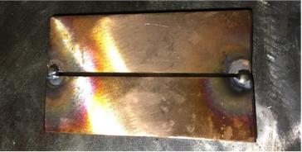Figure 7.2: Backing Plate Used in Copper Welding

O n e o f t h e m a j o r c h a l l e n g e s i n c o p p e r w e l d i n g i s i t s h i g h t h e r m a l e x p a n s i o n .
D u e t o t h i s c h a r a c t e r i s t i c , t h e h e a t a p p l i e d d u r i n g w e l d i n g c a u s e s v i s i b l e d e f o r m a t i o n i n t h e p a r t .
W h e n t h e h e a t i s r e m o v e d , c o p p e r c o n t r a c t s a t t h e s a m e r a t e , m a k i n g w e l d i n g m o r e d i f f i c u l t .
T h i s e x p a n s i o n a n d s u b s e q u e n t c o n t r a c t i o n c a n l e a d t o c r a c k i n g i n w e l d e d j o i n t s .

C o m p a r e d t o s t e e l a n d i t s a l l o y s , c o p p e r w e l d i n g r e q u i r e s :
A w i d e r g r o o v e a n g l e a n d r o o t g a p M o r e t a c k w e l d s
H i g h e r p r e h e a t i n g b e t w e e n p a s s e s

A d d i t i o n a l l y :
T h e l a r g e s t p o s s i b l e e l e c t r o d e d i a m e t e r s h o u l d b e s e l e c t e d b a s e d o n t h e t h i c k n e s s o f t h e m a t e r i a l .
W h e n e v e r p o s s i b l e , w e l d i n g s h o u l d b e d o n e i n t h e h o r i z o n t a l p o s i t i o n .

7 . 1 . 4 . C o p p e r W e l d i n g P r o c e s s
I n c o p p e r w e l d i n g , g r o o v e d e s i g n a n d a n g l e s g e n e r a l l y d o n o t
d i f f e r s i g n i f i c a n t l y f r o m t h o s e u s e d f o r s t e e l . P r e - W e l d P r e p a r a t i o n
F o r p a r t s u p t o 3 . 5 m m t h i c k , b u t t w e l d i n g w i t h o u t a r o o t g a p i s p o s s i b l e .
F o r t h i c k e r s e c t i o n s , a s i n g l e V - g r o o v e ( 6 0 - 9 0 ° ) o r a d o u b l e V - g r o o v e ( 7 0 - 9 0 ° ) s h o u l d b e u s e d .
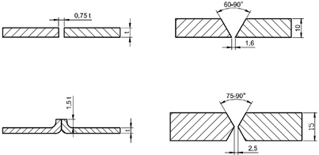
T h e r o o t g a p s h o u l d n o t e x c e e d 3 . 5 m m .

Figure 7.3: Weld Groove and Dimensions Used in Copper Welding

O i l , d i r t , a n d o x i d e s o n t h e s u r f a c e o f t h e p a r t s t o b e w e l d e d m u s t b e t h o r o u g h l y c l e a n e d u s i n g a w i r e b r u s h a n d s a n d i n g s t o n e b e f o r e w e l d i n g a n d t h e n d r i e d .
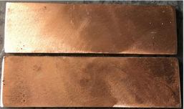
Figure 7.4: Cleaned Copper Surface

E l e c t r o d e s U s e d i n C o p p e r W e l d i n g
T h e c o p p e r a n d i t s a l l o y s a v a i l a b l e i n t h e m a r k e t h a v e d i f f e r e n t c h e m i c a l c o m p o s i t i o n s .
T o e n s u r e h i g h - q u a l i t y w e l d i n g , t h e e l e c t r o d e s u s e d m u s t b e c o m p a t i b l e w i t h t h e s e c h e m i c a l c o m p o s i t i o n s .
D u e t o t h i s , v a r i o u s t y p e s o f e l e c t r o d e s w i t h d i f f e r e n t c h e m i c a l c o m p o s i t i o n s a r e a v a i l a b l e .
E l e c t r o d e s a r e c l a s s i f i e d a c c o r d i n g t o t h e A m e r i c a n W e l d i n g S o c i e t y ( A W S ) s t a n d a r d A 5 . 6 .
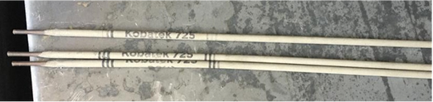
Figure 7.5: Copper Electrode
P u r e c o p p e r e l e c t r o d e s a r e u s e d f o r w e l d i n g p u r e c o p p e r , a s w e l l a s f o r r e p a i r w e l d i n g o f c o a t i n g s o n c a s t i r o n a n d s t e e l . S i l i c o n b r o n z e e l e c t r o d e s a r e u s e d f o r w e l d i n g b r a s s , c o p p e r , a n d s o m e i r o n - b a s e d a l l o y s .
P h o s p h o r b r o n z e e l e c t r o d e s a r e u s e d f o r w e l d i n g b r a s s a n d p h o s p h o r b r o n z e .
C o p p e r - n i c k e l a l l o y e l e c t r o d e s a r e u s e d f o r w e l d i n g c o p p e r -
n i c k e l a l l o y s a n d f o r a p p l y i n g c o p p e r - n i c k e l c o a t i n g s o n s t e e l .
A l u m i n u m b r o n z e e l e c t r o d e s a r e u s e d f o r w e l d i n g a l u m i n u m
b r o n z e , a s w e l l a s f o r j o i n i n g c o p p e r a l l o y s w i t h o t h e r t y p e s o f a l l o y s .

A r c L e n g t h , E l e c t r o d e M o v e m e n t s , a n d A m p e r a g e A d j u s t m e n t
I n s h i e l d e d m e t a l a r c w e l d i n g ( S M A W ) o f c o p p e r , t h e a r c l e n g t h ( t h e d i s t a n c e b e t w e e n t h e e l e c t r o d e a n d t h e w o r k p i e c e ) s h o u l d b e k e p t
s h o r t , g e n e r a l l y a r o u n d 3 m m .
T h e e l e c t r o d e s h o u l d b e h e l d a t a n a n g l e o f 6 0 - 8 0 d e g r e e s t o t h e w o r k p i e c e .

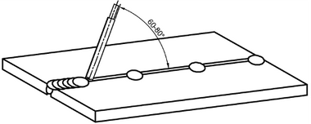

Figure 7.5: Electrode Angle in Copper Welding

T h e e l e c t r o d e s h o u l d b e g i v e n a s l i g h t o s c i l l a t i o n m o v e m e n t , b u t t h i s m o v e m e n t s h o u l d n o t e x c e e d t w i c e t h e e l e c t r o d e d i a m e t e r .
W e l d i n g s h o u l d b e p e r f o r m e d i n t h e h o r i z o n t a l p o s i t i o n w h e n e v e r p o s s i b l e .
T h e c u r r e n t s e t t i n g o n t h e w e l d i n g m a c h i n e s h o u l d b e 5 0 a m p s p e r m i l l i m e t e r o f e l e c t r o d e d i a m e t e r .
F o r m u l a f o r C a l c u l a t i n g C u r r e n t I n t e n s i t y : I = 5 0 × d I = 5 0 × d
W h e r e :
I = C u r r e n t i n t e n s i t y ( a m p e r e s ) 5 0 = C o n s t a n t c o e f f i c i e n t
d = E l e c t r o d e d i a m e t e r ( m m )

7 . 1 . 5 . A p p l i c a t i o n o f t h e W e l d i n g M e t h o d a n d P o s t - W e l d P r o c e d u r e s
- P r e - W e l d P r e p a r a t i o n
T h e e d g e s o f t h e w o r k p i e c e s s h o u l d b e t h o r o u g h l y c l e a n e d o f o i l , d i r t , a n d m o i s t u r e .
T h e a p p r o p r i a t e r o o t g a p s h o u l d b e l e f t , a n d t h e w e l d g r o o v e s h o u l d b e p r e p a r e d .
- W o r k p i e c e P o s i t i o n i n g
B a s e d o n t h e r o o t g a p , f l a t o r s p e c i a l l y s h a p e d b a c k i n g p l a t e s s h o u l d b e c l a m p e d t o t h e w o r k p i e c e s u s i n g a v i s e .
- P r e h e a t i n g
F o r m a t e r i a l s t h i c k e r t h a n 2 m m , p r e h e a t i n g b e t w e e n 2 0 0 - 3 0 0 ° C s h o u l d b e a p p l i e d .
A n e l e c t r o d e m a t c h i n g t h e c h e m i c a l c o m p o s i t i o n o f t h e m a t e r i a l a n d c l o s e t o t h e t h i c k n e s s o f t h e w o r k p i e c e s h o u l d b e s e l e c t e d .
T h e e l e c t r o d e s h o u l d b e c o n n e c t e d t o t h e p o s i t i v e ( + ) p o l e .

- W e l d i n g P r o c e s s
T h e c u r r e n t s h o u l d b e a d j u s t e d b a s e d o n t h e e l e c t r o d e d i a m e t e r . T h e a r c l e n g t h s h o u l d b e k e p t s h o r t .
T h e e l e c t r o d e s h o u l d b e h e l d a t a 6 0 - 8 0 ° a n g l e t o t h e w o r k p i e c e . A s m a l l o s c i l l a t i o n m o v e m e n t s h o u l d b e u s e d w h i l e w e l d i n g .
S l o w c o o l i n g s h o u l d b e e n s u r e d a f t e r w e l d i n g .
- P o s t - W e l d C l e a n i n g
S l a g s h o u l d b e r e m o v e d f r o m t h e w e l d e d j o i n t .
R a p i d c o o l i n g s h o u l d b e a v o i d e d t o p r e v e n t s h r i n k a g e a n d c r a c k i n g o f t h e w e l d m e t a l .
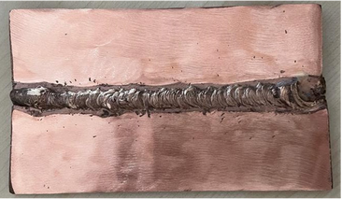
Figure 7.5: Copper Joint Welding

7 . 2 . B R A S S W E L D I N G
B r a s s i s a n a l l o y o f c o p p e r ( C u ) a n d z i n c ( Z n ) . I t s m e l t i n g
t e m p e r a t u r e v a r i e s d e p e n d i n g o n t h e z i n c c o n t e n t , a p p r o x i m a t e l y 9 0 0 ° C .

B r a s s A l l o y a n d I t s I n d u s t r i a l A p p l i c a t i o n s
B r a s s e s a r e g e n e r a l l y c a t e g o r i z e d i n t o t h r e e g r o u p s b a s e d o n t h e i r z i n c c o n t e n t a n d a l l o y i n g e l e m e n t s . I f t h e z i n c c o n t e n t i s b e l o w
2 0 % , i t i s c a l l e d l o w - z i n c ( r e d ) b r a s s , w h i l e i f i t e x c e e d s 2 0 % , i t i s r e f e r r e d t o a s h i g h - z i n c ( M u n t z m e t a l ) b r a s s . I n a d d i t i o n t o c o p p e r a n d z i n c , e l e m e n t s s u c h a s t i n ( S n ) , m a n g a n e s e ( M n ) , a l u m i n u m
( A l ) , i r o n ( F e ) , a n d p h o s p h o r u s ( P ) c a n b e i n c l u d e d i n t h e c o m p o s i t i o n , f o r m i n g l o w - a l l o y e d b r a s s e s .
T h e i r r e s i s t a n c e t o m a c h i n i n g , c o l d f o r m i n g , a n d e x t e r n a l e f f e c t s a r e a m o n g t h e i r m o s t i m p o r t a n t p r o p e r t i e s . H i g h f a t i g u e s t r e n g t h , g o o d m e c h a n i c a l p r o p e r t i e s , a n d a f f o r d a b i l i t y m a k e t h e m s u i t a b l e f o r u s e i n t h e d e f e n s e i n d u s t r y , s h i p b u i l d i n g , l i g h t b u l b s o c k e t s , m u s i c a l i n s t r u m e n t c o m p o n e n t s , a n d s c r e w m a n u f a c t u r i n g .
T h e I m p o r t a n c e o f B r a s s W e l d i n g i n I n d u s t r y
B r a s s h a s a b r o a d r a n g e o f c o p p e r - z i n c a l l o y s , w h i c h c a n f u r t h e r e x p a n d w i t h t h e a d d i t i o n o f l e a d , a l u m i n u m , t i n , p h o s p h o r u s ,
s i l i c o n , a n d m a n g a n e s e . T h i s r e s u l t s i n a v a r i e t y o f d i f f e r e n t
w e l d i n g b e h a v i o r s . 60

S i n c e l e a d - c o n t a i n i n g m a n u f a c t u r i n g b r a s s e s t e n d t o f o r m p o r o u s s t r u c t u r e s a n d b e c o m e b r i t t l e a t h i g h t e m p e r a t u r e s , t h e y a r e
p r e f e r a b l y j o i n e d u s i n g s o l d e r i n g i n s t e a d o f w e l d i n g . A d d i t i o n a l l y , d u e t o t h e f o r m a t i o n o f a b r i t t l e a l u m i n u m l a y e r d u r i n g w e l d i n g , t h e M I G o r T I G w e l d i n g m e t h o d s a r e p r e f e r r e d .
W h e n t h e c o r r e c t e l e c t r o d e s e l e c t i o n i s m a d e b a s e d o n t h e z i n c
c o n t e n t a n d a l l o y i n g e l e m e n t s , h i g h - q u a l i t y w e l d s c a n b e a c h i e v e d
u s i n g s h i e l d e d m e t a l a r c w e l d i n g ( S M A W ) . F u r t h e r m o r e , t h i s m e t h o d i s a p p l i c a b l e w h e r e h i g h t e n s i l e a n d f a t i g u e r e s i s t a n c e a r e
r e q u i r e d .

7 . 2 . 1 . I m p o r t a n c e o f R e v e r s e P o l a r i t y i n B r a s s W e l d i n g
A n e l e c t r o d e s u i t a b l e f o r t h e b r a s s a l l o y i s s e l e c t e d a n d c o n n e c t e d t o t h e p o s i t i v e ( + ) t e r m i n a l .

7 . 2 . 2 . P r e h e a t i n g
B e f o r e w e l d i n g , b r a s s p a r t s a r e p r e h e a t e d t o 2 0 0 - 3 0 0 ° C . S i n c e
s i l i c o n - c o n t a i n i n g b r a s s e s a r e b r i t t l e , p r e h e a t i n g i s n o t a p p l i e d t o
t h e m . T h e i n t e r p a s s t e m p e r a t u r e s h o u l d n o t e x c e e d 9 3 ° C .

7 . 2 . 3 . I m p o r t a n c e o f V e n t i l a t i o n A g a i n s t Z i n c E v a p o r a t i o n
S i n c e t h e p r i m a r y m e t a l i n b r a s s i s c o p p e r , b r a s s w e l d i n g e x h i b i t s
c h a r a c t e r i s t i c s s i m i l a r t o c o p p e r w e l d i n g . H o w e v e r , t h e p r e s e n c e o f z i n c m a k e s w e l d i n g m o r e c h a l l e n g i n g . T h e w e l d i n g t e m p e r a t u r e
( 9 0 0 ° C ) i s h i g h e r t h a n z i n c ' s m e l t i n g p o i n t ( 4 2 0 ° C ) , a n d a s t h e
w e l d i n g p r o c e s s p r o g r e s s e s , z i n c b e g i n s t o e v a p o r a t e ( a t 9 0 5 ° C ) , a l t e r i n g t h e a l l o y ' s c h e m i c a l c o m p o s i t i o n .
I f p r o p e r v e n t i l a t i o n i s n o t e n s u r e d , t h e w e l d e r m a y b e e x p o s e d t o h a r m f u l z i n c o x i d e f u m e s . A d d i t i o n a l l y , z i n c o x i d e f u m e s o b s c u r e v i s i o n , h i n d e r t h e f l o w o f m o l t e n m e t a l , a n d p r e v e n t t h e p r o p e r
w e t t i n g o f t h e w e l d i n g s u r f a c e . E x c e s s i v e e v a p o r a t i o n l e a d s t o s i g n i f i c a n t z i n c l o s s , w h i c h a f f e c t s t h e p h y s i c a l a n d m e c h a n i c a l p r o p e r t i e s o f t h e b a s e m e t a l . T o a c h i e v e t h e b e s t r e s u l t s a n d
m i n i m i z e z i n c e v a p o r a t i o n , w e l d i n g s h o u l d b e p e r f o r m e d i n a
h o r i z o n t a l p o s i t i o n , u s i n g t h e l a r g e s t p o s s i b l e e l e c t r o d e d i a m e t e r a n d a p p l y i n g f a s t w e l d p a s s e s .

7 . 2 . 4 . B r a s s W e l d i n g P r o c e s s
B e f o r e w e l d i n g , s u r f a c e c l e a n i n g m u s t b e p e r f o r m e d .
C l e a n i n g o f B r a s s C o m p o n e n t s B e f o r e W e l d i n g
A s i n c o p p e r w e l d i n g , a n y g r e a s e , d i r t , a n d o x i d e s o n t h e s u r f a c e o f b r a s s m a t e r i a l s m u s t b e t h o r o u g h l y c l e a n e d u s i n g a w i r e b r u s h a n d g r i n d i n g s t o n e . I f t h e s e c o n t a m i n a n t s a r e n o t r e m o v e d , t h e y r e d u c e w e l d s t r e n g t h a n d c o m p l i c a t e t h e w e l d i n g p r o c e s s .

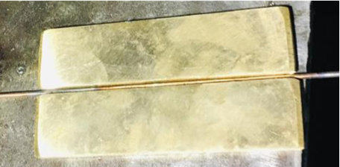Figure 7.6: Copper Joint Welding

E l e c t r o d e s U s e d i n B r a s s W e l d i n g
T h e e l e c t r o d e s u s e d i n b r a s s w e l d i n g a r e s e l e c t e d b a s e d o n t h e z i n c c o n t e n t a n d t h e d e s i r e d p r o p e r t i e s o f t h e w e l d s e a m .
I f t h e z i n c c o n t e n t i s b e l o w 2 0 % , p h o s p h o r b r o n z e [ ( E C u S n - A ) a n d ( E C u S n - C ) ] o r s i l i c o n b r o n z e ( E C u S i ) e l e c t r o d e s a r e
u s e d .
I f t h e z i n c c o n t e n t e x c e e d s 2 0 % , p h o s p h o r b r o n z e a n d s i l i c o n b r o n z e e l e c t r o d e s , a s w e l l a s a l u m i n u m b r o n z e ( E C u A l A 2 )
e l e c t r o d e s , c a n b e u s e d .
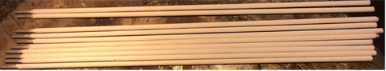
Figure 7.7: Brass Electrode
A l u m i n u m b r o n z e e l e c t r o d e s a r e u s e d i n c a s e s w h e r e h i g h t e n s i l e s t r e n g t h , f a t i g u e r e s i s t a n c e , a n d g o o d c o r r o s i o n r e s i s t a n c e a r e
r e q u i r e d . M e d i u m - q u a l i t y w e l d s c a n b e a c h i e v e d w i t h s i l i c o n b r o n z e a n d a l u m i n u m b r o n z e e l e c t r o d e s .

W e l d G r o o v e S h a p e s a n d D i m e n s i o n s i n B r a s s W e l d i n g
F o r b r a s s m a t e r i a l s u p t o 4 m m i n t h i c k n e s s , b u t t w e l d i n g i s a p p l i e d .
F o r t h i c k e r m a t e r i a l s , a 6 0 - d e g r e e s i n g l e o r d o u b l e - s i d e d V - g r o o v e i s c r e a t e d .
W e l d i n g i s g e n e r a l l y p e r f o r m e d i n a h o r i z o n t a l p o s i t i o n .
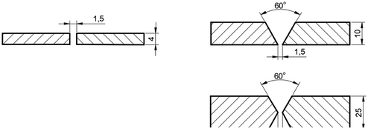
C o m p a r e d t o s t e e l m a t e r i a l s , a w i d e r g a p i s l e f t b e t w e e n t h e t w o m a t e r i a l s .

Figure 7.8: Weld Groove Shapes and Dimensions Used in Brass Welding

E l e c t r o d e A r c L e n g t h , M o v e m e n t s , a n d A m p e r a g e S e t t i n g
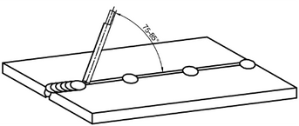
I n t h e w e l d i n g o f b r a s s m a t e r i a l s , t h e a r c l e n g t h s h o u l d b e k e p t s h o r t . T o p r e v e n t z i n c v a p o r i z a t i o n , t h e w e l d p o o l s h o u l d b e k e p t a s s m a l l a s p o s s i b l e . E x c e s s i v e o s c i l l a t i o n m o v e m e n t o f t h e e l e c t r o d e s h o u l d b e a v o i d e d . T h e h o r i z o n t a l a n g l e b e t w e e n t h e e l e c t r o d e a n d t h e m a t e r i a l s h o u l d b e b e t w e e n 7 5 - 8 5 d e g r e e s .
Figure 7.9: Angle to be Given to the Electrode in Brass Welding

T h e a m p e r a g e s e t t i n g i s c a l c u l a t e d u s i n g t h e f o l l o w i n g f o r m u l a , a s i n c o p p e r w e l d i n g :
d : E l e c t r o d e d i a m e t e r I : A m p e r a g e s e t t i n g
I = 5 0 × d

7 . 2 . 5 . A p p l i c a t i o n o f t h e W e l d i n g M e t h o d a n d P o s t - W e l d i n g P r o c e d u r e s
- T h e o i l a n d d i r t o n t h e e d g e s o f t h e m a t e r i a l s t o b e w e l d e d a r e
c l e a n e d . F o r m a t e r i a l s t h i c k e r t h a n 4 m m , a 6 0 - d e g r e e s i n g l e o r
d o u b l e - s i d e d V g r o o v e i s o p e n e d , a n d a w i d e r g a p i s l e f t b e t w e e n t h e m a t e r i a l s c o m p a r e d t o s t e e l m a t e r i a l s .
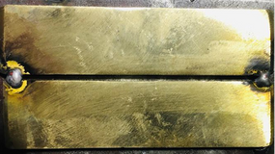
Figure 7.10: Weld Groove Shapes and Dimensions Used in Brass Welding

T h e e l e c t r o d e i s h e l d a t a n g l e s o f 7 5 - 8 5 d e g r e e s t o t h e m a t e r i a l s a n d w e l d e d i n a h o r i z o n t a l p o s i t i o n w i t h a s h o r t a r c l e n g t h a n d m i n i m a l o s c i l l a t i o n m o v e m e n t .
- Z i n c v a p o r i z a t i o n m a y o c c u r d u r i n g w e l d i n g , w h i c h i s h a r m f u l t o h u m a n h e a l t h . T h e r e f o r e , t h e w e l d i n g e n v i r o n m e n t m u s t b e v e r y w e l l v e n t i l a t e d .
- T h e w e l d e d p i e c e i s c o o l e d s l o w l y , a n d t h e w e l d i n g s l a g i s b r o k e n a n d c l e a n e d .

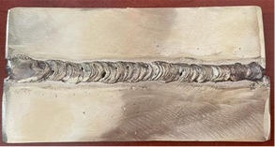

Figure 7.11: Brass Joint Welding

7 . 3 . W E L D I N G O F A L U M I N U M A N D I T S A L L O Y S
A f t e r s t e e l , t h e m o s t c o n s u m e d m e t a l l i c m a t e r i a l i s a l u m i n u m ( A l ) a n d i t s a l l o y s . I t i s a s i l v e r - c o l o r e d m e t a l w i t h a m e l t i n g p o i n t o f
6 6 0 ° C . P u r e a l u m i n u m i s s o f t a n d h a s o n e - t h i r d t h e w e i g h t o f s t e e l .
D u e t o i t s s e n s i t i v i t y t o o x y g e n , i t f o r m s a s t r o n g a n d t h i n o x i d e l a y e r ( A l ₂ O ₃ ) o n i t s s u r f a c e , w h i c h m a k e s i t h i g h l y r e s i s t a n t t o
o x i d a t i o n a n d p r o t e c t s i t f r o m e x t e r n a l f a c t o r s .
A l u m i n u m i s p r o d u c e d f r o m b a u x i t e , t h e m o s t a b u n d a n t o r e .
D e p e n d i n g o n t h e e l e m e n t s c o n t a i n e d , b a u x i t e i s c l a s s i f i e d i n t o f o u r g r o u p s : w h i t e b a u x i t e , r e d b a u x i t e , s i l i c e o u s r e d b a u x i t e , a n d b r o w n b a u x i t e . I n g e n e r a l , a l u m i n u m a l l o y s a r e d i v i d e d i n t o t w o g r o u p s :
h e a t - t r e a t a b l e a l l o y s a n d n o n - h e a t - t r e a t a b l e a l l o y s .
T h e R o l e a n d I m p o r t a n c e o f A l u m i n u m W e l d i n g i n I n d u s t r y
D u e t o i t s l i g h t w e i g h t , g o o d t h e r m a l a n d e l e c t r i c a l c o n d u c t i v i t y , a n d c o r r o s i o n r e s i s t a n c e , a l u m i n u m i s w i d e l y u s e d i n t h e f o o d i n d u s t r y , c h e m i c a l i n d u s t r y , a u t o m o t i v e a n d s h i p b u i l d i n g i n d u s t r y , m a c h i n e r y a n d e q u i p m e n t m a n u f a c t u r i n g , a s w e l l a s a r c h i t e c t u r a l a p p l i c a t i o n s a n d c o n s t r u c t i o n .
T o d a y , a p p r o x i m a t e l y 5 0 % o f a l u m i n u m a l l o y j o i n t s i n v a r i o u s
i n d u s t r i e s a r e m a d e u s i n g w e l d i n g . S h i e l d e d m e t a l a r c w e l d i n g
( S M A W ) f o r a l u m i n u m i s n o t c o m m o n l y u s e d a s i t g e n e r a l l y d o e s n o t m e e t t h e d e s i r e d c o n d i t i o n s .

7 . 3 . 1 . T h e I m p o r t a n c e o f R e v e r s e P o l a r i t y i n A l u m i n u m a n d A l l o y W e l d i n g
I n w e l d i n g w i t h d i r e c t c u r r e n t ( D C ) p o w e r s o u r c e s , t h e e l e c t r o d e i s c o n n e c t e d t o t h e p o s i t i v e ( + ) t e r m i n a l .

7 . 3 . 2 . D r y i n g E l e c t r o d e s B e f o r e W e l d i n g
A c c o r d i n g t o t h e A m e r i c a n W e l d i n g S o c i e t y ( A W S ) A 5 . 3 s t a n d a r d , t w o t y p e s o f e l e c t r o d e s a r e u s e d i n t h e e l e c t r i c a r c w e l d i n g o f
a l u m i n u m : E 1 1 0 0 a n d E 4 0 4 3 . A l l o y 1 1 0 0 i s c o m m e r c i a l l y p u r e ( 9 9 % ) a l u m i n u m , w h i l e a l l o y 4 0 4 3 c o n t a i n s 9 5 % a l u m i n u m a n d 5 % s i l i c o n
a n d i s s u i t a b l e f o r m o s t g e n e r a l - p u r p o s e a p p l i c a t i o n s .

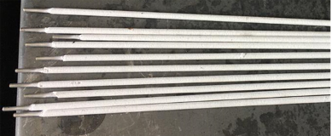

Figure 7.12: Aluminum Electrode

T h e w e l d m e t a l h a s s t r e n g t h . W h e n c o r r o s i o n r e s i s t a n c e i s
r e q u i r e d , a n e l e c t r o d e w i t h p r o p e r t i e s s i m i l a r t o t h e m a t e r i a l b e i n g w e l d e d s h o u l d b e s e l e c t e d . E l e c t r o d e s s h o u l d b e s t o r e d i n d r y
e n v i r o n m e n t s . M o i s t e l e c t r o d e s c a u s e p o r o s i t y i n t h e w e l d s e a m . T h e r e f o r e , e l e c t r o d e s t h a t a r e n o t c o m p l e t e l y d r y s h o u l d b e b a k e d i n a n o v e n a t 1 7 5 - 2 0 0 ° C f o r a b o u t o n e h o u r t o d r y t h e m p r o p e r l y . 7 . 3 . 3 . C l e a n i n g A l u m i n u m a n d I t s A l l o y s ' S u r f a c e s w i t h

M e c h a n i c a l a n d C h e m i c a l S o l u t i o n s
T h e p a r t s t o b e w e l d e d u s u a l l y a r r i v e a t t h e w e l d e r ' s s t a t i o n a f t e r b e i n g c u t a n d s h a p e d . T h e s e p r o c e s s e s c a u s e t h e f o r m a t i o n o f o i l l a y e r s , d u s t , a n d b u r r s o n t h e m a t e r i a l s u r f a c e .
T h e h y d r o g e n , o x y g e n , a n d p o r o s i t y f o u n d i n o i l s a n d g r e a s e s c r e a t e f o a m , r e d u c i n g w e l d i n g q u a l i t y . T h e r e f o r e , o i l s o n t h e
s u r f a c e o f t h e m a t e r i a l a r e r e m o v e d c h e m i c a l l y , w h i l e c h e m i c a l l y
f o r m e d d u s t a n d b u r r s a r e c l e a n e d m e c h a n i c a l l y . T h e w e l d i n g j o i n t a r e a s h o u l d b e c l e a n e d w i t h a s t a i n l e s s s t e e l w i r e b r u s h , a n d t o
c o m p l e t e l y r e m o v e t h e o x i d e l a y e r f r o m t h e s u r f a c e , t h e a r e a m u s t b e s c r a p e d ( s e e F i g u r e 7 . 1 3 ) .
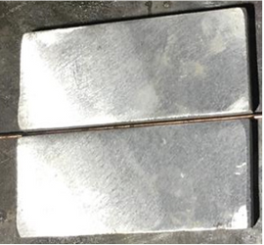
Figure 7.13: Aluminum part with a cleaned surface

7 . 3 . 4 . T h e P r o c e s s o f W e l d i n g A l u m i n u m a n d I t s A l l o y s
T h e s h i e l d e d e l e c t r o d e e l e c t r i c a r c w e l d i n g m e t h o d c a n b e u s e d f o r w e l d i n g a l l t y p e s o f a l u m i n u m a n d n o n - h e a t - t r e a t a b l e a l l o y s .
A l u m i n u m h a s a s t r o n g t e n d e n c y t o a b s o r b o x y g e n , e s p e c i a l l y a t h i g h t e m p e r a t u r e s . A l t h o u g h t h e o x i d e l a y e r t h a t f o r m s o n t h e
s u r f a c e i s b e n e f i c i a l , i t c a u s e s s i g n i f i c a n t p r o b l e m s d u r i n g t h e w e l d i n g p r o c e s s . T h i s i s b e c a u s e t h e m e l t i n g p o i n t o f t h e o x i d e l a y e r ( 2 1 0 0 ° C ) i s m u c h h i g h e r t h a n t h a t o f a l u m i n u m . D u r i n g
w e l d i n g , e x c e s s i v e h e a t i s r e q u i r e d t o m e l t t h e o x i d e , c a u s i n g t h e b a s e m e t a l t o m e l t s u d d e n l y a n d c o l l a p s e . T o a d d r e s s t h i s i s s u e , t h e o x i d e l a y e r o n t h e s u r f a c e o f t h e a l u m i n u m m u s t b e r e m o v e d b e f o r e w e l d i n g .
T h e h i g h t e n s i l e s t r e s s e s o f a l u m i n u m a l l o y s a n d t h e l a c k o f p r o p e r f i x a t i o n o f t h e p i e c e s t o b e j o i n e d c a n l e a d t o t h e f o r m a t i o n o f h o t
c r a c k s i n t h e w e l d m e t a l . T h e s e c r a c k s c a n b e m i n i m i z e d b y p r e h e a t i n g , m o d i f y i n g t h e j o i n t d e s i g n , a n d s e l e c t i n g a m o r e s u i t a b l e e l e c t r o d e .
A l u m i n u m m a t e r i a l s a r e g e n e r a l l y n o t t a c k - w e l d e d u n l e s s
n e c e s s a r y , a n d a s i n g l e - p a s s w e l d b e a d i s p r e f e r r e d . T h i s i s
b e c a u s e a l u m i n u m o x i d i z e s q u i c k l y w h e n e x p o s e d t o h e a t , r e q u i r i n g r e p e a t e d c l e a n i n g w h e n t a c k w e l d i n g o r p e r f o r m i n g m u l t i p l e w e l d
p a s s e s . I n s t e a d , a l u m i n u m m a t e r i a l s a r e s e c u r e d u s i n g w e i g h t s a n d v a r i o u s f a s t e n i n g e l e m e n t s . A f t e r t a c k w e l d i n g a n d b e a d
a p p l i c a t i o n , a c r a t e r f o r m s a t t h e t i p o f t h e e l e c t r o d e , c o v e r i n g i t s
e n d a n d p r e v e n t i n g a r c f o r m a t i o n . T h e r e f o r e , t h e c r a t e r a t t h e t i p o f t h e e l e c t r o d e m u s t b e o p e n e d w i t h a s i d e c h i s e l .
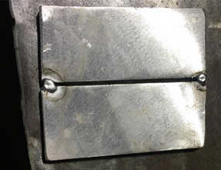
Figure 7.14: Backing used in aluminum welding.

T h e I m p o r t a n c e o f W e l d S e a m C l e a n i n g i n A l u m i n u m W e l d i n g
T h i c k a l u m i n u m m a t e r i a l s n e e d t o b e w e l d e d w i t h m u l t i p l e p a s s e s . T h e r e f o r e , s l a g m u s t b e t h o r o u g h l y c l e a n e d a f t e r e a c h p a s s .

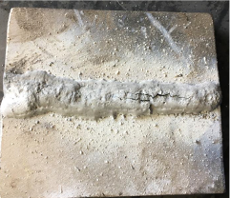
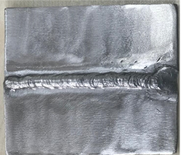
Figure 7.15: Weld Seam Cleaning in Aluminum Welding
a) Slag not cleaned b) Slag cleaned

O t h e r w i s e , s l a g r e s i d u e s w i l l f o r m a n d m a y c a u s e c r a c k s . T h e s l a g f o r m e d m u s t b e t h o r o u g h l y c l e a n e d a f t e r e a c h w e l d s e a m u s i n g a
p o i n t e d w e l d i n g c h i s e l o r a w i r e b r u s h . A d d i t i o n a l l y , t h e w e l d
s u r f a c e s h o u l d b e s c r a p e d t o r e m o v e t h e o x i d e l a y e r f o r m e d d u r i n g w e l d i n g . T h e s e p r o c e s s e s a r e e s s e n t i a l f o r t h e s t r e n g t h o f t h e w e l d . W e l d G r o o v e P r e p a r a t i o n f o r A l u m i n u m M a t e r i a l s
F o r m a t e r i a l s u p t o 4 . 5 - 5 m m i n t h i c k n e s s , a s q u a r e b u t t w e l d i s a p p l i e d . I f t h e e d g e s a r e c u t p r e c i s e l y a n d s q u a r e l y , n o
a d d i t i o n a l p r e p a r a t i o n i s r e q u i r e d .
F o r t h i c k e r m a t e r i a l s , a s i n g l e o r d o u b l e - s i d e d V - g r o o v e i s p r e p a r e d a t a n a n g l e o f 6 0 - 9 0 d e g r e e s .
D e p e n d i n g o n t h e t h i c k n e s s , t h e r o o t f a c e i s s e t b e t w e e n 1 . 5 - 6 m m , a n d t h e r o o t g a p i s b e t w e e n 0 . 8 - 1 . 5 m m .
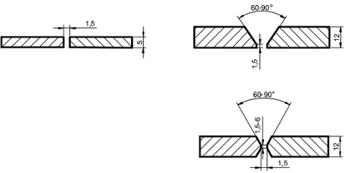
Figure 7.16: Weld Groove Shapes and Dimensions Used in Aluminum Welding

P r e h e a t i n g i n A l u m i n u m W e l d i n g
G e n e r a l l y , p r e h e a t i n g i s n o t a p p l i e d t o m a t e r i a l s w i t h a t h i c k n e s s o f u p t o 5 m m .
F o r a l u m i n u m m a t e r i a l s t h i c k e r t h a n 5 m m , p r e h e a t i n g a r o u n d 2 0 0 ° C i s a p p l i e d .
T h i s p r o c e s s c a n b e c a r r i e d o u t u s i n g a n o x y - a c e t y l e n e f l a m e .

. 3 . 5 . A p p l i c a t i o n o f t h e W e l d i n g M e t h o d a n d P o s t - W e l d i n g P r o c e d u r e s
T h e w e l d g r o o v e s o f t h e p a r t s t o b e w e l d e d a r e p r e p a r e d , a n d s u r f a c e c l e a n i n g i s p e r f o r m e d b e f o r e w e l d i n g
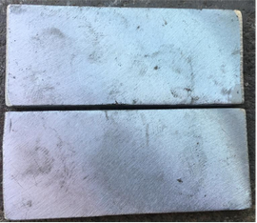
Figure 7.17: Aluminum part with surface cleaning

A f t e r t h e c l e a n i n g p r o c e s s , w e l d i n g s h o u l d b e p e r f o r m e d w i t h o u t d e l a y .
  - T o p r e v e n t i n t e r n a l s t r e s s e s a n d d i s t o r t i o n s , t h e p a r t s a r e t a c k - w e l d e d o r f i x e d w i t h w e i g h t s . A f t e r t a c k w e l d i n g , t h e s a m e i n i t i a l c l e a n i n g p r o c e s s i s r e p e a t e d .
  - S i n c e b o t h t h e a l u m i n u m e l e c t r o d e a n d t h e b a s e m e t a l m e l t a n d s o l i d i f y q u i c k l y , e l e c t r o d e s t i c k i n g c a n b e a n i s s u e . T h e r e f o r e , t h e e l e c t r o d e i s i g n i t e d b y m a k i n g a b r u s h i n g m o t i o n o n t h e s u r f a c e o f t h e b a s e m e t a l .
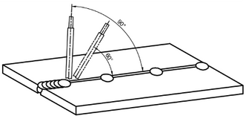
  - T h e e l e c t r o d e s h o u l d b e h e l d a t 9 0 d e g r e e s i n i t i a l l y a n d t h e n a t 6 0 d e g r e e s i n t h e d i r e c t i o n o f t h e w e l d s e a m a s w e l d i n g
p r o g r e s s e s .

Figure 7.18: Holding the electrode at a 90-degree angle initially and at a 60- degree angle as welding progresses.

T h e e l e c t r o d e s h o u l d n o t b e t i l t e d t o o m u c h a s i t c a u s e s p o r o s i t y a n d s p a t t e r i n g .
- C a r e s h o u l d b e t a k e n t o c o n t r o l t h e e l e c t r o d e s o t h a t t h e s l a g f l o a t s o n t h e w e l d p o o l .
- T h e e l e c t r o d e s h o u l d n o t b e m o v e d e x c e s s i v e l y f r o m s i d e t o s i d e .
- T h e a r c l e n g t h s h o u l d b e s h o r t ( 3 - 5 m m ) t o p r e v e n t e x c e s s i v e m e l t i n g .
- I f p o s s i b l e , a s i n g l e - p a s s w e l d s h o u l d b e p r e f e r r e d . M u l t i p l e p a s s e s a r e g e n e r a l l y a v o i d e d d u e t o p o t e n t i a l d i f f i c u l t i e s i n
c l e a n i n g t h e f l u x c o a t i n g f r o m t h e w e l d s u r f a c e .
- I f m u l t i p l e p a s s e s a r e r e q u i r e d , t h e s a m e c l e a n i n g p r o c e s s s h o u l d b e a p p l i e d a f t e r e a c h p a s s .
- T h e s l a g s h o u l d b e c l e a n e d a t t h e e n d o f t h e w e l d i n g p r o c e s s .
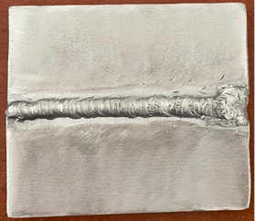

Figure 7.19: Aluminum Joint Welding

A t t h e e n d o f t h e w e l d i n g p r o c e s s , t h e s l a g f o r m e d o n t h e w e l d i s m e c h a n i c a l l y c l e a n e d u s i n g a w i r e b r u s h a n d a p o i n t e d c h i p p i n g h a m m e r .
- A d d i t i o n a l l y , t h e w e l d s e a m i s c l e a n e d b y a p p l y i n g s t e a m o r s c r u b b i n g w i t h h o t w a t e r .
- T h e p r e s e n c e o f s l a g r e s i d u e s b e t w e e n p a s s e s o r o n t h e s u r f a c e
i s c h e c k e d b y a p p l y i n g a 5 % s i l v e r n i t r a t e s o l u t i o n t o t h e w e l d a r e a . I f s l a g r e m a i n s , i t f o a m s a n d r e v e a l s i t s e l f .

P R E P A R E D B Y
I n n o w e l d
WELDING METHOD FOR
ALLOYED STEELS

LEARNING UNIT

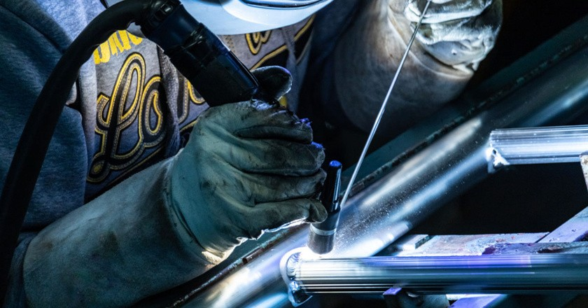

8 . 1 . W E L D I N G O F A L L O Y E D S T E E L S
8 . 2 . W E L D I N G O F S T A İ N L E S S S T E E L S
8 . 3 . W E L D I N G O F T O O L S T E E L S 70

8 . 1 . W E L D I N G O F A L L O Y S T E E L S
A l t h o u g h c a r b o n s t e e l s a r e e c o n o m i c a l t o p r o d u c e , t h e y d o n o t m e e t a l l r e q u i r e m e n t s . I n p a r t i c u l a r , d u e t o t h e i r l o w w e a r
r e s i s t a n c e a n d t o u g h n e s s p r o p e r t i e s , a l l o y i n g i s p e r f o r m e d t o e n h a n c e o r m o d i f y t h e d e s i r e d p r o p e r t i e s o f t h e s t e e l .

8 . 2 . W E L D I N G O F S T A I N L E S S S T E E L S
S t e e l s t h a t c o n t a i n 1 2 % o r m o r e c h r o m i u m a r e c a l l e d s t a i n l e s s
s t e e l s . A v e r y t h i n b u t i m p e r m e a b l e c h r o m i u m o x i d e ( C r ₂ O ₃ ) l a y e r f o r m s o n t h e s u r f a c e o f t h e s e s t e e l s , p r e v e n t i n g r u s t f r o m
p e n e t r a t i n g i n w a r d .
I f o n l y n i c k e l i s p r e s e n t a s a n a l l o y i n g e l e m e n t i n s t e e l , i t m a k e s
t h e s t e e l r e s i s t a n t t o c o r r o s i o n . H o w e v e r , t h e s y n e r g i s t i c s t r u c t u r e f o r m e d b y u s i n g n i c k e l t o g e t h e r w i t h c h r o m i u m p r o v i d e s m u c h
h i g h e r c o r r o s i o n r e s i s t a n c e . M o l y b d e n u m i s a n o t h e r e l e m e n t t h a t e n h a n c e s c o r r o s i o n r e s i s t a n c e , b u t i t i s e x p e n s i v e .
T h e d i f f e r e n t t y p e s o f s t a i n l e s s s t e e l s t r u c t u r e s a r e a s f o l l o w s : A u s t e n i t i c s t a i n l e s s s t e e l s
F e r r i t i c s t a i n l e s s s t e e l s
M a r t e n s i t i c s t a i n l e s s s t e e l s D u p l e x s t a i n l e s s s t e e l s
P r e c i p i t a t i o n - h a r d e n e d s t a i n l e s s s t e e l s

A r c W e l d i n g o f A u s t e n i t i c S t a i n l e s s S t e e l s
T h e w e l d i n g o f c h r o m i u m - n i c k e l s t a i n l e s s s t e e l s i n v o l v e s j o i n i n g t h e m w i t h o t h e r s t e e l s o r r o l l i n g p r o d u c t s t a i n l e s s s t e e l s . I f
s t a i n l e s s s t e e l p a r t s r e q u i r e r e p a i r s , w e l d i n g i s a g a i n u s e d . I n t h e w e l d i n g o f a u s t e n i t i c s t a i n l e s s s t e e l s , c o v e r e d e l e c t r o d e a r c
w e l d i n g , a s w e l l a s T I G a n d M I G w e l d i n g m e t h o d s , a r e c o m m o n l y u s e d .
C o v e r e d e l e c t r o d e a r c w e l d i n g i s f r e q u e n t l y a p p l i e d i n t h e w e l d i n g o f a u s t e n i t i c s t a i n l e s s s t e e l s , w h e r e e l e c t r o d e s w i t h s i m i l a r
c o m p o s i t i o n s a r e p r e f e r r e d . D u r i n g t h e p r o c e s s , p r o p e r w e l d i n g s e q u e n c e i s f o l l o w e d t o m i n i m i z e w e l d i n g s t r e s s e s . F o r t h i c k
s e c t i o n s , p r e h e a t i n g b e t w e e n 1 0 0 - 1 5 0 ° C a n d h a m m e r i n g t h e w e l d
b e a d a f t e r e a c h p a s s a r e m e t h o d s u s e d t o r e d u c e w e l d i n g s t r e s s e s .
T o p r e v e n t c a r b i d e p r e c i p i t a t i o n a n d s u b s e q u e n t i n t e r g r a n u l a r
c o r r o s i o n , t h e w e l d e d a r e a s h o u l d b e r a p i d l y c o o l e d . T h i s m e t h o d i s a p p l i e d o n l y t o s t e e l s c o n t a i n i n g m o r e t h a n 0 . 0 6 % c a r b o n . I n t h e
c a s e o f r e p a i r i n g c a s t i n g d e f e c t s i n s t a i n l e s s s t e e l c a s t i n g s , a
s o l u t i o n h e a t t r e a t m e n t a n d r a p i d c o o l i n g s h o u l d b e p e r f o r m e d a f t e r w e l d i n g . A n y h e a t t r e a t m e n t a p p l i e d t o t h e c a s t i n g m u s t a l s o b e
a p p l i e d a f t e r t h e r e p a i r .

A u s t e n i t i c c h r o m i u m - n i c k e l s t a i n l e s s s t e e l s a r e s u s c e p t i b l e t o h o t
c r a c k i n g , e s p e c i a l l y w h e n u s i n g c o v e r e d e l e c t r o d e a r c w e l d i n g . T h e p r e c a u t i o n s a n d c o n s i d e r a t i o n s t o a v o i d t h i s i n c l u d e :
S e l e c t i n g t h e s m a l l e s t p o s s i b l e e l e c t r o d e d i a m e t e r A p p l y i n g t h e l o w e s t c u r r e n t i n t e n s i t y
A v o i d i n g z i g z a g m o v e m e n t s o f t h e e l e c t r o d e a n d m a k i n g t h i n w e l d p a s s e s
C o o l i n g t h e w o r k p i e c e t o r o o m t e m p e r a t u r e b e t w e e n p a s s e s i n m u l t i - p a s s w e l d i n g
E n s u r i n g t h a t t h e c r a t e r a t t h e e n d o f t h e w e l d i s p r o p e r l y f i l l e d I f c r a c k s a r e d e t e c t e d , g r i n d i n g t h e m a w a y b e f o r e p r o c e e d i n g
w i t h w e l d i n g
F o r t h e s e s t e e l s , w e l d i n g m a t e r i a l s w i t h a h i g h m a n g a n e s e c o n t e n t a r e u s e d . E x p e r i m e n t s h a v e s h o w n t h a t a u s t e n i t i c w e l d s c o n t a i n i n g 7 - 1 0 % m a n g a n e s e p r o v i d e b e t t e r r e s i s t a n c e t o h o t c r a c k i n g a t h i g h t e m p e r a t u r e s .

A r c W e l d i n g o f F e r r i t i c S t a i n l e s s S t e e l s
F e r r i t i c s t a i n l e s s s t e e l s a r e b e s t w e l d e d u s i n g T I G , M I G , a n d p l a s m a w e l d i n g m e t h o d s , a s t h e y i n c o r p o r a t e a s h i e l d i n g g a s .
T h e r e f o r e , f e r r i t i c s t a i n l e s s s t e e l s a r e n o t w e l d e d u s i n g c o n v e n t i o n a l a r c w e l d i n g .

A r c W e l d i n g o f M a r t e n s i t i c S t a i n l e s s S t e e l s
V a r i o u s t y p e s o f e l e c t r o d e s a r e u s e d f o r m a n u a l w e l d i n g o f t h e s e s t e e l s . T h e c o m p o s i t i o n o f t h e s e e l e c t r o d e s m a y m a t c h t h a t o f t h e
b a s e m e t a l , b u t s o m e t i m e s t h e p r o p o r t i o n s o f e l e m e n t s l i k e c a r b o n , m a n g a n e s e , a n d c h r o m i u m a r e a d j u s t e d t o a c c o u n t f o r p o t e n t i a l
d e p l e t i o n i n t h e m o l t e n m e t a l .
F o r h i g h - c a r b o n s t e e l s ( C > 0 . 5 0 % ) , t h e c a r b o n c o n t e n t i s m o d i f i e d t o r e d u c e b r i t t l e n e s s a f t e r s o l i d i f i c a t i o n . T h e c o m p o s i t i o n o f t h e
m o l t e n m e t a l i s a l s o a d j u s t e d t o e n s u r e a h i g h a u s t e n i t e c o n t e n t , w h i c h p r o v i d e s s i g n i f i c a n t d u c t i l i t y . T h i s t y p e o f f i l l e r m e t a l i s
s u i t a b l e f o r h i g h - c a r b o n a n d p r e c i p i t a t i o n - h a r d e n e d s t e e l s b u t m a y n e g a t i v e l y a f f e c t w e a r r e s i s t a n c e i n a b r a s i v e e n v i r o n m e n t s .
T y p i c a l l y , b a s i c - c o a t e d e l e c t r o d e s ( + e l e c t r o d e ) a r e u s e d , a n d a
v e r y s h o r t a r c i s m a i n t a i n e d . I n d i f f i c u l t p o s i t i o n s ( s u c h a s v e r t i c a l o r o v e r h e a d w e l d i n g ) , l o w e r c u r r e n t i n t e n s i t y i s a p p l i e d . T h e
r e c o m m e n d e d c u r r e n t i n t e n s i t y v a r i e s d e p e n d i n g o n t h e s p e c i f i c w e l d i n g c o n d i t i o n s .

T h e j o i n t p r e p a r a t i o n f o r h i g h - a l l o y s t e e l s i s s i m i l a r t o t h a t o f
r e g u l a r s t e e l s . F o r t h i c k n e s s e s u p t o 3 m m , w e l d i n g c a n b e d o n e i n a s i n g l e p a s s , b u t i n s u c h c a s e s , a b a c k i n g p l a t e s h o u l d b e u s e d . I n m u l t i - p a s s w e l d i n g , p r o p e r f u s i o n o f t h e r o o t p a s s a n d t h e s u r f a c e
f i n i s h o f s u b s e q u e n t p a s s e s m u s t b e e n s u r e d . S l a g s h o u l d b e
t h o r o u g h l y c l e a n e d b e t w e e n p a s s e s u s i n g a s t a i n l e s s s t e e l b r u s h
a n d c h i s e l , e n s u r i n g t h a t t h e t e m p e r a t u r e o f t h e j o i n t d o e s n o t f a l l
b e l o w t h e p r e h e a t t e m p e r a t u r e .
C u r r e n t T y p e s , E l e c t r o d e M o v e m e n t s , A r c L e n g t h , a n d A m p e r a g e

S e t t i n g s i n S t a i n l e s s S t e e l W e l d i n g
A s h o r t a r c l e n g t h a n d l o w c u r r e n t i n t e n s i t y s h o u l d b e u s e d i n
w e l d i n g s t a i n l e s s s t e e l s . F o r c o v e r e d e l e c t r o d e w e l d i n g , e i t h e r D C w i t h a p o s i t i v e ( + ) e l e c t r o d e o r A C / D C e l e c t r o d e s i s c o m m o n l y
u s e d . R u t i l e e l e c t r o d e s a r e p r e f e r r e d f o r w e l d i n g t h i n s t a i n l e s s s t e e l s h e e t s i n f l a t p o s i t i o n s . H o w e v e r , w h e n m a t e r i a l t h i c k n e s s e x c e e d s 2 m m , b a s i c e l e c t r o d e s s h o u l d b e u s e d .
W i t h t e c h n o l o g i c a l a d v a n c e m e n t s , n e w e l e c t r o d e p r o d u c t s c o n t i n u e t o b e i n t r o d u c e d . B e f o r e s t a r t i n g t h e w e l d i n g p r o c e s s , t h e
i n f o r m a t i o n o n t h e e l e c t r o d e p a c k a g e s h o u l d b e r e v i e w e d t o e n s u r e i t m a t c h e s t h e w o r k p i e c e a n d w e l d i n g p o s i t i o n .
S t a i n l e s s s t e e l e l e c t r o d e s g e n e r a t e m o r e f u m e s c o m p a r e d t o o t h e r e l e c t r o d e s , s o s p e c i a l p r e c a u t i o n s s h o u l d b e t a k e n f o r h e a l t h a n d s a f e t y .
A f t e r w e l d i n g s t a i n l e s s s t e e l , t h e h i g h h e a t c a u s e s o x i d a t i o n a r o u n d t h e w e l d , r e s u l t i n g i n d i s c o l o r a t i o n o r d a r k e n i n g . T o r e m o v e t h i s
d i s c o l o r a t i o n , s p e c i a l p a s t e s a r e u s e d . S i n c e t h e s e p a s t e s c o n t a i n s t r o n g c h e m i c a l s , d i r e c t s k i n c o n t a c t s h o u l d b e a v o i d e d , a n d
n e c e s s a r y p r e c a u t i o n s s h o u l d b e t a k e n b e f o r e u s i n g t h e m .
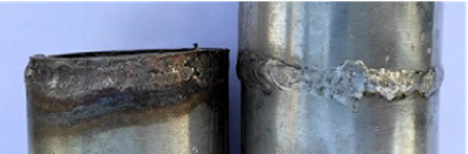

Figure 8.1: Oxidation of Stainless Steel Weld Metal

E l e c t r o d e S e l e c t i o n f o r S t a i n l e s s S t e e l W e l d i n g
T h e t y p e o f s t a i n l e s s s t e e l t o b e w e l d e d i s d e t e r m i n e d f r o m t h e i n f o r m a t i o n l a b e l o f t h e p a r t . T h e n , t h e a p p r o p r i a t e e l e c t r o d e i s s e l e c t e d b a s e d o n t h e i n f o r m a t i o n l a b e l o f t h e e l e c t r o d e .
I f t h e i n f o r m a t i o n m a t c h e s , w e l d i n g c a n p r o c e e d . T h e d e t e r m i n a t i o n o f m a t c h i n g i n f o r m a t i o n i s d o n e i n l i g h t o f t h e f o l l o w i n g d e t a i l s :
C a r b o n a n d a l l o y e d s t e e l s h a v e l o w e l e c t r i c a l c o n d u c t i v i t y
r e s i s t a n c e . I n s t a i n l e s s s t e e l s , t h i s v a l u e i s 4 t o 7 t i m e s h i g h e r . T h e r e f o r e , s t a i n l e s s s t e e l e l e c t r o d e s h e a t u p m o r e q u i c k l y , a r e p r o d u c e d s h o r t e r , a n d a r e l o a d e d w i t h a c u r r e n t i n t e n s i t y t h a t i s 2 5 % l o w e r c o m p a r e d t o n o r m a l e l e c t r o d e s .

. 2 . 1 . P r o c e s s S t e p s i n S t a i n l e s s S t e e l W e l d i n g
T h e a r e a t o b e w e l d e d m u s t f i r s t b e f r e e f r o m p a i n t , v a r n i s h , a n d o t h e r f o r e i g n s u b s t a n c e s . M o i s t u r e , s u l f u r , a n d o t h e r c h e m i c a l
s u b s t a n c e s n e g a t i v e l y a f f e c t t h e q u a l i t y o f t h e w e l d .
F o r h i g h - q u a l i t y w e l d i n g , t h e b e s t q u a l i t y s t a i n l e s s s t e e l m a t e r i a l a n d e l e c t r o d e s s h o u l d b e u s e d .
T h e w e l d i n g g r o o v e s h o u l d b e p r o p e r l y a n d a p p r o p r i a t e l y o p e n e d .
A g r i n d i n g t o o l o r s t a i n l e s s s t e e l w i r e b r u s h s h o u l d b e u s e d f o r c l e a n i n g w e l d i n g s l a g a n d s p a t t e r .
E l e c t r o d e s m u s t b e w e l l p r o t e c t e d f r o m m o i s t u r e . U n u s e d
e l e c t r o d e s s h o u l d b e s t o r e d i n s p e c i a l r a c k s o r d r y i n g o v e n s . T h e w e l d i n g g r o o v e s h o u l d b e d r i e d w i t h a t o r c h o r d r y a i r t o r e m o v e m o i s t u r e .
F o r 3 0 0 s e r i e s s t a i n l e s s s t e e l s , p r e h e a t i n g a n d p o s t - w e l d h e a t t r e a t m e n t a r e n o t r e q u i r e d .
T o k e e p t h e h e a t i n p u t l o w , s m a l l - d i a m e t e r e l e c t r o d e s s h o u l d b e u s e d .
E l e c t r o d e s c o m p a t i b l e w i t h t h e b a s e a l l o y o r o n e g r a d e h i g h e r i n t h e s a m e g r o u p s h o u l d b e u s e d .
I f p r o p e r p r e c a u t i o n s a r e n o t t a k e n d u r i n g c o o l i n g i n 3 0 0 s e r i e s s t a i n l e s s s t e e l w e l d i n g , c r a c k s m a y o c c u r i n t h e w e l d .
I n h o r i z o n t a l a n d f l a t w e l d i n g , t h e e l e c t r o d e s h o u l d b e h e l d a t a n a n g l e o f 1 5 0 d e g r e e s i n t h e w e l d i n g d i r e c t i o n , a n d a s h o r t a r c
l e n g t h s h o u l d b e m a i n t a i n e d .
I n v e r t i c a l w e l d i n g , t h e e l e c t r o d e s h o u l d b e h e l d p e r p e n d i c u l a r t o t h e p l a t e a n d m o v e d o v e r t h e f i r s t p a s s w i t h s l i g h t o s c i l l a t i o n s .
O v e r h e a d w e l d i n g s h o u l d b e p e r f o r m e d w i t h a s h o r t a r c a n d
w i t h o u t e x c e s s i v e e l e c t r o d e m o v e m e n t . 74

T h e b e s t w e a r r e s i s t a n c e i s a c h i e v e d w i t h l o w a m p e r a g e a n d d i r e c t c u r r e n t f l a t w e l d i n g .
V e r y l o w a m p e r a g e c a n c a u s e a n u n s t a b l e a r c , e l e c t r o d e
s t i c k i n g , s l a g f o r m a t i o n , a n d d i f f i c u l t c l e a n i n g , l e a d i n g t o l o s s e s i n w e a r r e s i s t a n c e .
V e r y h i g h a m p e r a g e o r a l o n g a r c l e n g t h c a n d i s t o r t t h e w e l d i n g s e q u e n c e a n d c a u s e c r a c k i n g .
I f t h e s l a g i s d i f f i c u l t t o c l e a n , t h e p o s s i b l e r e a s o n s c o u l d b e : T h e w e l d i n g g r o o v e i s d i r t y o r n a r r o w .
T h e w e l d i n g p a s s e s a r e n o t u n i f o r m . T h e e l e c t r o d e h a s a b s o r b e d m o i s t u r e . T h e w e l d h a s n o t f u l l y c o o l e d .
C r a c k i n g i n s t a i n l e s s s t e e l w e l d i n g c a n o c c u r d u e t o : C r a t e r f o r m a t i o n i n t h e p a s s e s .
L e a v i n g a l o n g a r c l e n g t h a t t h e s t a r t a n d e n d o f t h e w e l d . O v e r h e a t i n g t h e p a r t .
R a p i d w e l d i n g p a s s e s .
I n c o r r e c t w e l d i n g g r o o v e p r e p a r a t i o n . U s i n g t h e w r o n g e l e c t r o d e t y p e .
S i n c e s t a i n l e s s s t e e l i s s m o o t h a n d c l e a n , d e e p p e n e t r a t i o n i s n o t r e q u i r e d . E n s u r i n g c o m p l e t e f u s i o n i n t h e f i n a l p a s s e s i s
s u f f i c i e n t .

8 . 2 . 2 . A p p l i c a t i o n o f S t a i n l e s s S t e e l W e l d i n g a n d P o s t - W e l d P r o c e d u r e s
T h e a r e a t o b e w e l d e d i s f i r s t c l e a n e d o f p a i n t , v a r n i s h , a n d o t h e r f o r e i g n s u b s t a n c e s .
T h e h i g h e s t q u a l i t y s t a i n l e s s s t e e l m a t e r i a l a n d e l e c t r o d e s a r e u s e d f o r a h i g h - q u a l i t y w e l d .
T h e w e l d g r o o v e s p a c i n g i s a d j u s t e d .
A g r i n d i n g t o o l o r s t a i n l e s s s t e e l w i r e b r u s h i s u s e d t o c l e a n w e l d i n g s p a t t e r a n d s l a g .
E l e c t r o d e s a r e r e m o v e d f r o m t h e d r y i n g o v e n .
P r e h e a t i n g a n d p o s t - w e l d h e a t t r e a t m e n t a r e p e r f o r m e d .
I n h o r i z o n t a l a n d f l a t w e l d i n g , t h e e l e c t r o d e i s h e l d a t a n a n g l e
o f 1 5 0 d e g r e e s i n t h e w e l d i n g d i r e c t i o n , a n d a s h o r t a r c l e n g t h i s m a i n t a i n e d .
T h e e l e c t r o d e i s m o v e d a c r o s s t h e p l a t e w i t h s l i g h t o s c i l l a t i o n s . S l a g i s c l e a n e d a f t e r w e l d i n g

8 . 3 . W E L D I N G O F T O O L S T E E L S

A p p l i c a t i o n A r e a s o f T o o l S t e e l s
T o o l s t e e l s a r e g e n e r a l l y u s e d i n t h e p r o d u c t i o n o f v a r i o u s w o r k
t o o l s s u c h a s d r i l l s , d e e p d r a w i n g d i e s , p u n c h e s , a n d a l l t y p e s o f c u t t i n g b l a d e s . T h e r e f o r e , t h e y a r e p r i m a r i l y u t i l i z e d i n t h e
p r o c e s s i n g a n d s h a p i n g o f f u n d a m e n t a l m a t e r i a l s , e s p e c i a l l y m e t a l s .
W e l d i n g i s p e r f o r m e d o n t o o l s t e e l s f o u n d i n a l l p r o f e s s i o n a l w o r k s h o p s f o r t w o m a i n r e a s o n s :
R e p a i r a n d m a i n t e n a n c e o f w o r n - o u t p a r t s J o i n i n g o f b r o k e n t o o l s
I n c a s e s w h e r e w e l d i n g i s n e c e s s a r y , p r o p e r w e l d i n g p r e p a r a t i o n s s h o u l d b e c a r r i e d o u t b e f o r e p r o c e e d i n g w i t h t h e p r o c e s s .

8 . 3 . 1 . T h e W e l d i n g P r o c e s s o f T o o l S t e e l
T h e w e l d i n g o f t o o l s t e e l s i s n o t s i g n i f i c a n t l y d i f f e r e n t f r o m o t h e r w e l d i n g m e t h o d s . T h e m o s t c r u c i a l a s p e c t i s s e l e c t i n g t h e
a p p r o p r i a t e e l e c t r o d e f o r t h e s t e e l .
W h e n w e l d i n g t h e h a r d t i p t o o l s o f m a c h i n e r y , e l e c t r o d e s s h o u l d b e c h o s e n a c c o r d i n g t o t h e i r h a r d n e s s l e v e l . T h e s e e l e c t r o d e s i n c l u d e :
A u s t e n i t i c e l e c t r o d e s w i t h c a r b o n a n d n i c k e l f o r a r e a s e x p o s e d t o m i n i m a l w e a r .
H i g h - m a n g a n e s e e l e c t r o d e s f o r a r e a s e x p o s e d t o m o d e r a t e w e a r . H i g h - h a r d n e s s e l e c t r o d e s f o r a r e a s e x p o s e d t o e x t r e m e w e a r .
R e p a i r i n g W o r n P a r t s
W h e n f i l l i n g t h e w o r n p a r t s o f t o o l s t e e l s u s e d i n t h e c u t t i n g t e e t h o f c o n s t r u c t i o n m a c h i n e r y o r e x c a v a t o r b u c k e t s , e a c h p a s s s h o u l d b e l a i d p e r p e n d i c u l a r ( 9 0 d e g r e e s ) t o t h e p r e v i o u s o n e .
T o p r e v e n t c r a c k i n g , a s o f t e r e l e c t r o d e s h o u l d b e p r e f e r r e d b e t w e e n t h e b a s e m e t a l a n d t h e t o p l a y e r s . P r e h e a t i n g s h o u l d b e a p p l i e d
b e f o r e s t a r t i n g t h e w e l d i n g p r o c e s s . D u r i n g w e l d i n g , t h e h e a t f r o m t h e p r e v i o u s p a s s w i l l a c t a s p r e h e a t i n g f o r t h e n e x t p a s s .
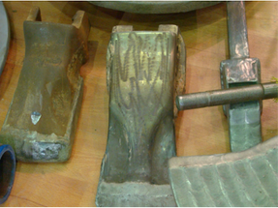

Figure 8.2: Welding of Worn Parts

E l e c t r o d e s U s e d i n t h e W e l d i n g o f T o o l S t e e l s
T h e r e a r e v a r i o u s t y p e s o f e l e c t r o d e s a v a i l a b l e o n t h e m a r k e t .
E l e c t r o d e s s h o u l d b e s e l e c t e d b a s e d o n t h e p r o p e r t i e s o f t h e t o o l s t e e l b y r e f e r r i n g t o t h e i n f o r m a t i o n p r o v i d e d o n t h e e l e c t r o d e
p a c k a g i n g .
P r e h e a t i n g i n t h e W e l d i n g o f T o o l S t e e l s
I n t h e w e l d i n g o f t o o l s t e e l s , p r e h e a t i n g i s a p p l i e d w i t h i n a r a n g e o f 1 0 0 t o 4 0 0 ° C , d e p e n d i n g o n t h e t y p e o f s t e e l m a t e r i a l .

8 . 3 . 2 . A p p l i c a t i o n o f T o o l S t e e l W e l d i n g a n d P o s t - W e l d i n g P r o c e s s e s
T h e w e l d e d p a r t s h o u l d b e c l e a n e d o f o x i d e , o i l , a n d d i r t . A n e l e c t r o d e s u i t a b l e f o r t o o l s t e e l s h o u l d b e s e l e c t e d .
T h i n p a r t s s h o u l d b e t a c k - w e l d e d w i t h a g a p . P r e h e a t i n g s h o u l d b e a p p l i e d .
A s h o r t a r c l e n g t h a n d s h o r t w e l d s s h o u l d b e u s e d w i t h o u t e x c e s s i v e e l e c t r o d e m o v e m e n t .

P R E P A R E D B Y
I n n o w e l d
WELDING OF
LARGE DIAMETER
PIPES

LEARNING UNIT

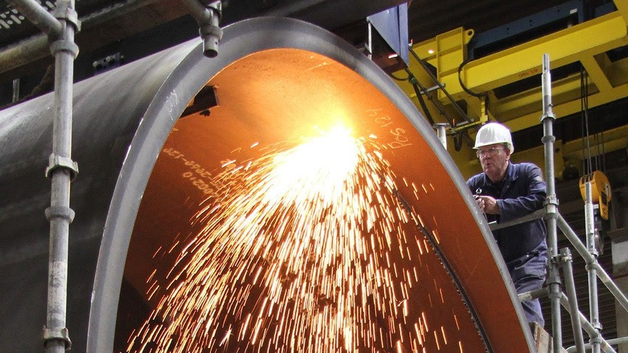

9 . 1 . L A R G E D İ A M E T E R P İ P E S
9 . 2 . B U T T W E L D İ N G O F L A R G E D İ A M E T E R P İ P E S
9 . 3 . F L A N G E W E L D İ N G O F L A R G E D İ A M E T E R P İ P E S
9 . 4 . T - W E L D İ N G O F L A R G E D İ A M E T E R P İ P E S
9 . 5 . L - W E L D İ N G O F L A R G E D İ A M E T E R P İ P E S 78

9 . 1 . L A R G E D I A M E T E R P I P E S
T h r o u g h o u t h i s t o r y , h u m a n s h a v e e m p l o y e d v a r i o u s m e t h o d s t o t r a n s p o r t w a t e r t o p l a c e s o f u s e , c o n s t r u c t i n g c h a n n e l s a n d
a q u e d u c t s .
A s t e c h n o l o g y h a s a d v a n c e d , n e e d s h a v e i n c r e a s e d , f a c t o r i e s h a v e b e e n b u i l t , c i t i e s h a v e g r o w n , a n d t h e v a r i e t y a n d q u a n t i t y o f f l u i d s t o b e t r a n s p o r t e d h a v e e x p a n d e d .

9 . 1 . 1 . T h e R o l e a n d I m p o r t a n c e o f L a r g e D i a m e t e r P i p e s i n I n d u s t r y
P i p e s a r e m a t e r i a l s u s e d t o t r a n s p o r t l i q u i d s , g a s e s , a n d s m a l l g r a n u l a r s o l i d s ( s u c h a s m i n e r a l s a n d f o o d ) f r o m o n e p l a c e t o a n o t h e r .
I n f a c t o r i e s , c i t i e s , a n d e v e n b e t w e e n c o u n t r i e s a n d c o n t i n e n t s ,
p i p e s a r e u s e d t o t r a n s p o r t w a t e r , s e w a g e , p e t r o l e u m , n a t u r a l g a s , a n d o t h e r f l u i d s u b s t a n c e s . A d d i t i o n a l l y , t h e y a r e u t i l i z e d i n t h e
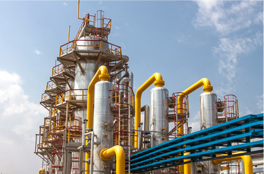
c o n s t r u c t i o n o f t u n n e l s , b u i l d i n g s , r o o f s , b r i d g e p l a t f o r m s , a n d o t h e r s t r u c t u r e s .

Figure 9.1: The Use of Large Diameter Pipes in Industry

P i p e s a r e m a n u f a c t u r e d f r o m d i f f e r e n t m a t e r i a l s d e p e n d i n g o n
w h e r e t h e y a r e u s e d a n d t h e c h a r a c t e r i s t i c s o f t h e f l u i d p a s s i n g t h r o u g h t h e m .
T h e t y p e s o f p i p e s b a s e d o n t h e m a t e r i a l s t h e y a r e m a d e o f a r e a s f o l l o w s :
S t e e l p i p e s ( W e l d e d a n d s e a m l e s s s t e e l p i p e s , F i g u r e 9 . 2 ) P V C p i p e s
C o n c r e t e p i p e s C a s t i r o n p i p e s
P i p e s m a d e f r o m c o p p e r a n d i t s a l l o y s
P i p e s m a d e f r o m a l u m i n u m a n d i t s a l l o y s

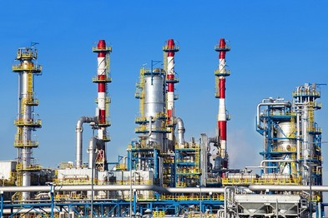

Figure 9.2: One of the Application Areas of Pipes

9 . 1 . 2 . L a r g e - D i a m e t e r P i p e s U s e d i n G a s a n d L i q u i d T r a n s m i s s i o n
R o u n d - s e c t i o n p i p e s a r e g e n e r a l l y u s e d f o r t r a n s m i t t i n g g a s e s a n d l i q u i d s . P i p e s a r e m a n u f a c t u r e d f r o m d i f f e r e n t m a t e r i a l s d e p e n d i n g o n t h e t y p e o f l i q u i d o r g a s t h e y c a r r y a n d a r e u s u a l l y n a m e d a f t e r t h e i r a p p l i c a t i o n a r e a s . T h e s e n a m e s i n c l u d e :
B o i l e r p i p e s W a t e r p i p e s
N a t u r a l g a s p i p e s
O i l p i p e l i n e s
P E - c o a t e d p i p e s
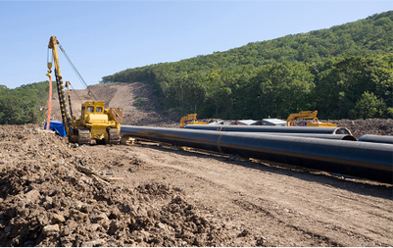
P P R C i n s t a l l a t i o n p i p e s U n d e r f l o o r h e a t i n g p i p e s S R M p i p e s

Figure 9.3: Oil Pipeline Installation

9 . 1 . 3 . L a r g e D i a m e t e r P i p e s i n S t e e l C o n s t r u c t i o n
R o u n d , s q u a r e , a n d r e c t a n g u l a r s e c t i o n p i p e s a r e u s e d i n t h e
c o n s t r u c t i o n o f r e s i d e n c e s , o f f i c e b u i l d i n g s , r o o f s , b r i d g e s , s t e e l
f u r n i t u r e , a u t o m o t i v e , a r c h i t e c t u r a l d e c o r a t i o n , e t c . T h e s e p i p e s a r e r e f e r r e d t o b y t h e f o l l o w i n g n a m e s :
S p e c i a l p i p e s
I n d u s t r i a l p i p e s
S q u a r e a n d r e c t a n g u l a r p r o f i l e s
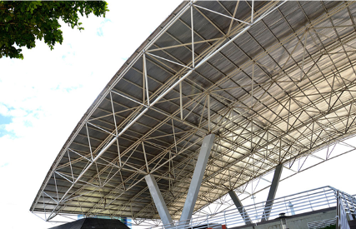
Figure 9.4: Steel structure

9 . 2 . B U T T W E L D I N G O F L A R G E - D I A M E T E R P I P E S
P i p e s u s e d i n l i q u i d a n d g a s t r a n s m i s s i o n l i n e s a r e j o i n e d b y b u t t w e l d i n g .

9 . 2 . 1 . F i t t i n g P a r t s i n B u t t W e l d i n g o f L a r g e - D i a m e t e r P i p e s
C u t a n d c l e a n e d p i p e s n e e d t o b e f i t t e d t o g e t h e r b e f o r e w e l d i n g .
O t h e r w i s e , w e l d i n g d e f e c t s m a y o c c u r . T o o l s u s e d f o r e d g e
p r e p a r a t i o n a n d c l e a n i n g c a n b e u t i l i z e d f o r t h e f i t t i n g p r o c e s s .

9 . 2 . 2 . B e v e l i n g f o r L a r g e - D i a m e t e r P i p e s
T h e b e v e l i n g o f p i p e s s h o u l d b e d o n e a c c o r d i n g t o t h e i r d i a m e t e r s
a n d w a l l t h i c k n e s s e s . D i f f e r e n t c u t t i n g p r o c e s s e s a r e a p p l i e d f o r
b e v e l i n g .

C u t t i n g
P i p e s s h o u l d b e c u t a c c o r d i n g t o t h e r e q u i r e d m e a s u r e m e n t s a n d p o s i t i o n a t t h e a s s e m b l y s i t e . C o m m o n c u t t i n g m e t h o d s i n c l u d e :
O x y - g a s c u t t i n g
C u t t i n g w i t h e l e c t r o d e s P l a s m a c u t t i n g
C u t t i n g w i t h a n a n g l e g r i n d e r C u t t i n g w i t h a b a n d s a w
C u t t i n g w i t h a h y d r a u l i c s a w

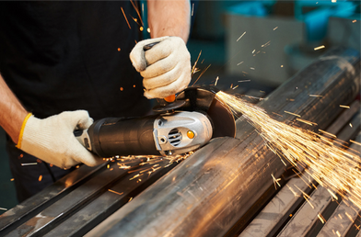

Image 9.5: Fitting and deburring

9 . 2 . B U T T W E L D I N G O F L A R G E - D I A M E T E R P I P E S
P i p e s u s e d i n l i q u i d a n d g a s t r a n s m i s s i o n l i n e s a r e j o i n e d b y b u t t w e l d i n g .

9 . 2 . 1 . F i t t i n g P a r t s i n B u t t W e l d i n g o f L a r g e - D i a m e t e r P i p e s
C u t a n d c l e a n e d p i p e s n e e d t o b e f i t t e d t o g e t h e r b e f o r e w e l d i n g .
O t h e r w i s e , w e l d i n g d e f e c t s m a y o c c u r . T o o l s u s e d f o r e d g e
p r e p a r a t i o n a n d c l e a n i n g c a n b e u t i l i z e d f o r t h e f i t t i n g p r o c e s s .

9 . 2 . 2 . B e v e l i n g f o r L a r g e - D i a m e t e r P i p e s
T h e b e v e l i n g o f p i p e s s h o u l d b e d o n e a c c o r d i n g t o t h e i r d i a m e t e r s
a n d w a l l t h i c k n e s s e s . D i f f e r e n t c u t t i n g p r o c e s s e s a r e a p p l i e d f o r
b e v e l i n g .

C u t t i n g
P i p e s s h o u l d b e c u t a c c o r d i n g t o t h e r e q u i r e d m e a s u r e m e n t s a n d p o s i t i o n a t t h e a s s e m b l y s i t e . C o m m o n c u t t i n g m e t h o d s i n c l u d e :
O x y - g a s c u t t i n g
C u t t i n g w i t h e l e c t r o d e s P l a s m a c u t t i n g
C u t t i n g w i t h a n a n g l e g r i n d e r C u t t i n g w i t h a b a n d s a w
C u t t i n g w i t h a h y d r a u l i c s a w

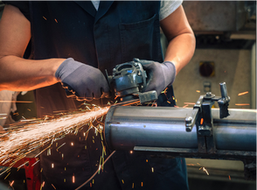
Image 9.5: Fitting and deburring

9 . 2 . B U T T W E L D I N G O F L A R G E - D I A M E T E R P I P E S
P i p e s u s e d i n l i q u i d a n d g a s t r a n s m i s s i o n l i n e s a r e j o i n e d b y b u t t w e l d i n g .

9 . 2 . 1 . F i t t i n g P a r t s i n B u t t W e l d i n g o f L a r g e - D i a m e t e r P i p e s
C u t a n d c l e a n e d p i p e s n e e d t o b e f i t t e d t o g e t h e r b e f o r e w e l d i n g .
O t h e r w i s e , w e l d i n g d e f e c t s m a y o c c u r . T o o l s u s e d f o r e d g e
p r e p a r a t i o n a n d c l e a n i n g c a n b e u t i l i z e d f o r t h e f i t t i n g p r o c e s s .

9 . 2 . 2 . B e v e l i n g f o r L a r g e - D i a m e t e r P i p e s
T h e b e v e l i n g o f p i p e s s h o u l d b e d o n e a c c o r d i n g t o t h e i r d i a m e t e r s
a n d w a l l t h i c k n e s s e s . D i f f e r e n t c u t t i n g p r o c e s s e s a r e a p p l i e d f o r
b e v e l i n g .

C u t t i n g
P i p e s s h o u l d b e c u t a c c o r d i n g t o t h e r e q u i r e d m e a s u r e m e n t s a n d p o s i t i o n a t t h e a s s e m b l y s i t e . C o m m o n c u t t i n g m e t h o d s i n c l u d e :
O x y - g a s c u t t i n g
C u t t i n g w i t h e l e c t r o d e s P l a s m a c u t t i n g
C u t t i n g w i t h a n a n g l e g r i n d e r C u t t i n g w i t h a b a n d s a w
C u t t i n g w i t h a h y d r a u l i c s a w
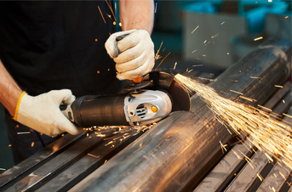

Image 9.6: Cutting with an angle grinder

C l e a n i n g
D u r i n g t h e c u t t i n g p r o c e s s , b u r r s f o r m i n s i d e t h e p i p e s . T o p r e v e n t f u t u r e b l o c k a g e s , b u r r s a n d f o r e i g n s u b s t a n c e s ( o i l , r u s t , p a i n t )
m u s t b e t h o r o u g h l y c l e a n e d . T o r e m o v e t h e s e , c h i s e l s , f i l e s ,
h a n d h e l d a n d s t a t i o n a r y g r i n d e r s , w i r e b r u s h e s , s a n d p a p e r , a n d
c h e m i c a l s u b s t a n c e s a r e u s e d . N o f o r e i g n r e s i d u e s h o u l d r e m a i n t o e n s u r e t h e w e l d ' s s t r e n g t h .

I n t e r s e c t i o n a n d B e v e l i n g f o r W e l d i n g
P i p e s a r e n o t a l w a y s l a i d b y w e l d i n g t h e m e n d - t o - e n d ( l i n e a r l y ) .
P i p e i n s t a l l a t i o n s m a y i n c l u d e a n g u l a r t u r n s i n d i f f e r e n t d i r e c t i o n s ,
i n t e r s e c t i o n s o f p i p e s c o m i n g f r o m d i f f e r e n t d i r e c t i o n s , a n d t h e
j o i n i n g o f p i p e s w i t h d i f f e r e n t d i a m e t e r s .
I n s u c h c a s e s , i n t e r s e c t i o n c u t t i n g i s r e q u i r e d , a n d f o r p i p e s w i t h a w a l l t h i c k n e s s g r e a t e r t h a n 5 m m , b e v e l i n g f o r w e l d i n g m u s t b e
p e r f o r m e d . S p e c i a l b e v e l i n g t e c h n i q u e s a r e u s e d i n t h e s e s i t u a t i o n s , w i t h b e v e l a n g l e s r a n g i n g b e t w e e n 5 0 ° a n d 9 0 ° .
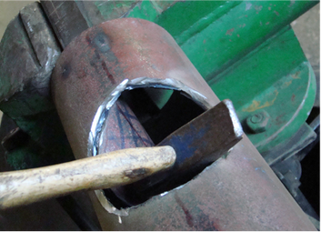
Figure 9.7: Intersection Cutting

9 . 2 . 3 . T h e P r o c e s s o f B u t t W e l d i n g L a r g e - D i a m e t e r P i p e s
I n s o m e p i p e w e l d i n g a p p l i c a t i o n s , t h e m a t e r i a l p r o p e r t i e s a n d l a r g e d i m e n s i o n s o f t h e p i p e r e q u i r e s p e c i a l p r e p a r a t i o n s . A n n e a l i n g a n d c l a m p i n g d e v i c e s a r e u s e d f o r t h e s e p r e p a r a t i o n s .
A n n e a l i n g
T h e p a r t s r e q u i r e p r e h e a t i n g a n d s l o w c o o l i n g a f t e r w e l d i n g . I n s o m e c a s e s , a n n e a l i n g c o n t i n u e s d u r i n g t h e w e l d i n g p r o c e s s .
A d d i t i o n a l l y , h e a t t r e a t m e n t c a n b e a p p l i e d a f t e r w e l d i n g t o r e l i e v e s t r e s s .
A n n e a l i n g i s a p p l i e d t o a l l o y a n d c a r b o n s t e e l p i p e s w i t h a w a l l
t h i c k n e s s g r e a t e r t h a n 1 3 m m . T h e s e a p p l i c a t i o n s c a n b e c a r r i e d o u t u s i n g p r o p a n e h e a t e r s , e l e c t r i c a l r e s i s t a n c e , a n d i n d u c t i o n
c u r r e n t d e v i c e s .

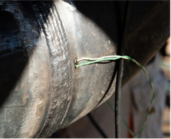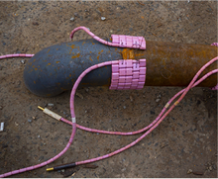

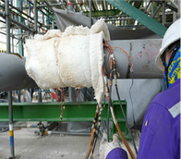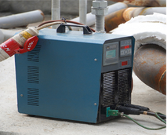a) b) c) d) Figure 9.8: Induction Heat Treatment Steps

- C o n n e c t i o n o f c o n t a c t t h e r m o m e t e r
- W r a p p i n g o f t h e h e a t e r
- I n s u l a t i o n o f t h e h e a t e r
- S e t t i n g t h e v a l u e f r o m t h e c o n t r o l p a n e l

C l a m p i n g A p p a r a t u s
B e f o r e s t a r t i n g w e l d i n g , t h e p i p e s t o b e w e l d e d m u s t b e t a c k -
w e l d e d . S i n c e l a r g e - d i a m e t e r p i p e s a r e c y l i n d r i c a l , a l i g n i n g t h e m i s d i f f i c u l t . D u r i n g t a c k w e l d i n g , t h e s e p i p e s s h o u l d b e t e m p o r a r i l y
h e l d t o g e t h e r u s i n g s p e c i a l c l a m p s , V - b e d s , a n d c l a m p i n g
a p p a r a t u s . T a c k w e l d s i n s i d e t h e w e l d i n g g r o o v e s h o u l d b e a p p l i e d i n a w a y t h a t p r e v e n t s c r a t e r c r a c k s . D u r i n g t h e p i p e j o i n t w e l d i n g p r o c e s s , t h e s e t a c k w e l d s m a y n e e d t o b e g r o u n d a n d r e m o v e d .
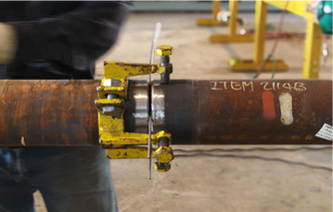
Figure 9.9: Apparatus Used for Pipe End Preparation

C o n s i d e r a t i o n s i n B u t t ( B u t t J o i n t ) W e l d i n g
I f n e c e s s a r y , a n a p p r o p r i a t e w e l d i n g b e v e l s h o u l d b e m a d e o n t h e p i p e s t o b e w e l d e d .
P i p e s m u s t b e c u t a c c u r a t e l y a n d t o t h e c o r r e c t d i m e n s i o n s ( F i g u r e 9 . 1 2 ) .
B e f o r e w e l d i n g , t h e e d g e s o f t h e w e l d b e v e l m u s t b e c l e a n e d o f r u s t , o x i d e , o i l , p a i n t , a n d o t h e r f o r e i g n s u b s t a n c e s a t l e a s t 2 0 m m w i d e f r o m b o t h t h e i n s i d e a n d o u t s i d e .

C a r e m u s t b e t a k e n t o e n s u r e t h a t t h e r e i s n o m i s a l i g n m e n t i n t h e a x i s o f t h e p i p e s b e i n g j o i n e d .
M i s a l i g n m e n t s c a u s e d b y o v a l i t y o r t h i c k n e s s d i f f e r e n c e s i n t h e p i p e s s h o u l d b e p r e v e n t e d .
P r o p e r l y f i t t e d p a r t s s h o u l d b e t a c k w e l d e d i n c l a m p i n g d e v i c e s , a n d a g a u g e s h o u l d b e u s e d d u r i n g t a c k w e l d i n g .
T h e w e l d i n g p o s i t i o n s h o u l d b e s e l e c t e d c a r e f u l l y . I f p o s s i b l e , t h e p a r t s h o u l d b e r o t a t e d h o r i z o n t a l l y w h i l e w e l d i n g ; h o w e v e r , t h i s i s n o t a l w a y s f e a s i b l e . I n s u c h c a s e s , t h e p i p e s h o u l d b e
w e l d e d u s i n g a l l p o s i t i o n s .

9 . 2 . 4 . A p p l i c a t i o n o f L a r g e D i a m e t e r P i p e B u t t W e l d i n g a n d P o s t - W e l d i n g O p e r a t i o n s
A f t e r c u t t i n g , c l e a n i n g , f i t t i n g , a n d p r e p a r i n g t h e w e l d b e v e l , t h e p a r t s a r e t a c k w e l d e d i n a V - b e d w i t h p r o p e r s p a c i n g .
A t e m p l a t e i s u s e d b e t w e e n t h e t w o p a r t s d u r i n g t a c k w e l d i n g . A r o o t p a s s i s a p p l i e d t o t h e t a c k - w e l d e d p a r t s i n t h e h o r i z o n t a l p o s i t i o n . T h e r o o t p a s s c a n b e p e r f o r m e d u s i n g T I G w e l d i n g .
A f t e r s l a g r e m o v a l f r o m t h e w e l d e d p a r t s , a d d i t i o n a l p a s s e s a r e m a d e , a n d t h e w e l d a r e a i s c l e a n e d .
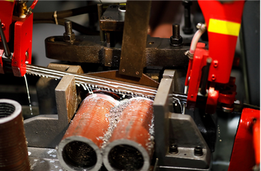
Figure 9.10: Pipe Cutting with a Band Saw
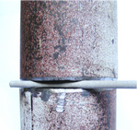
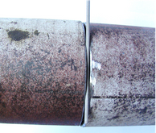
- b) c) d)
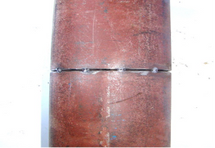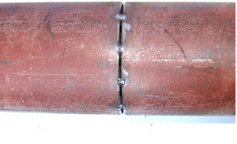Figure 9.11: The Sequence of Operations to be Followed in Pipe Welding
- Tack welding spacing on the horizontal axis
- Tack welding spacing on the vertical axis
- Tack welding on the horizontal axis
- Tack welding on the vertical axis

9 . 3 . F L A N G E W E L D I N G O F L A R G E D I A M E T E R P I P E S
P i p e s a r e u s e d t o t r a n s p o r t f l u i d s f r o m o n e p l a c e t o a n o t h e r . I n s o m e c a s e s , p i p e s n e e d t o b e c o n n e c t e d t o p u m p s , b o i l e r s , o r e a c h o t h e r i n a d e t a c h a b l e m a n n e r .
S i n c e w e l d s c r e a t e p e r m a n e n t j o i n t s , f l a n g e s a r e w e l d e d t o
s e c t i o n s o f p i p e s t h a t n e e d t o b e r e m o v a b l e . T h e s e f l a n g e s a r e
t h e n b o l t e d t o g e t h e r . W h e n m a i n t e n a n c e o r r e p l a c e m e n t i s
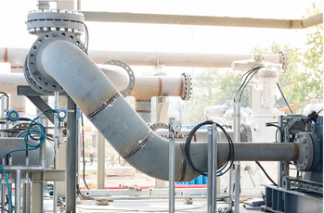
r e q u i r e d i n p i p i n g s y s t e m s , t h e f l a n g e s a r e u n b o l t e d , s e p a r a t e d , a n d n e c e s s a r y w o r k i s c a r r i e d o u t ( F i g u r e 9 . 1 2 ) .
Figure 9.12: Pipe assembly joined with a flange

9 . 3 . 1 . A l i g n m e n t o f P a r t s i n F l a n g e W e l d i n g
F l a n g e s p l a y a c r u c i a l r o l e i n t h e t r a n s p o r t a t i o n o f l i q u i d s , g a s e s , a n d s o l i d m a t e r i a l s . F l a n g e d c o n n e c t i o n s a r e p a r t i c u l a r l y u s e d i n a r e a s r e q u i r i n g h i g h d u r a b i l i t y .

9 . 3 . 2 . B e v e l P r e p a r a t i o n i n F l a n g e d J o i n t s
L a r g e - d i a m e t e r p i p e s a r e g e n e r a l l y p r e p a r e d w i t h a V - g r o o v e f o r w e l d i n g . T h e b e v e l i n g p r o c e s s i s p e r f o r m e d e i t h e r m a n u a l l y o r
u s i n g a u t o m a t e d m a c h i n e s .

9 . 3 . 3 . E x e c u t i o n o f F l a n g e W e l d i n g
T h e a p p r o p r i a t e f l a n g e t y p e i s s e l e c t e d b a s e d o n t h e c o n n e c t i o n c o n d i t i o n s a n d t h e m a t e r i a l s u s e d ( F i g u r e 9 . 1 5 ) .
B l i n d f l a n g e s
T h r e a d e d f l a n g e s S t u b - e n d f l a n g e s
B a c k i n g r i n g f l a n g e s S l i p - o n f l a n g e s
S t e e l f l a n g e s
F l a n g e s a r e t a c k w e l d e d t o t h e p i p e s a f t e r e n s u r i n g t h a t t h e b o l t h o l e s a l i g n .
T h e g a s k e t t h i c k n e s s r e q u i r e d t o e n s u r e a l e a k - p r o o f s e a l i s c o n s i d e r e d i n l e n g t h c a l c u l a t i o n s .
P r e c a u t i o n s a r e t a k e n a g a i n s t d i s t o r t i o n s c a u s e d b y h e a t d u r i n g w e l d i n g .

9 . 3 . 4 . A p p l i c a t i o n o f F l a n g e W e l d i n g a n d P o s t - W e l d i n g P r o c e s s e s
I f n e c e s s a r y , a b e v e l i s p r e p a r e d o n t h e p i p e a n d f l a n g e , a n d t h e y a r e a l i g n e d .
T h e p i p e a n d f l a n g e a r e t a c k - w e l d e d a t e q u a l i n t e r v a l s a t a 9 0 - d e g r e e a n g l e o r a t t h e d e s i r e d a n g l e ( F i g u r e 9 . 1 3 ) .
I f r e q u i r e d , p r e h e a t i n g i s a p p l i e d .
A n i n s i d e c o r n e r w e l d i s p e r f o r m e d d e p e n d i n g o n t h e w e l d i n g p o s i t i o n .
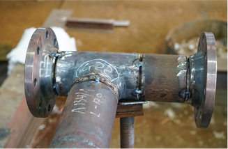
S o m e f l a n g e s a r e w e l d e d e x t e r n a l l y , w h i l e o t h e r s a r e w e l d e d i n t e r n a l l y ( F i g u r e s 9 . 1 4 a n d 9 . 1 5 ) .

Figure 9.13: Tack Welding of the Flange

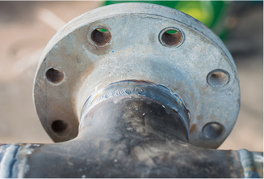
Figure 9.14: External Welding of the Flange

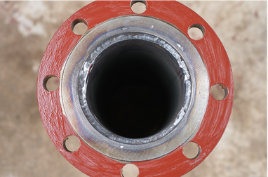

Figure 9.15: Tack Welding of the Flange

9 . 3 . 4 . A p p l i c a t i o n o f F l a n g e W e l d i n g a n d P o s t - W e l d i n g P r o c e s s e s
I f n e c e s s a r y , a b e v e l i s p r e p a r e d o n t h e p i p e a n d f l a n g e , a n d t h e y a r e a l i g n e d .
T h e p i p e a n d f l a n g e a r e t a c k - w e l d e d a t e q u a l i n t e r v a l s a t a 9 0 - d e g r e e a n g l e o r a t t h e d e s i r e d a n g l e ( F i g u r e 9 . 1 3 ) .
I f r e q u i r e d , p r e h e a t i n g i s a p p l i e d .
A n i n s i d e c o r n e r w e l d i s p e r f o r m e d d e p e n d i n g o n t h e w e l d i n g p o s i t i o n .
S o m e f l a n g e s a r e w e l d e d e x t e r n a l l y , w h i l e o t h e r s a r e w e l d e d i n t e r n a l l y ( F i g u r e s 9 . 1 4 a n d 9 . 1 5 ) .

Figure 9.13: Tack Welding of the Flange
Figure 9.14: External Welding of the Flange
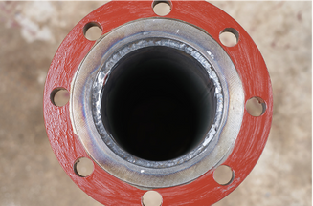

Figure 9.15: Tack Welding of the Flange
I f n e c e s s a r y , h e a t t r e a t m e n t i s a p p l i e d a f t e r t h e w e l d i n g p r o c e s s .
A f t e r w e l d i n g , a s e a l i n g a n d p r e s s u r e t e s t i s c o n d u c t e d .

9 . 4 . W E L D I N G O F L A R G E D I A M E T E R P I P E S - T W E L D I N G
I t i s p e r f o r m e d b y j o i n i n g t w o o r m o r e p i p e s i n d i f f e r e n t w a y s .

9 . 4 . 1 . C r o s s - s e c t i o n s o f P i p e s t o b e T - J o i n t e d
T h e i n t e r s e c t i o n s t h a t o c c u r a t t h e j u n c t i o n p o i n t s o f t w o o r m o r e p i p e s b e i n g j o i n e d a r e c a l l e d c r o s s - s e c t i o n s .
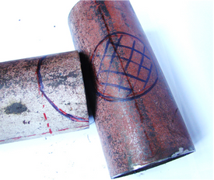
T o m a r k t h e c r o s s - s e c t i o n o n p i p e s , e i t h e r t e m p l a t e s a r e p r e p a r e d u s i n g c r o s s - s e c t i o n m e t h o d s o r p r a c t i c a l m e t h o d s a r e u s e d t o d r a w d i r e c t l y o n t o t h e p i p e s .

Figure 9.16: Pipes with Cross-Sections Cut and Beveled, Forming a Segmented Elbow

9 . 4 . 3 . B e v e l i n g f o r T J o i n t s
C r o s s - s e c t i o n d e v e l o p m e n t i s t h e m o s t c o m m o n l y u s e d T w e l d i n g p r e p a r a t i o n .

9 . 4 . 4 . C o n s i d e r a t i o n s i n C r o s s - S e c t i o n T J o i n t W e l d i n g
T h e c o r r e c t d r a w i n g m e t h o d s h o u l d b e c h o s e n w h e n a d j u s t i n g p i p e s b y c r o s s - s e c t i o n o p e n i n g .
M a r k i n g s h o u l d b e d o n e a c c u r a t e l y .
A f t e r c u t t i n g a n d f i t t i n g , b u r r s i n s i d e t h e p i p e m u s t b e c l e a n e d . D u r i n g t a c k w e l d i n g , t h e n e c e s s a r y r u l e s f o r p i p e j o i n i n g s h o u l d b e f o l l o w e d , a n d e q u a l s p a c i n g s h o u l d b e l e f t a r o u n d t h e t a c k - w e l d e d a r e a .
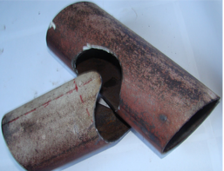
9 . 4 . 5 . I m p l e m e n t a t i o n o f T W e l d i n g a n d P o s t - W e l d i n g P r o c e s s e s C a r d b o a r d t e m p l a t e s a r e w r a p p e d a r o u n d t h e p i p e s t o d r a w t h e c r o s s - s e c t i o n , o r m a r k i n g i s d o n e d i r e c t l y o n t h e p i p e s .
Figure 9.17: Cross-Section Marking

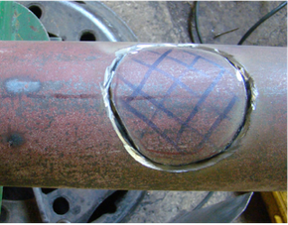
Figure 9.18: Cutting of the Cross-Section with a Chip Removal Machine

A f t e r c l e a n i n g t h e b u r r s a n d p r e p a r i n g t h e w e l d i n g e d g e s , t h e p i p e s a r e a l i g n e d a n d t a c k - w e l d e d w i t h e q u a l s p a c i n g
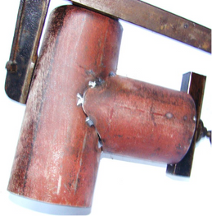
Figure 9.19: Tack Welding of Pipes with Cut and Fitted Intersections

A r o o t p a s s i s p e r f o r m e d , f o l l o w e d b y t h e c o m p l e t i o n o f t h e w e l d .
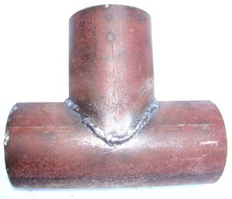
Figure 9.20: Welding of Pipes with Beveled (T) Joint
I f n e c e s s a r y , a h e a t t r e a t m e n t i s a p p l i e d a f t e r w e l d i n g .
T h e w e l d s e a m i s i n s p e c t e d f o r l e a k a g e a n d p r e s s u r e t e s t e d .

9 . 5 . W E L D I N G O F L A R G E D I A M E T E R P I P E S I N L J O I N T S
W h e n l a y i n g p i p e l i n e s , i t m a y b e n e c e s s a r y t o c h a n g e d i r e c t i o n .
T h e c o n n e c t i o n e l e m e n t s u s e d a t c o r n e r s f o r d i r e c t i o n c h a n g e s a r e c a l l e d e l b o w s . E l b o w s a r e n a m e d a c c o r d i n g t o t h e i r a n g l e s ( e . g . ,
9 0 - d e g r e e e l b o w , 1 2 0 - d e g r e e e l b o w , e t c . ) .
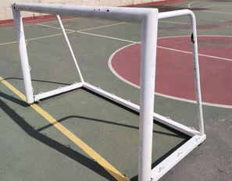
T h e r e a r e a l s o p r e - m a n u f a c t u r e d e l b o w s a v a i l a b l e , w h i c h a r e p r o d u c e d a s s i n g l e o r m u l t i - p i e c e c o m p o n e n t s .
Figure 9.21: Locations Where L Elbows Are Used

9 . 5 . 1 . F i t t i n g P a r t s i n L W e l d i n g
U s e d i n t h e j o i n i n g o f n a r r o w a n d w i d e - a n g l e p a r t s .

9 . 5 . 2 . B e v e l i n g i n L J o i n t s
T h e s m a l l e s t a n g l e b e v e l i n g p r o c e s s i s a p p l i e d t o t h e e d g e s o f c o r n e r a n d e l b o w p i p e s .

9 . 5 . 3 . C o n s i d e r a t i o n s i n L W e l d i n g
- T h e c u t t i n g a n g l e m u s t b e c o r r e c t l y c a l c u l a t e d a c c o r d i n g t o t h e a n g l e o f t h e e l b o w t o b e m a d e .
- T h e c o r r e c t c u t t i n g m e t h o d s h o u l d b e c h o s e n .
- P i p e s m u s t b e f i t t e d t o g e t h e r a n d t a c k e d .
- T h e r o o t w e l d m u s t n o t p r o t r u d e i n s i d e t h e p i p e , a s o v e r t i m e , i t m a y a c c u m u l a t e r e s i d u e a n d c a u s e b l o c k a g e s .

9 . 5 . 4 . A p p l i c a t i o n o f L W e l d i n g a n d P o s t - W e l d i n g P r o c e s s e s
- P i p e s a r e c u t u s i n g a s u i t a b l e c u t t i n g t o o l t o c r e a t e t h e
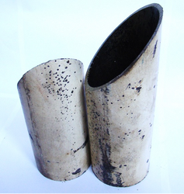
a p p r o p r i a t e i n t e r s e c t i o n s f o r t h e i r d i a m e t e r s a n d t h e n f i t t e d t o g e t h e r ( F i g u r e 9 . 2 2 ) .

Figure 9.22: Angled Cut L Elbow

T h e p i p e s a r e t a c k w e l d e d t o e a c h o t h e r a t 9 0 d e g r e e s
p e r p e n d i c u l a r o r a t t h e d e s i r e d a n g l e w i t h e q u a l s p a c i n g .
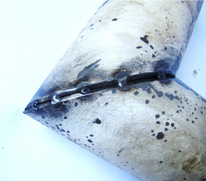
Figure 9.23: Tack Welding of L Elbow

I f n e c e s s a r y , p r e h e a t i n g i s a p p l i e d .
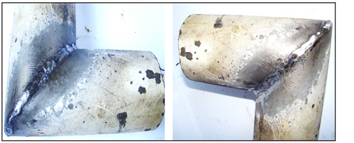
T h e w e l d i n g s e a m i s p e r f o r m e d b y a d j u s t i n g t h e e l e c t r o d e a n g l e a n d m o v e m e n t a c c o r d i n g t o t h e w e l d i n g p o s i t i o n
Figure 9.24: Welding of L Elbow

I f n e c e s s a r y , h e a t t r e a t m e n t i s a p p l i e d .
  - T h e s e a l i n g a n d p r e s s u r e c o n t r o l o f t h e w e l d s e a m i s p e r f o r m e d .

W e l d i n g D e f e c t s T h a t O c c u r A f t e r t h e A p p l i c a t i o n o f L a r g e D i a m e t e r P i p e L W e l d i n g
V a r i o u s f a c t o r s ( e n v i r o n m e n t a l a n d w e l d e r e r r o r s ) c a n c a u s e
d e f e c t s d u r i n g w e l d i n g . T h e s e d e f e c t s c a n p r e v e n t t h e p i p e s f r o m p e r f o r m i n g t h e i r i n t e n d e d f u n c t i o n i n t h e i r a p p l i c a t i o n a r e a s a n d
m a y e v e n l e a d t o a c c i d e n t s . T h e r e f o r e , p r e c a u t i o n s s h o u l d b e t a k e n t o p r e v e n t t h e s e d e f e c t s . T h e m a i n w e l d i n g d e f e c t s a r e a s f o l l o w s :
  - P o r o s i t y
  - S l a g a n d f o r e i g n m a t e r i a l r e s i d u e s
  - U n d e r c u t t i n g
  - C r a c k s
  - W e l d i n g s t a r t a n d e n d p o i n t s

I n s p e c t i o n M e t h o d s C o n d u c t e d A f t e r t h e A p p l i c a t i o n o f L a r g e D i a m e t e r P i p e L W e l d i n g
P i p e s m u s t b e i n s p e c t e d a f t e r w e l d i n g . I f t h e r e a r e l e a k s i n t h e f l u i d s p a s s i n g t h r o u g h t h e p i p e s , v a r i o u s a c c i d e n t s m a y o c c u r d e p e n d i n g o n t h e n a t u r e a n d p r e s s u r e o f t h e f l u i d .
F o r t h i s r e a s o n , a n a p p r o p r i a t e i n s p e c t i o n m e t h o d i s s e l e c t e d a n d a p p l i e d b a s e d o n t h e i m p o r t a n c e a n d s p e c i f i c a t i o n s o f t h e w e l d .
I n s p e c t i o n m e t h o d s a r e d i v i d e d i n t o d e s t r u c t i v e a n d n o n - d e s t r u c t i v e t e s t i n g . M a t e r i a l s s u b j e c t e d t o d e s t r u c t i v e t e s t i n g a r e n o t u s e d b u t a r e p r o d u c e d f o r t e s t i n g p u r p o s e s .
B e f o r e o p e r a t i n g w e l d e d p i p e s i n a s y s t e m , n o n - d e s t r u c t i v e t e s t i n g i s a p p l i e d . I f t h e t e s t r e s u l t s a r e p o s i t i v e , t h e p i p e s y s t e m s a r e p u t i n t o o p e r a t i o n . N o n - d e s t r u c t i v e t e s t i n g m e t h o d s i n c l u d e :
  - V i s u a l I n s p e c t i o n : E x t e r n a l d e f e c t s i n t h e w e l d s e a m a r e d e t e c t e d t h r o u g h v i s u a l e x a m i n a t i o n . V i s u a l i n s p e c t i o n s a r e p e r f o r m e d
b e f o r e , d u r i n g , a n d a f t e r w e l d i n g .
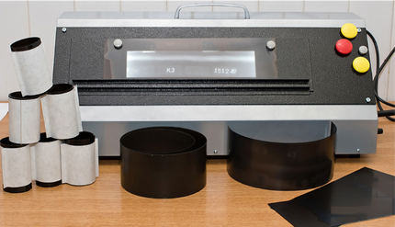
  - X - r a y ( R a d i o g r a p h i c ) I n s p e c t i o n : T h i s m e t h o d i n v o l v e s t a k i n g a n X - r a y i m a g e o f t h e w e l d e d a r e a t o i n s p e c t i t .
Figure 9.25: Examination of X-ray Film
U l t r a s o n i c I n s p e c t i o n : A w e l d i n g i n s p e c t i o n m e t h o d u s i n g h i g h - f r e q u e n c y s o u n d w a v e s .
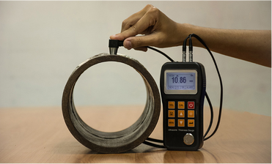
I t i s p r i m a r i l y u s e d t o d e t e c t i n t e r n a l d e f e c t s .

  - D y e P e n e t r a n t I n s p e c t i o n : A t e s t i n g m e t h o d u s i n g s p e c i a l d y e s t o r e v e a l s u r f a c e d e f e c t s s u c h a s p i t s , c r a c k s , a n d v o i d s .
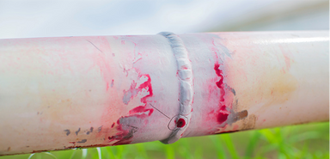
Figure 9.27: Inspection with Dye
H a r d n e s s T e s t I n s p e c t i o n : A m e t h o d u s e d t o m e a s u r e w h e t h e r t h e w e l d s e a m h a s t h e d e s i r e d h a r d n e s s . I t i s p e r f o r m e d u s i n g o n e o f t h e h a r d n e s s m e a s u r e m e n t m e t h o d s .
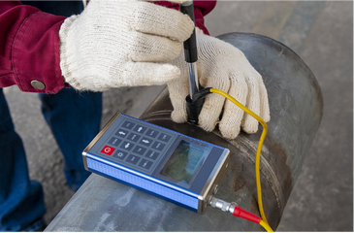
Figure 9.28: Hardness Measurement Test Device

M a g n e t i c I n s p e c t i o n : U s e d t o d e t e c t d e f e c t s i n w e l d s w i t h m a g n e t i c p r o p e r t i e s u s i n g m a g n e t i c p a r t i c l e s .
P r e s s u r e T e s t i n g : A m e t h o d u s e d t o c h e c k f o r l e a k s a n d m e a s u r e
t h e s t r e n g t h o f w e l d s e a m s i n p i p e s u s i n g p r e s s u r i z e d l i q u i d s o r a i r .

